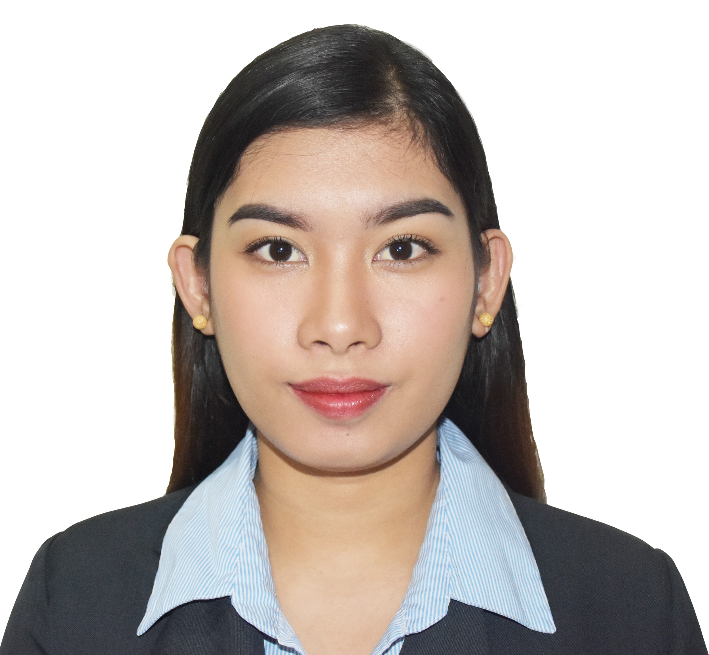

**Hazel D. Mabilangan**

Address: Al Maraya Building, Al Satwa, Dubai

Contact Number: +971552729563

Email: Hazelmabilangan27@gmail.com

**OBJECTIVE:**

Seeking the job of Shadow Teacher. Bringing enormous experience at providing the right environment for learning for all students to achieve both academic and social

Success.

**WORK EXPERIENCE**

**WORK EXPERIENCES**

**Private Tutor**

JLT Dubai, UAE

June 2020 - Present

Job Descriptions;

* Prepare lessons, assignments, and other assessments for the students
* Help students develop intricate learning skills like writing and listening and easy ways to deal with difficult topics.
* Make corrections in assignments and other assessments where the students did not perform well
* Helped students refine study skills and become independent learners.

**Receptionist**

Discovery Travel Dubai

City Pharmacy Dubai, UAE

November 2018 – November 2020

* Greet and welcome guests as soon as they arrive at the office
* Direct visitors to the appropriate person and office
* Answer, screen and forward incoming phone calls
* Ensure reception area is tidy and presentable, with all necessary stationery and material (e.g. pens, forms and brochures)
* Provide basic and accurate information in-person and via phone/email
* Receive, sort and distribute daily mail/deliveries
* Maintain office security by following safety procedures and controlling access via the reception desk (monitor logbook, issue visitor badges)
* Order front office supplies and keep inventory of stock

**SPED Teacher**

**Western Colleges. Inc,**

Latoria Cavite, Philippines

June 2017- June 2018

Job Descriptions;

**PERSONAL INFORMATION**

**Gender:** Female **Civil Status:** Single

**Nationality:** Filipino **Religion:** Roman Catholic

**Date of Birth:** October 27, 1997 **Visa Status:** Visit Visa

**SKILLS**

Ability to work efficiently under pressure, well organized with great time management, effective leadership skills, excellent interpersonal and communication skills, outgoing and friendly personality, a patient, resourceful, and resilient personality, Excellent interpersonal and communication skills, Experience working with children with a wide range of disabilities

**EDUCATIONAL BACKGROUND**

**Year**

**Tertiary Level:** Cavite State University Main Campus 2013 - 2017

Indang, Cavite

**TRAININGS ATTENDED**

August 23 – October 27, 2016 **On-the-Job Training**

Cebu Pacific Air Domestic Road Pasay City

Security Department

October 15 – November 24, 2016  **On-the-Job Training**

Microtel by Wyndham Eagle Ridge Cavite

Housekeeping Department

**CHARACTER REFERENCES**

**GAY MARCE**

Position: Tours Supervisor

Discovery Travel Dubai LLC.

Contact No: +971555427524

*I hereby certify that all information above is true and correct to the best of my knowledge.*

**__________________________**

**HAZEL D. MABILANGAN**