SUMMARY
Innovative Electrical Engineer with a proven track record of evaluating electrical systems and applying knowledge of electricity and materials in a beneficial way. Committed to working as a collaborative and positive team member, striving to utilize my knowledge and expertise for optimal engineering results.

SKILL HIGHLIGHTS
- Leadership  - Problem-solving abilities  - Ability to Work in a Team | - Computer proficiency  - Decision Making  - Computer skills

TECHNICAL SKILL HIGHLIGHTS
- SAP MM  - MS OFFICE  - .NET  - OPERATING SYSTEMS WINDOWS XP, WINDOWS 7. | - AUTOCAD  - LABVIEWS  - MATLAB

SUMMARY OF PROFESSIONAL EXPERIENCE

ELECTRICAL ENGINEER - 01/2019 to 12/2021
JAZAL ENGINEERING AND CONTRACTING LLC, ABU DHABI, UAE

- Supervision of Cable laying up to 11kv, Jointing, Termination for LV and HV Cables as per ADDC Standard.
- Installations of all electrical works were carried out as per approved drawings ensuring compliance with safety requirements and as per standards.
- Submits site daily reports, inspection requests, estimates and all applicable monitoring reports on regular basis or as required.
- Executed project in compliance with technical specifications and safety standards with method of statements.
- Supervising contracted staff and instructing them to carry out the job as per schedule.
- Check for the availability of materials to suit the requirement and ensure weather it matches the client requirement.
- Maintaining a safe, secure, and healthy work environment by adhering to and enforcing safety codes.
- Providing PPE training to the subcontracted and staff for road and street light maintenance.
- Our major clients list includes ADDC, ABU DHABI MUNICIPALITY, BILFINGER TEBODIN MIDDLE EAST LTD , LULU GROUP.

Contact
Phone:
+971-543605232(WhatsApp no.)
+91-6385391291

Email:
manoranjit91@gmail.com
DOB: 01/10/1991

Nationality: Indian

LinkedIn:
linkedin.com/in/manoranjit-sivasanku-7b14a2b0
UAE Driving Licence: Yes

Languages
★★★★★ ENGLISH
★★★★★ HINDI
★★★★★ TAMIL

Hobbies
- Gardening
- Yoga
- Painting
- Cooking
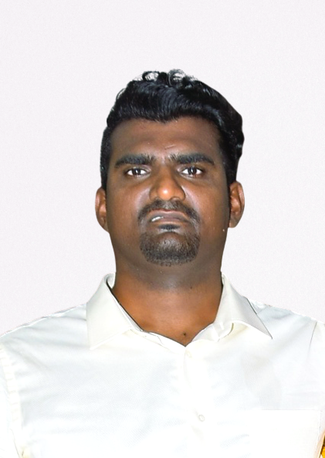
MANORANJIT
SIVASANKU
SITE ENGINEER- 04/2016 to 06/2018
GOLDEN BUILDER,TAMILNADU, INDIA
- Conduced project monitoring to ensure quality construction and safety.
- Read construction plan and communicated them to worker.
- Adjusted work scheduled As needed in order to meet all project deadline.
- Check for the availability of materials to suit the requirement and ensure weather it matches the client requirement.
- Supervising contracted staff and instructing them to carry out the job as per schedule.
- Accomplishing project by defining the scope and resourced required.
- Conduced on-site observation of construction in progress and produced site visit report.

SITE ENGINEER- 04/2014 to 03/2016
JB BUILDING CONTRACTING, TAMILNADU, INDIA
- Ensures that all the works done are in accordance with the approved construction drawings, contract documents, project specifications, and all applicable standards whether local, national, or international standards.
- To handle Operation &amp; Maintenance Electrical works, Site work &amp; documentation work, including making &amp; maintain daily report, monthly reports.
- Check for the availability of materials to suit the requirement and ensure weather it matches the client requirement.
- Supervising contracted staff and instructing them to carry out the job as per schedule.
- Constantly work to improve processes.
- Train, guide and evaluate new workers.

EDUCATION

- Bachelor of Engineering: Electrical and Electronics Engineering – 2014
SKR Engineering College, Tamilnadu, India.
- 12th (HSC)- BTS Higher Secondary School, Balco, Chhattisgarh, India-2010
- 10th (SSC)-Kendriya Vidyalaya, Balco, Chhattisgarh, India-2008

DECLARATION

I hereby declare that the information furnished above is true to the best of my knowledge.

(MANORANJIT SIVASANKU)

