DOCTOR Professional-BDS
Position Applied For Administrative Role, Treatment Coordinator,
voice process, tutor, assistance role, calls management, front desk, customer and accounts related services.

Personal Profile:  SRI KARUNA SANKKARY G  Tel +971589268487  DUBAI(U,A,E)  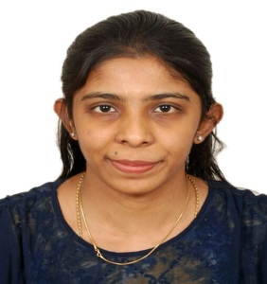  Email:  drsrilovely02@gmail.com  Native address:  02,Narayanan Nagar,  Pallikaranai,  Chennai-100  TamilNadu- India.  Tel:+91 9884733762 (INDIA)  0558605150  Personal Data:  Gender : Female  Date of Birth :02-01-1991  Marital Status : Married  Nationality : Indian  Passport No :N0806879  Expiry Date :28/06/2025  Languages Known:  - English --- Good  - Tamil --- Good  - Malayalam --- Good  - French --- Moderate  Visa status:  Permanent visa  Date of Join.  Avail to join Immediate | 3 YEARS 2 MONTHS RELEVANT EXPERIENCE:  Academic Details:  - Bachelor of Dental Surgery in from Sree Balaji Dental College & Hospital. Chennai, TamilNadu- India  - H.S.C from Alpha Higher Secondary school,Chennai,Tamilnadu-India  - S.S.L.C from Alpha Higher Secondary school,Chennai,Tamilnadu-India  Area of Exposure:  - Handled various cases well versed in apps handling and social media including marketing strategies.  - Assisted in various profit maintenance conditions and situations  - Managed Overall aspects in hospital single handedly including patients, their treatments and Administration.  - Advised clients regarding treatment modalities, coordination and needs.  - Administration including calls, Appointments Fixations, management of new & Old Patients, Profit maintenance and etc.  Organisational Experience:  - December 2014 to October 2016 : Dr.Prabhu’s Dental Studio  - April 2013 to November 2014: Dentakings Dental Clinic.  Seminars presented :  Had presented various seminars out of which few one are listed below  - Fixed Functional Appliances  - Crown and Bridges  - Maintenance of Oral Hygiene.  PERSONAL PROFILE / PERSONAL ATTRIBUTES:  Extremely reliable and dependable - analytical and questioning, strives for quality.  - Adaptable and flexible; well-organized planner and scheduler.  - Seeks new responsibilities, initiative & self-sufficient.  - Completer-finisher; checks and follows up - immaculate record-keeper.  - Critical thinker - strong analytical skills; accurate and probing  DECLARATION :  I hereby declare that the above information provided are true to the knowledge and belief. Am also confident of my ability to work as a team and contribute my best for the development of the Organization.  Place: Yours faithfully,  Date: (Sri Karuna Sankkary)

