CURRICULUM VITAE

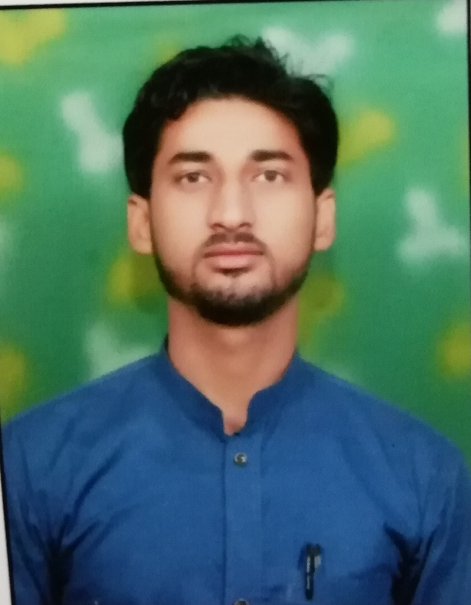  Mahbub Aalam  Email:mahboobusmani5@gmail.com  Mobile No. : +971509605131  Permanent Address  Ajman dubai  Personal Details  Date Of Birth : 06th Aug 1997  Father’s Name : Mr. Safi ahmad  Mother’s Name: Mrs.khatija vegum  Nationality : Indian  Interests : Traveling, Helping Others | Career Objective  To successfully integrate myself in the corporate hierarchy through high target orientation and motivation as well as to seek a dynamic and challenging career in an organization to promote professional growth while making positive contributions towards the organization.  Experience Summary  - Worked as a Assistant Software Engineer on Asp.Net Technology in “Euthissa care technology pvt Ltd bhubaneswar Orissa” From 7th April 2020 to 7th-March 2021.  Technical Qualification  - Bachelor of Technology (Teerthanker Mahaveer University Moradabad)  Technical Expertise  C#, AspNet, HTML and XML, MySQL,  Education  - 10+2 from subha smarak inter college khandikhera , Rampur(UP).  - 10th Rizwanulhaq Memorial Inter college Moradabad(UP).

Projects

Company : Euthissa care technology Pvt. Ltd. working from April 2020 to till date.
Project Title : Employee management system
Role : Doveloper
Operating Systems : Windows
Tech. & Tool(s) C# Asp. Net, My sql server
Team Member : 2
Status : Live.
Project Description:

Employee Management system is an application that enables users to create and store Employee Records. The application also provides facilities of a payroll system which enables user to generate Pay slips too. This application is helpful to department of the organization which maintains data of employees related to an organization .

Technical Exposure:
Programming | C#, Html and Xml (asp. Net Framework ),SQL
Web technology | HTML, Asp. Net
Databases | Mysql

Assets:
- Quick Learner
- Positive attitude.
- Team working spirit.

Computer Skills :
1 year computer diploma (PGDCA) from Rampur.
6 month mobile hardware and software diploma (Hi-tech) from Delhi.

Declaration

I hereby declare that all the above written particulars are true to the best of my knowledge and belief.

Date: .…/….../……

Place: (Mahbub Aalam)

