Raghavendra Bashetty Email: raaghavendra@gmail.com
Sr Salesforce Developer Phone: +91 9949224001
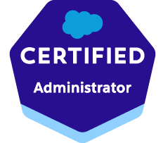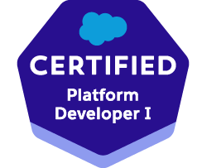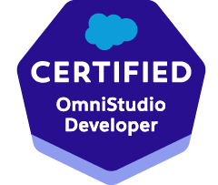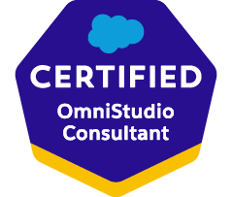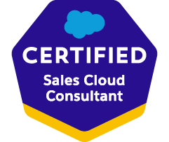

Professional Summary:
- Having 6 years of experience in development of Salesforce, Vlocity (Salesforce Industries) projects and looking for Senior Salesforce Developer/Senior Omistudio Developer roles.
- Having 10 years of experience in Siebel CRM design & development.
- Having 16 years of overall professional experience in IT.
- Having strong functional knowledge in CRM & CPQ domain.
- Having work experience in Insurance (Financial Cloud), Public Sector, Telecom Domain Projects.
- Having long term onsite experience with Belgium, Saudi Arabian Clients and short-term onsite experiences with USA, South African Clients.
- Having good Communication & Analytical skills.
Technical Experience:
- Salesforce Development (Apex, LWC , Flows, Approval Process, Integration, Process Builder,Validation Rules, Profile & Permission Sets, Administration & Experience Cloud Configuration , Reports & Dashboards Configuration).
- Salesforce Omnistuido Development (Omniscripts, Dataraptors, Integration Procedures, Flex Cards, Business Rule Engine(Decision Matrix, Decission Tables, Expression Sets , Document Template)
Certifications:
- Salesforce Certified Administrator
- Salesforce Certified Platform Developer I
- Salesforce Certified OmniStudio Developer
- Salesforce Certified OmniStudio Consultant
- Salesforce Sales Cloud Consultant

Employment Summary:

Employer Name | From (DD/MM/YY) | To (DD/MM/YY)
Coforge Limited | 30/11/23 | Till Date
GetOnCRM Solutions Pvt Ltd | 14/11/22 | 31/10/23
Tech Mahindra Limited | 14/03/22 | 14/10/22
Salesforce.com India Private Limited | 05/04/21 | 28/02/22
Infosys Limited | 24/09/18 | 12/03/21
TATA consultancy services limited | 09/01/13 | 14/09/18
Polaris Financial Technology | 25/01/12 | 04/01/13
IBM India Private Limited | 15/09/10 | 23/01/12
TATA consultancy services limited | 28/07/08 | 27/08/10

Project Details:
Project Name | Trinet GOQ Enhancements
Client | Trinet, USA
Description | ​TriNet is a professional employer organization (PEO) that provides human resources (HR) solutions for small and medium-sized businesses (SMBs). Trinet is using Sales cloud for generating the Health Plan Pricing Quotes and also implemented customized solution Medical Pricing Tool to generate the Medical pricing record to calculate the Band for Prospect and Client Pricing. Our team is responsible for development of new enhancements for various Trinet initiated Projects(Epics) and Production Issue Fixes. Recent delivered project are MPT, IDP(Intelligent Document Processing).
Role | Senior Salesforce Developer
Technical Platform | Salesforce Sales Cloud
Work location | Hyderabad, India

Project Name | SECU Life Online
Client | State Employees Credit Union, USA
Description | SECU is implementing the Salesforce Application & Community Portal in order to provide the ability for their members to apply the Term Life Insurance digitally. Project is Planned as MVP mainly to focus on design and implementing of the Quotation process to issue Term Life Insurance, Claim related Process & Beneficiary Change Process using Vlocity Insurance Package.
Role | Salesforce Vlocity Developer
Technical Platform | Salesforce FSC, Experience Cloud, Vlocity Insurance
Work location | Hyderabad, India

Project Name | New Mexico Medical Board Community Portal Implementation
Client | New Mexico Medical Board, USA
Description | New Mexico Medical Board is implementing the Salesforce Application & Community Portal in order to provide the ability for their Providers/Agents to digitally apply various medical board related licences . As part of this Project Intake/Renewal licence applications for various medical board departments are designed and developed which can be filled by either Provider/Agent/Employee.
Role | Salesforce Vlocity Developer
Technical Platform | Salesforce Sales Cloud, Experience Cloud, Vlocity Public Sector, Salesforce Omnistudio
Work location | Hyderabad, India

Project Name | PRM Implementation
Client | Baker Hughes, USA
Description | Baker Hughes is implementing the Partner Relationship Management system to smoothly onboard the Partners and provided the capability of self-managing of the Leads & Opportunities using the Salesforce PRM (Experience Cloud) solution. Also planned to develop the Partner training & Certification system using Salesforce myTrailhead Solution. This implementation is planned in various phases.
Role | Salesforce Developer
Technical Platform | Salesforce Sales Cloud, Experience Cloud, MyTrailhead
Work location | Hyderabad, India

Project Name | M1 Sales Console Uplift
Client | M1, Singapore
Description | M1 is planned to uplift the existing Sales Console in order to increase the UI/UX experience and performance of the application. As part of this project existing mobile custom guided journeys are re designed and developed using the Vlocity Omniscripts and Flexcard Framework.
Role | Salesforce Vlocity Developer
Technical Platform | Salesforce Sales Cloud, Vlocity CMT(Salesforce Industries)
Work location | Hyderabad, India

Project Name | PMI Employee Experience Platform
Client | PMI,UK
Description | Philip Morris International is implementing the Employee experience application using Salesforce Service Cloud solution, so that employees can raise the requests related to facilities and queries. Also implementing the Knowledge management module to improve the case management process by enabling the capabilities to create/publish/revise the knowledge articles in service cloud application.
Role | Salesforce Developer
Technical Platform | Salesforce Service Cloud
Work location | Hyderabad, India

Project Name | British Telecom Digico Programme
Client | British Telecom, UK
Description | British telecom is planned to implement the CPQ system in order to enable the Quote/Order support for their Digital products (Like Zoom, Microsoft teams…etc) by using the Salesforce Vlocity Industries CPQ Solution. This is a greenfield project where front end systems and backend systems are fully installed, Configured, Integrated from scratch. Delivery of project is planned in phase wise and in each phase various products were designed and quote & order process were enabled for End-to-End provisioning.
Role | Salesforce Vlocity Developer
Technical Platform | Salesforce Sales Cloud , Vlocity CMT(Salesforce Industries)
Work location | Hyderabad, India

Project Name | Verizon Partner Solutions (CX)
Client | Verizon, USA
Description | Verizon is implementing the Partner relationship management system to enable the Quotation & Ordering capabilities for partners using Salesforce Industries CPQ & Experience Cloud solutions. This project is planned in various releases and in each release few Wholesales Products were targeted for design and development using velocity CPQ,EPC, Omniscript guided journey framework.
Role | Salesforce Vlocity Developer
Technical Platform | Salesforce Sales Cloud, Vlocity CMT(Salesforce Industries)
Work location | Hyderabad, India

Siebel Platform Project Details:
Project/Clients Worked | MTN, Airtel, Saudi Telecom, Proximus, CITI, NETAPP, BSNL CRM/BSS Transformation Projects
Roles & Responsibilities | Worked as Developer/Designer/Lead/Functional Analyst roles in Siebel CRM implementation projects in various engagements.
Technical Platform | Siebel CRM
Period | 2008-2018

Education Details:
Qualification | Specialisation | University | Percentage | Passed Year
M.Tech | VLSI Design | Vellore Institute Of Technology University | 85.3% | 2008
B.Tech | Electronics and Communication Engineering | Jawaharlal Nehru Technological University | 73.1% | 2006
HSC | MPC | Board Of Intermediate Education AP | 84.1% | 2001
SSC |  | Board Of Secondary Education AP | 73.16% | 1999

Personal Details:
Date Of Birth | 05-Aug-1984
Sex | Male
Nationality | Indian
Passport | Z3980994
Marital Status | Married

Declaration:
I hereby declare that the above furnished information is true to best of my knowledge.
Raghavendra Bashetty

