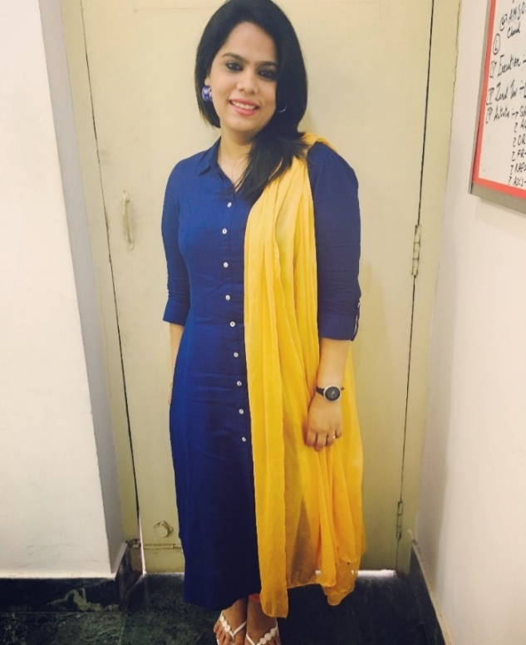**NASEEM BANU**

Contact no – 00971 55 1055319

Email:[naseembanu84@gmail.com](mailto:naseembanu84@gmail.com)

Seven plus years of experience in the Telecom, Automobile, and Healthcare industry in various roles, including Operations, Business Development, and Customer Service.

**Skills:** Amenable to new ideas, adaptable to the new environment, good inter-personnel skills with excellent verbal and written communication skills, quick learner, good analytical and conceptual skills.

**Education:**

Bachelor’s in arts specialized in Office Management, Economics, Secretarial Practice) from St. Agnes College, Mangalore University, India in 2005

**WORK EXPERIENCE**

**AJ Hospital & Research Centre, Mangalore as**

**Assistant Manager, Operations Customer Relation and Medical Tourism from June 2019 till date**

* As a supervisor, handling a team of 25 members, including team leaders and frontline staff, review team performance periodically, presentation to senior management on key issues and action plan/way forward. Some of the vital accomplishment Include the following:

**Operations and Customer Experience:**

* Streamlining of operations in Front Office, emergency department, inpatient admissions, Out Patient Department and Telephone operations
* Improvement in TAT for registration process and admission process
* Improvement in accuracy of medical records/data entry
* Training of frontline team in all departments on soft skills and grooming, and department orientation to new joiners
* Set-up a system for end-to-end feedback management to improve customer experience
* Handling priority customers in premium wards
* Handling billing-related complaints
* Set-up a system to generate essential Marketing MIS reports on referrals to support decision making on business development initiatives and developed a system to ensure continuous communication with referral doctors
* Streamlining of telephone operators through the implementation of SOP and training on telephone etiquettes
* Streamlining of admission process through system configuration, improvement in coordination between various departments, and better up-gradation process. Also, set-up a system to analyze monthly utilization data to support decision making and revenue generation
* Handling all non-clinical operations of the emergency department
* Overall responsible for OPD.
* Managing customer complaints that cannot be handled by the patient coordinators and working with management on patient service.
* Make sure that all activities of the team are in line with our internal procedures.
* Supervising the performance of the OPD and developed new strategies to improve performance standards.
* Prepare monthly reports and present in Quality Improvement meeting and operational Review Meeting.
* Monitoring team performance and effectiveness and motivating, and coordinating with their day to day work.
* Conduct monthly departmental meetings.

**Medical Tourism:**

* Responsible for end-to-end service delivery for International patients, including:
* Logistics such as an appointment with the consultants, travel arrangements, and legal documentation
* Liaison with international health insurers to facilitate cash-less transactions for medical tourists
* Managing the End-to-end discharge process formalities, including liaison with respective Embassies/Consulates' in the event of adverse outcomes.
* Facilitation for end-to-end service delivery for foreign tourists availing treatment in the hospital
* Recruitment of international medical facilitators for business development and participation in international events and seminar to promote Hospital services

**Bharti Airtel Limited as a Territory Sales Manager – Apr' 2015 to Oct' 2017**

* Managed the team of 2 Team leaders and 30 Smartphone promoters (Mangalore Shimoga Udupi) across the territory.
* Proactively appointing and imparting training of Smartphone promoters.
* Skillfully conducting the market audit and survey of current marketing trends for implementation for business growth.
* Revenue generation through the Channel and to meet the Zonal Revenue and Sales Targets.
* Joining with a team leader with regular gate meeting motivating them, designing the incentive structure for promoters, discussing their performance, understanding their product knowledge on new plans. Working on low performers to show a way forward to reach their targets.
* Conducting weekly/monthly reviews for promoters and awarding the star performers of the month.
* Training the team towards achieving higher sales productivity.
* Promotional/Branding activities of the product in and around the Zone.
* Visiting all the smartphone promoter outlets daily and monitoring them in all the parameters. Working with Team Leader in the market.
* Traveling twice a week to other zones (Market Visit).
* Helping other Territory Sales Managers to launch company products in the market and create demand for the same.
* Ensure zero-tolerance policy for regulatory guidelines and ensure 100% compliance on all parameters of documents etc. Take corrective actions, go the extra mile to escalate the breach of compliance, and create influence to correct the situation.

**Jubilant Motor Works Pvt Ltd – Audi, Mangalore as a CRO (Customer Relation Officer) & Accessories In charge – Sep' 2013 to Oct' 2014**

* Ensure sales satisfaction processes are implemented
* Proper follow up of every customer and recording their feedback
* Record all customer complaints and resolve to customer satisfaction
* Support sales team in delivery preparation and participate in the delivery ceremony and establish a personal rapport with the customers
* Ensure proper review of customer care activities and supervisor the customer care team and conduct periodic training workshops
* Counsel low performing sales consultants on sales satisfaction
* Follow proper escalation mechanism as per Audi India and ensure that the sales escalations are within the target (BSC norms)

**Customer Service Deliverables:**

* Ensure that not more than 5% of customer complaints with sales made and escalated to the sales manager.
* Ensure Customer handling as per Audi Sales Process
* Ensure compliance to Balance Score Card deliverables related to customer Satisfaction
* Ensure positive scores in mystery shopping
* Customer Management by maintaining appropriate trackers and ensuring customer satisfaction

**Accessories In Charge:**

* Informing and advising customers about the range of accessories and the dealership itself, including modern information technology.
* Demonstrating and presenting the required vehicle/model with attractive Audi Genuine Accessories®
* Demonstrating the product attributes and benefits; where appropriate advising of improvements to the product
* Distributing accessories brochures and other information materials
* Active and intensive demonstration of Audi Genuine Accessories® on vehicles

**Bharti Airtel Limited as a Showroom Manager – May’2012 to Sep' 2013**

* Responsible for maintaining zero percent of service issues in Showroom.
* Interacting with walking customers to understand their service issues and escalate the same to the concerned department.
* Maintaining and handling the base management closely to retain the customer churn out less than 1%.
* Job responsibility was to increase the showroom revenue by increasing the walking customers for bill payment and sales.
* Headed a team of more than 8 Customer Relationship Officers and focused on improving the quality of work & customer experience.
* Ensured improvement in service quality and sales through the walk-in customer in the Showroom.
* Planning and executing monthly schemes and offers to drive sales.
* Handling services related issues exclusively for corporate and solitaire customers.
* Motivating and reviewing the performance of Showroom CROs to improve productivity and customer handling skills.
* Maximizing customer satisfaction level by on-time delivery, monitoring customer complaints, providing efficient services.
* Record all customer complaints and resolve to customer satisfaction
* Leading, training & monitoring team members' performance to ensure efficiency in sales operations and meeting of individual & group targets.
* Defining service standards and guidelines that serve as the benchmark for excellent service delivery, thereby contributing towards ameliorated service revenue generation.

**Tata Tele Services Pvt Ltd as a Store Manager – Mar' 2011 to May' 2012**

* Handled all the three store activities in the Mangalore area.
* Efficiently led a team of 8 CRO Officers and mentored & motivated them to achieve organizational& individual goals.
* Handled all the stocks in the stores.
* Manage all the administrative work.
* Coordinating with the Sales team to increase sales in Showroom
* Record all customer complaints and resolve to customer satisfaction
* Ensure that to reach the sales target of all the three stores by the end of the month.
* Handled all the customer-related issue and their queries
* Indent stocks and maintain all stock report
* Handled Recruitment for Showroom whenever required
* Helping the Auditor of Company Auditing time, and make sure all the stocks are available in store.

**PERSONAL DETAILS**

Date of Birth :7th April 1984

Marital Status : Married

Nationality : Indian

# **Languages Known : English, Hindi, Kannada, Urdu**

# **Contact number : 00971 55 1055319 / 0091 9591259259**

# **Valid Driving License : India**