CURRICULUM VITAE

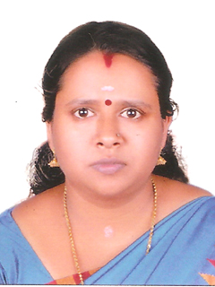 | GEETHU SOMAN SajithaBhavan  Karackal  Arkkannoor P.O.  Ayoor  Kollam – 691533  Mobile No: 9526860557

geethusomankj@gmail.com

CAREER OBJECTIVE:

Intend to build a remarkable career with a leading corporate environment with committed and dedicated people which will help me to explore myself , realize my full potential and to contribute my best for the growth of the organization.

WORK EXPERIENCE
3 years’ experience as Audit Assistant and thereafter 6 months experience as Articled Assistant in Rangamani& Company, Chartered Accountant Firm, Kottayam. 8 months experience in a Private Firm (Accountant, Kosamattom Finance Pvt., Ltd., Kottayam). 6 Yrs worked as an Accountant in Chaithanya Marbles Distributors, Anchal.
PERSONAL PROFILE:
Name : GEETHU SOMAN
Date of Birth : 23-03-1988
Father’s Name : Soman K.J
Nationality : Indian
Present Address : SajithaBhavan
Karackal
Arkkannoor P.O.,
Ayoor, Kollam - 691533
India.
Phone No : 9526860557 (Mob)
Sex : Female
Marital Status : Married
Husband’s Name : Sunil Kumar .A
Religion & Caste : Hindu, Vilakkithala Nair
Languages Known : Malayalam, English, Hindi

EDUCATIONAL QUALIFICATIONS:
Examination | Discipline/  Specialization | Board/  University | Percentage | Year of Passing
CA INTER |  | Institute of Chartered Accountants | 51% | 2011
MCom | Finance | M G University | 71% | 2011
BCom | Taxation | M.G.University, Kottayam, Kerala | 83% | 2008
+2 | Commerce | Board of Secondary Examination, Kerala | .  82% | 2005
Xth |  | Board of Examination, Kerala | 72% | 2003

COMPUTER SKILLS:
Application skills : MS Office, Tally

Declaration:

I hereby declare that above information are correct to the best of my knowledge.

Place: Ayoor
Date:
GEETHU SOMAN

