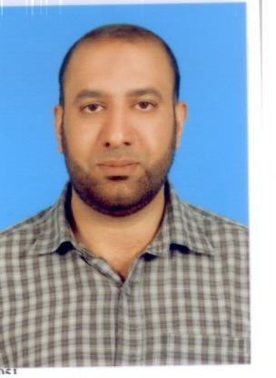
CURRICULUM
VITAE
TALAL BIN YOUNAS
Contact # 0092-301-8479229, 0092-331-6479229, 0092-55-3844155.

OBJECTIVE:

Seeking the opportunity where I would be able to best demonstrate my

Potential in highly competitive environment and to enhance my professional skills.
PERSONAL PROFILE:

Father Name: Younas Riaz

Date of Birth: 28-09-1978
CNIC : 34101-5559244-9
Marital Status: Single
Religion: Islam
Nationality: Pakistani
Email: talalyounas517@gmail.com
Passport Number AD6902443
Postal Address 341-A Model Town, City: Gujranwala.
ACADEMIC RECORDS:

Degree | Years of Passing | Grad/Division | Board/ University
Matric (Science) | 1994 | 2nd | BISE Gujranwala
Diploma of (Commerce ) | 1996 | 2nd | P.B.T.E Lahore
Bachelor of (Commerce ) | 1998 | 2nd | Lahore College of Commerce (Exam took by Punjab University)
Application of BIT in Business (MS Excel, Word) | 1999 | A | Lissba College of Computer Science Lahore

REFERENCE:

- Working as an Account in Judge Enterprises, Gujranwala.
- 4 Years Experience as an Accountant, Purchaser, Handled installation team in
Al-Taarraf Group of Companies. (CCTV Electronics) Dubai UAE.
(2005 to 2009)
- One Year Experience as an Accountant in Punjab College of Commerce, Gujranwala.
(2004 to 2005)
- 9 Months Experience as a KPO in PTCL, Islamabad on Contract Basis. (2004)
- 2 Years Experience as an Assistant Godown in Borjan (Pvt) Ltd, Lahore. (2001 - 2003)
- 2 Years Experience as an Accountant in Paradigm Technology, Islamabad. (1999 to 2001)
LANGUAGES:

- English, Urdu.
REFERENCE:

- Will be provided on demand.

