**Mariam Malak Mekhaeil**

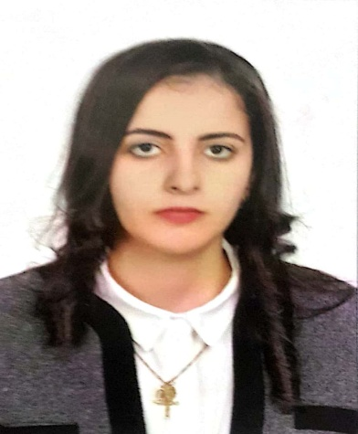

Current Position : Software Engineer

Address : DUBAI _ UAE

Mobile tel. number : (+971) 553907190

E-mail address : mariam.malak1305@gmail.com

Date of birth : 13th May 1996

Nationality : Egyptian



**OBJECTIVE**

Seeking a challenging position where I can utilize my talents and skills to contribute to leadership and interpersonal skills to the benefit of the organization.

**EDUCATION**

**MODERN ACADEMY IN MAADI 2018**

Bachelor degree in Computer Science & Software Engineering, 2018



**SKILLS**

**Personal skills:**

* A wide degree of creativity
* Problem Solver
* Ability to work well in a team as well as independently.
* Ability to learn new tasks quickly.
* Communication skills.
* Ability to work under pressure.

**Computer skills:**

- A good understanding of Microsoft Office applications (Word, Excel, PowerPoint and Outlook – General Apps)

**Language skills:**

* Native Language Arabic (reading and writing)
* Very Good in English (reading and writing)



**Personal Information**

* Mariam Malak
* Software Engineer
* Date of Birth: 13-05-1996.
* Nationality: Egyptian.
* Marital status: Married.