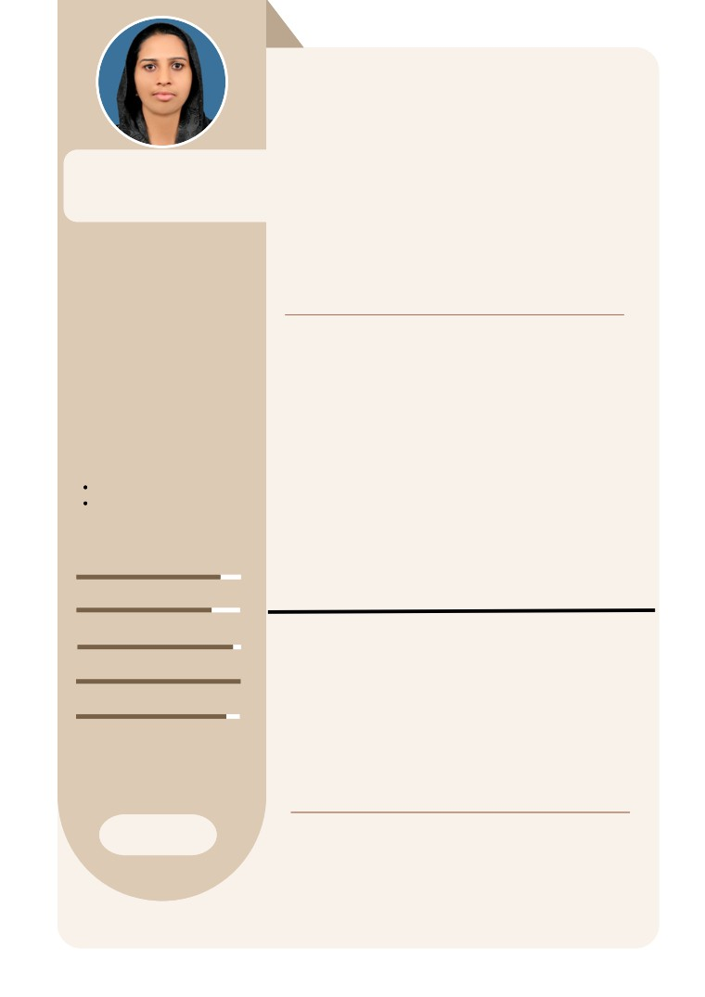

NOORA SHANAVAS

Registered Nurse (RN): 56019

PROFILE

*DHA licensed Registered Nurse*

*with Relevant Experience.*   
 DHA ID: 2643704

PERSONAL INFO

Address

**Makkah,Saudi Arabia**.  
**Ph.No- +9660542078638**

Profile

Nationality: Indian   
Marital Status: Married   
Date of Birth: 03/07/1988

[Email-shanavas00909@gmail.com](mailto:Email-shanavas00909@gmail.com).

Whatsup-918289876705.

EDUCATION

**Malik Deenar College of   
Nursing - Kasaragod, Kerala 2007 - 2011**

***Bachelor of Science in Nursing***

***4 Year Nursing Course***

SKILLS

Emergency Care   
Monitoring Vital Signs   
Patient & Family Education Patient Safety

Technology Skills

LICENSE INFO

Registered Nurse

The Kerala State Nurse & Midwives Council

Reg No: 56019

*Dedicated and compassionate Registered Nurse (RN) with progressive career history in direct patient care, triage and care coordination in fast-paced environment. Proven to remain calm under pressure and skillfully handle difficult patients and high-stress situations. Consistently developing strong relationships with patients and families through empathetic communication, respectful attitude and excellent customer service.*

EXPERIENCE HISTORY

Registered Staff Nurse | Security Forces

**Working in ER Department**

**Jan 2023- Present | Makkah, Saudi Arabia Under MOH.**

Staff nurse |EMS Hosital

Jun 2022 - Jan 2023 | Kerala,India

Registered Staff Nurse | Flores Hospital

Mar 2016 - Oct 2021 | Ghaziabad, UP

Staff Nurse | Uma Hospital

Mar 2012 - Dec 2015 | Kasaragod, Kerala

ACHIEVEMENTS

BLS (from American Heart Association)

28th October 2021

ACLS (from American Heart Association)

30th October 2021

DHA - Dubai Health Authority Examination

15th March 2022

PASSPORT INFO

Passport No: N6710219

Expiry Date: 4th February 2026   
Place of Issue: Thiruvananthapuram, Kerala