Curriculum Vitae
Muhammad Awais Bilal
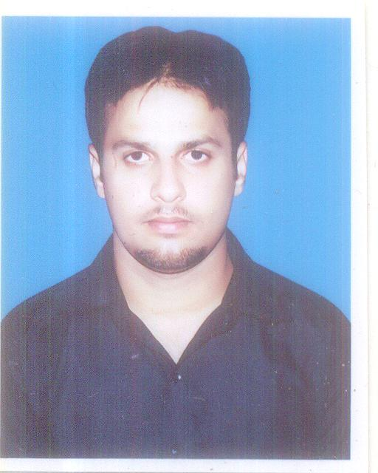

Current Address: Jabel Ali Industrial Area 1, Near Parco market, Dubai, UAE.

Permanent Address: 12-S-6 Muslim road, Ittefaq Colony, Sanda khurd, Lahore, Pakistan.

- +971-50-2585816 Mobile
- +92-332-4009732 Pak
 imawaisbilal@gmail.com

To present my best performance in a reputed organization, offering opportunities to enhance my professional abilities in communication and interpersonal skills.

Personal Information:

- Father’s Name: Bilal Ahmed
- Nationality: Pakistani
- Driving license: Pak (LMV Car, M bike)
- Languages: English, Urdu, Punjabi, Hindi, Arabic

Academic Qualification:

- BBA (Business Management)

- Federal Urdu University, Karachi, Pakistan.

- Intermediate in Commerce (I.Com).

- Govt. M.A.O College, Lahore, Pakistan
  - (Affiliated with Board of Intermediate & Secondary Education, Lahore, Pak.)

- Secondary School Certificate S.S.C (Matric) in Science Group.

- Govt. Central Model School, Lower mall, Lahore, Pak.
  - (Affiliated with Board of Intermediate & Secondary Education, Lahore, Pak)

Experience:

- Currently doing job in Federal Security Services LLC, Dubai, UAE.

- Post/Designation:

  - Operations Coordinator

- Types of work:

- Managing duty operations for incomings and outgoing staff for duty.
- Arranging vehicles.
- Tally daily basis expenses for vehicles and managing their records.
- Managing petty cash and all record expense for vehicles and their maintenance.
- Making daily basis records and reporting to management.

- Kamal Labs Pvt. limited, Lahore, Pakistan. 2 years and 3 months.

  - Post/Designation:

      - Senior Sales Officer.

- Types of work:

- Managing Sales Purchase records.
- Checking warehouse stock and distribution as per order and demands.
- Checking publicity criteria, managing the new Upcoming orders.
- Reporting to Management daily basis orders and send to clients.

- Nayyab Cosmetics. 1 year and 8 months.

- Post/Designation:

      - Sales officer

- Type of Work:

      - Managing Marketing team.
- Checking upcoming new orders and arranging courier and supply arrangement as per require location.
- Marketing throw social media and multimedia ads.
- Taking decision of increasing sale and getting new order.

Computer Skills:

- Computer Foundation. (Brains College Queens Road, Lahore.)
- Also known Graphics designing. (Corel draw X3, Adobe Photoshop CS2, Freehand)
- Also known Computer hardware. (Assembling, Trouble shooting, Windows and software’s installation)

Reference:

- Will be furnished on Demand.

