CURRICULUM VITAE
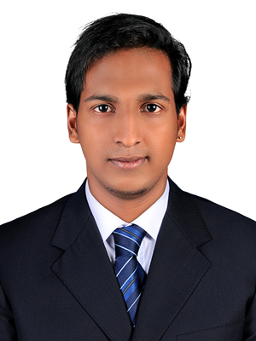
HARIKRISHNAN JAYAKUMAR BABY
Mob : +971 50-2950599
+919995740928
Email : haripunnamoodu@gmail.com
Place: Dubai(UAE)

_________________________________________________________________________

CARRIER OBJECTIVE

To succeed in an environment of growth and excellent and earn a job which provides job satisfaction and self-development. On the other hand, I shall implement my planning, designing and overseeing skills in construction and help the company to grow and achieve its goal.

ACADEMIC QUALIFICATION

- Diploma in AutoCAD , 3DS MAX (2015)

- Plus Two (Commerce) Board of Higher Secondary Education, Kerala (2011)

- S.S.L.C Board of Public Examination, Kerala (2009)

POSITIVE TRAITS

- Highly organized and dedicated with a positive attitude.

- Good communication and presentation skills.

- Hardworking, quick learner, adaptability and commitment to teamwork.

PROFESSIONAL EXPERIENCE

- Documents Controller & Draftsmen , Leader Metal Industries LLC. Dubai, UAE, Part of Juma Al Majid Group from ( March 2015 to February 2017 )

- Star East Building & Décor, Fujairah, Dibba, UAE as Draftsman, Accountant & site supervising from (March 2017 to November 2018 )

- Oriental World Antiques Novelties LLC Dubai , UAE, Public Relation Officer & Document Controller, Inventory Management From (November 2018 to November 2019 )

- Dunes pacifica Technical service LLC Currently Working as office managing, PRO work , Accounting, Sales, Draftsman,

LICENSE

Having UAE valid Light vehicle Driving License

No : 203330

Place of issue : Al Fujairah

Date of issue : 17-07-2017

Date of expiry : 15-07-2024

TECHNICAL SKILLS

- AutoCAD

- 3 DS Max

- Microsoft Office

PERSONAL INFORMATION

Father’s Name : Jayakumar

Date of Birth : 25-10-1993

Gender : Male

Marital Status : Single

Nationality : Indian

Languages Known : English, Hindi & Malayalam

PASSPORT DETAILS&VISA STATUS

Passport No : M2383356

Issued from : Thiruvandrum

Issued Date : 24-09-2014

Expiry Date : 23-09-2024

Visa : Employment Visa

DECLARATON

I,Harikrishnan Jayakumar Baby, hereby declare that above-mentioned facts are true to the best of my knowledge and belief. If I am placed in your esteemed concern, I will discharge my duties with utmost sincerity and to your full satisfaction.

PLACE: Jumeirah 1 Yours Faithfully
Harikrishnan Jayakumar Baby

