***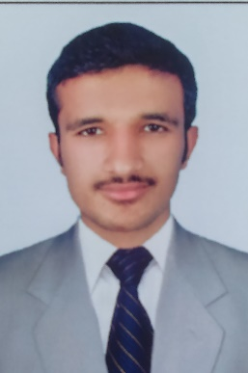* HASEEB UR REHMAN**

**(ADMINISTRATIVE JOB**)

Cell: +971552225418

Passport NO: KX9159881

Email haseebrehman39@gmail.com

* CARRERS OBJECTIVES:
* To work in professional environment where I can apply and enhance my knowledge by working in real world

Problems .To his hands on practicing the emerging technologies.

* Personal Attributes:
* Requires minimum supervisions and ability to delivers under pressure.
* Warm, friendly and an outgoing personality.
* Team player with an open mind.
* Quick to learn and result oriented.
* Work Experience:
* 02 year management and clerk
* Administration and check and balance of whole staff in G tech event LLC DUBAI Company.
* Educational Background:
* Diploma of associate engineer civil Govt. polytechnic institute Peshawar.
* Bachelor of Arts. University of Peshawar Pakistan.
* F.SC pre engineering: Board of intermediate and secondary education.
* SSC Science Group: Board of intermediate and secondary education.

**Professional skill.**

* MS office and windows.
* Certificate of information technology.
* Typing and short hand.
* Hardware and software and Ethernet cable repairing.
* Complete knowledge about AutoCAD civil (2d&3d)
* **Language :**
* **English** fluent and written :
* **Urdu**  fluent and written :
* **REFRENCE WILL BE PROVIDE :**