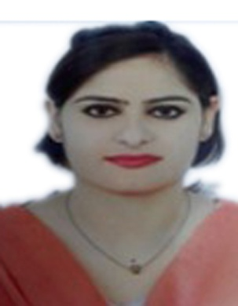
SAIRA BIBI
D.O.B: 26-12-1989
Nationality: Pakistani Location: Al Muteena, Deira
Mobile: +971526054172
Email: Usmansaira804@gmail.com
Pakistan Passport no. SA3092643
Visa Status: Visit Visa

POSITION:RECEPTIONIST

PROFILE

Enthusiastic Sales and Customer Service professional with expertise in communication and negotiating. Driven to provide superior quality customer service. Innovative in leveraging extensive knowledge of products and services as well as creating solutions for customers to drive loyalty, retention and revenue

OBJECTIVE
To achieve professional excellence in any above mentioned field that provides me with opportunities to fully utilize and develop my knowledge , skills, information and education. I am easily motivated, confident, and honest and dedicated to my job. And my personal dream is to work in UAE, because I want to know every think about UAE because I know in UAE work is not so easy and I love to take that opportunity and I just on daily basis work with my dream to complete it by my knowledge and my skills .

WORK EXPERIENCE

Company :AL ROWNAK AL JAMIL LLC ABHUDHABI,UAE
Position :Receptionist
Duration:2017-2018

Company :AL ZARA HOSPITAL SHARJAH,UAE
Position :Receptionist
Duration: 2018-2019

Company :AL YOUM TOURIST SHARJAH,UAE
Position :Receptionist
Duration:2017-2018

RPONSIBILITIES AND ROLE DETAILS

  - Possibly handling event coordination, both internally and externally.
  - Handling queries and complaints via phone, email and general correspondence.
  - Greeting all visitors.
  - Transferring calls as necessary.

EDUCATION

- Bachelor Degree (University of Punjab)
- Government Degree College of Rawalpindi
- HMC High school
- Diploma Nursing RMC

LANGUAGES
English,Urdu,Hindi,Pashto
SPECIALIZED SKILLS
- Healthy, Hand worker, team player, positive attitude and boundless energy.
- Capable of managing complex and multifaceted tasks.
- Expert in managing people in different situation.
- Having self-confidence & enthusiasm.
- Good communication skills with fluent. Interpersonal skills.

TECHNICAL SKILLS
  - Excellent in MS Excel, MS Word, MS Power point and MS Assesses
  - Good typing speed 50 wpm, with 96% accuracy.

OTHER INTEREST
Meditation, Reading Book, Traveling, Swimming

THANKS

SAIRA BIBI

