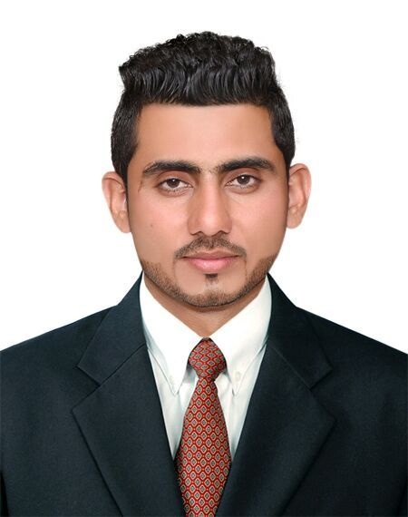

* Ability to be flexible and adaptable to the requirements of the position.
* Ability to understand critical issues and domain and is innovative to the solution for improvement.
* Supportive as a team player, can work under pressure and find it more challenging and stimulating, however, believes in planning and proper time management.
* I take directions and have the desire to reach success.

**ASSETS AND CAPABILITIES**

I am an approachable, motivated and confident sales executive with the ability to excel sales targets and make a real difference in the organisation’s revenue generation. I have expert knowledge of the selling process and I fully recognize the human and emotional aspects of buying and selling. I possess strong social skills that enable me to be a strong relationship builder with clients, colleagues and third –party.

**CAREER OBJECTIVE**

**IMRAN SADIQ**

**MASTER OF COMMERCE**

**Personal Information:**

**Date of Birth** 09 Sep.1988

**Civil Status**  Married

**Nationality** Pakistani

**Language** English, Urdu, Punjabi

**Manual LMV License 3767042**

**Visa Status:**

**Visit visa: 02 Sep. 2019 to 01 Dec. 2019**

**WORK EXPERIENCES**

***Personal Driver***

Furnished Holiday Homes Rental llc

Al barsha 2, Dubai

2017 to 2019

* Perform daily pre- and post-trip company vehicle inspections.
* Maintained family's vehicle cleanliness on a daily basis.
* Drove family's car to various city locations as assigned.
* Performed vehicle maintenance such as refueling, oil changing, and other minor task.
* Drove family and associates on weekends and evenings for special assignments.
* Provide Customer Service.
* Maintain Vehicle.
* Process Paperwork.
* Navigate.

***Sales Co-ordinator***

Modern bakery

Al Quoz, Dubai

Sep.2014 to Dec.2017

* Provide commercial support to sales managers, contents sales executive and channel distribution manager.
* Improve the develop reporting tools as well as performing monitoring.
* Making a significantly high number of daily outbound calls to prospective clients.
* Ensuring that all enquires are dealt with accurately, timely and professionally.
* Tracking sales orders to ensure that they are scheduled and sent you on time.
* Coordinating the sales team by managing schedules, filing important documents and communicating relevant information.
* Ensuring the adequacy of sales-related equipment or material.
* Responding to complaints from customers and give after-sales support when requested.
* Calculation of ANP for various products.

**Address:**

Apartment 107

Al Salam tower Al Barsha 1, Dubai

* 00971- 50-9648842

email: contact@yourdomain.com

* Emranshaheen.ucp@gmail.com

**EDUCATION**

* **Masters in Commerce (M.Com)**

Accounting & Finance s

University of Central Punjab (U.C.P)

2012-2014

* **Bachelor’s in Commerce (B.Com)**

Accounting & Finance

University of Punjab (U.O.P)

2010-2012

* **Intermediate in commerce (I.Com)**

Accounting

University of Punjab (U.O.P)

2008-2010

**PROFESSIONAL TRAINING AND ACHIEVEMENTS**

* Internship at Muslim commercial bank (MCB)
* Internship at ICI Company Lahore.
* Workshop on IT works from the trainzo team

.

**HONOURS AND CERTIFICATES**

* 1-year Diploma of MS-Office from Bestiean College, Gujrat.
* English Proficiency Certificate from Bestiean College, Gujrat.
* 2 times Awarded by principal of Punjab college (Cultural Festival 2013, 2014) main role Ranjha and Punnu

Web Develop:

**SKILLS**

* ***Soft skills***
* Expert knowledge of the selling process and effective sales techniques.
* Excellent communication and relationship builder.
* Motivated and target driven environment
* Teamwork, Self-Management and Problem Solving
* Confidence
* Flexibility
* **Technical Skills**
* SAP
* Ms-Office
* Data Management

**HOBBIES AND INTREST**

I enjoy socializing with friends and family and free time reading books. I am playing cricket and enjoy watching both international and local T-20 cricket.