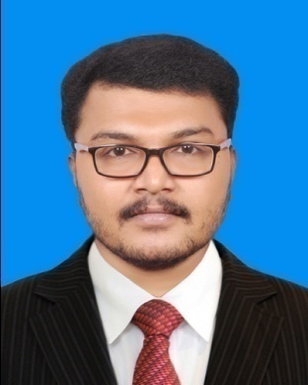**RESUME**

**Jithin anand v s**

**Vettuvelil (h)**

**Padiyoor p.o**

**Kannur 670703**

**Mob: +971-525463938**

**Mail id: jithinanandvs@gmail.com**

**OBJECTIVE**

**OBJECTIVE**

To establish myself amongst the successful professional in the industry And to work in an organization that explores my talents and provides me An opportunity to learn new skills

**ACADEMIC QUALIFICATION**

**ACADEMIC QUALIFICATION**

|  |  |  |  |  |
| --- | --- | --- | --- | --- |
| COURSE | BOARD/UNIVERSIY | COLLEGE | % OF  MARKS | YEAR |
| BSC DEGREE IN FD | ANNAMALAI UNIVERSITY | INIFD COCHIN | 76% | 2011 |
| PLUS TWO | HIGHER SECONDARY  BOARD | ST:MARY’S H.S.S  EDOOR | 75% | 2006 |
| SSLC | MATRICULATION  BOARD | K.P.C. H.S.S. PATTANOOR | 75% | 2004 |

**TECHNICAL SKILL**

* M.S office
* Adobe Photoshop
* FCP
* All type of business software
* Macintosh

**LANGUAGE SKILL**

**LANGUAGES KNOWN**

|  |  |  |  |
| --- | --- | --- | --- |
| **Language** | **Read** | **Write** | **Speak** |
| English | 🗸 | 🗸 | 🗸 |
| Malayalam | 🗸 | 🗸 | 🗸 |
| Hindi | 🗸 | 🗸 | 🗸 |
| Tamil | X | X | 🗸 |
| Arabic | X | X | √ |

**PROFESSIONAL STRENGTH**

* Positive attitude & hard work
* Can work under pressure environment
* Quick adaptable to the change
* Possess a good communication & interpersonal skills

**PHYSIQUE**

* No body odor
* Height 170 cm
* Weight 70kg
* Can work under pressure environment
* Body can quick adaptable change to whether and work nature

**WORK EXPERIENCE**

1. Worked as a Health manager in BEST WESTERN YUVRAJ HOTEL surat ,under Sukrutham healthcare & Pvt.Ltd

From 2015-January I joined Sukrutham Healthcare & Pvt.Ltd at Surat(Gujarat). Sukrutham healthcare is a private Limited firm Working inside a Best Western Hotel in surat. After one Year of my Health & Tourism carrier I promoted as a health manager. After I Worked As A Health manager in Sukrutham healthcare up-to 2018.

*Presently I am working as a health& Tourism manager in Al Ain Hotel Apartments in Ajman(United Arab Emirates) . My valuable Responsibilities in the industry are mentioned below in key skills.

**KEY SKILLS**

* Handling health side operations
* Cashiering and petty cash management
* Customer relations
* Stock & Inventory management
* Handling guest complaints
* Telecommunications
* Handling the GYM, Beauty session, team & Training the team
* Accounting verifying the promotions running
* Activating the promotion for the outlet
* In-house marketing & Outbound marketing management

**PERSONAL PROFILE**

**PERSONAL INFORMATION**

Father's Name : Sadanandan V V

Sex : Male

Date of Birth : 29/06/1989

Marital Status : Single

Religion : Hindu

Nationality : Indian

**WORK EXPERIENCE**

**DECLARATION**

I do hereby declare that all the particulars furnished above are true to the best of my knowledge and belief.

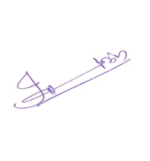Place: Ajman, Nuimiah 1 JITHIN ANAND V S

Date: 23/02/2020