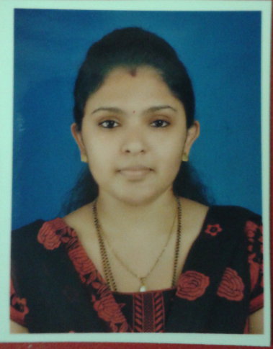
SUSHMITA N SHETTY
Bur Dubai, U.A.E.

Mob: +971 050 1199018.
Email: akshus196@gmail.com

Objective : To perform all tasks to the best of my ability, with
complete sincerity & dedication. To interact with
people & share their experiences to serve a learning
process for me.

Work Experience:-

Working with Neon Laboratories Limited as Assistant – Marketing Services from 06th Feb, 2017 to 30th Apr, 2019

Job Responsibility :

- Expense claim checking.
- Send communication in case of any deductions made in Expense claim along with necessary clarification.
- Maintaining Daily Sales Report (Distributor Wise).
- Field’s Joining Formalities.
- Field List updating.
- Field related query (Salary / Deduction in claims).
- Field’s Full and final settlement.

Worked at Bayer Pharmaceuticals Pvt. Ltd (India) as Sales Administration Executive from 04th Jan, 2010 to 22nd Feb, 2014

Job Responsibility :

- Check & forward Traveling Expenses Statement (TES) of sales personnel’s, Managers & Directors to Accounts dept.
- Send communication in case of any deductions made in TES along with necessary clarification.
- Provide National level TES provision to controlling department on monthly basis.
- Proper co-ordination amongst Marketing, Purchase team & Vendors for dispatch of new promotional products.
- Arrange for imprest money for new joinees.
- Co-ordinate with vendors for visiting cards, working bags of the employee.
- Track records of Customer Agreements (Pan India) and renew the same once expired.
- Check & forward vendor bills to the accounts department. Follow up for the same and maintain track record of the bills forwarded & ensure proper clearance.
- Maintain track record of all Promotional Activity conducted in the region.
- Provide provision of Promotional Expenses Statement, TES & vendor bills to the controlling department on monthly basis.
- Maintain employee list of the region and update the same in case of new joinees or resginees.
- Process full & final settlement of the resigned sales personnel’s.
- Maintain accurate information of the employees and update the same as and when necessary.
- Maintain leave details of the national sales staff and update the same to HR department on monthly basis.
- Hotel booking and other arrangements for regional meetings on quarterly basis or as & when required.
- Forward vendor bills with service entry and goods entry in SAP system.
- Raise request for creation of new vendor and employee code to our SAP team in Philippines.
- Arrange for department office stationeries.

Worked as Customer Care Executive in Country Vacations (Division of Country Club India Ltd) from 26th May, 2009 to 31st Dec, 2009: (India)

- Maintaining records of club members.
- Co-ordinating with HO for members club cards & membership cards.
- Attending calls for members booking, Solving queries of members.
- Preparing daily revenue report.
- Preparing monthly sales reports.
- Preparing monthly Commission & Incentive statement for sales team.
- Mailing daily updates of new members to the respective managers.
- Working and entering vouchers (i.e. Cash voucher entry, Bank Payments, Sales Invoices, Purchase Bills, Debit Note &amp; Credit Note).
- Entering Cash &amp; Bank Transactions &amp; Entries on daily basis.
- Maintaining Petty Cash Accurately.
- Collate all the financial transactions done in the daily operations of a business and record them in their respective accounts
- Receive checks and cash for deposit, verify amounts, and check accuracy of deposit slips
- Receive payment by cash, check, credit cards, vouchers, or automatic debits.
- Issue receipts, refunds, credits, or change due to customers.
- Pay company bills by cash, vouchers, or checks & maintain records accordingly.

Academic Performance:

Class | School/College | University/ Board | Appearance | Performance
Graduation | Model College, Dombivli | University of Mumbai | March 2009 | Second Class
HSC | Royal Jr College, Dombivli | Maharashtra  State Board | February 2006 | First Class
SSC | Don Bosco High School, Dombivli | Maharashtra  State Board | March 2004 | First Class

Other Qualification:-
Proficient with MS Word, Excel, MS-CIT.
Typing 30 wpm.
Tally 9.0

Personal Details:-

Sex : Female.

Date of Birth : 19th June, 1988.

Marital Status : Married.

Nationality : Indian.

Hobbies : Playing Badminton, Reading books.

Place: Dubai. (Sushmita. N .Shetty)

