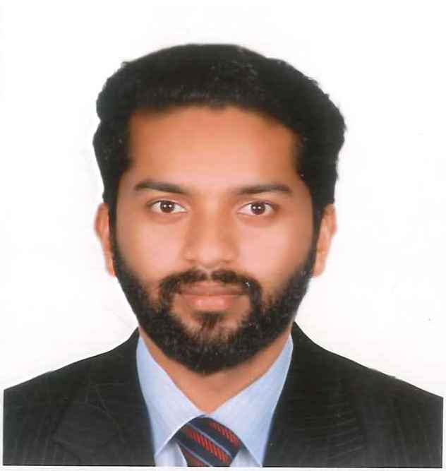 | MOHAMMED HASBULLA  Email : mdhasbu@gmail.com  Mobile : +971-507500301  Location : Ras Al Khaimah
 | Objective
To be a part of an organization where I can fully utilize my skills and make a significant
Contribution to the success of the employer and at the same times my individual growth. And to
Have a growth oriented and challenging career, where I can contribute my knowledge and
Skills to the organization and enhance my experience through continuous learning and
Teamwork.

PROFESSIONAL EXPERIENCE
Production & Quality Manager April 2016 – March 2017
AR ASSOCIATES Kerala India

Having a proven track record of minimizing the costs of the product and enhancing value for money, while still achieving the required standards and quality.

Duties and Responsibilities
* Production manager for one of the largest plywood manufacturing company in kerala.
* Cost effective production , without compromising the quality of the product.
* Creating good work environment for the workers for a better outcome.
* Managing raw materials usage.
----------------------------------------------------------------------------------------------------------------------------------------------
Sales Executive & Accounts Keeping May 2017 – August 2018
KK PLY AND BOARD Karnataka India

Duties and Responsibilities
* Target oriented sales in plywood , glass and hardware.
* Account keeping through BUSY accounting software.
* Organize and balance the cash drawer daily
* Doing post-sales follow-up and collection.

----------------------------------------------------------------------------------------------------------------------------------------------
Accountant & Customer Service December 2018 – September 2020
AL BAYAN DOCUMENTS CLEARING RAK UAE

Duties and Responsibilities
* Documents clearing and customer service related to Ras Al Khaimah Economic Department and Municipality
*Accounts Keeping through MICROSOFT EXCEL.
*Coordinating with customers and explaining them the procedure of incorporation of a company.
*Handling cash, making payment and daily reports.

ACADEMIC PROFILE
MBA (Pursuing) Swiss Business School Ras Al Khaimah
BBM in Marketing Bangalore University
Senior High School – PUC from Karnataka Board
High School – ICSE

SKILLS

- Working knowledge in quality management in industry.
- Experience in sales and customer maintaining techniques.
- Experienced in implementing the organizational quality assurance procedure and work flow.
- Working knowledge in accounting software.
- Good problem solver with high leadership skills and decision making skills.
- Proven communication skills.
- Proven ability in working under pressure.

ACHIEVEMENTS

- Knowledge in MS Office.
- Accounting Software (BUSY, ORISON )
- Analytical skills.
- Very good at mathematical calculations.
- Communication Skills.
- Proven ability in target achieving.

Birth date : 14th september 1993
Nationality : Indian
Languages : English , Hindi , Malayalam , Kannada , Tamil & Basic Arabic

