CURRICULUM VITAE

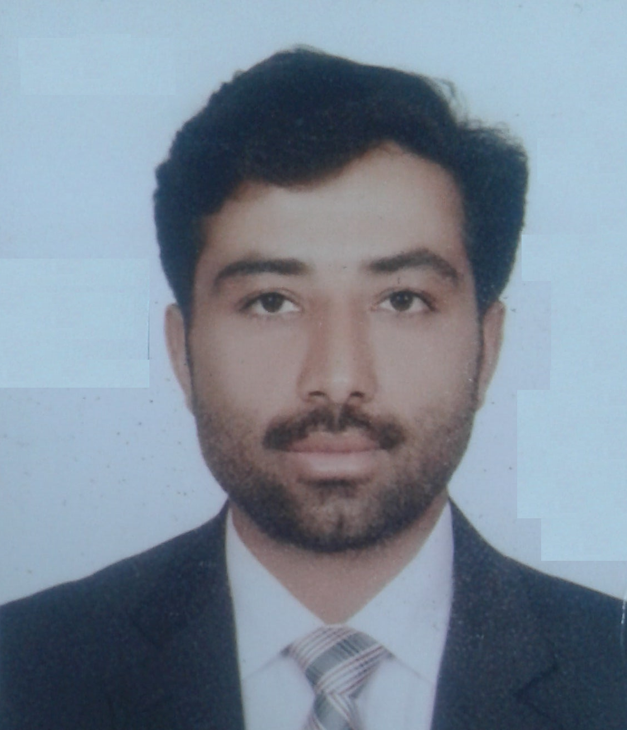
PARVAIZ AKHTAR
AL Narah Apartments, R-503B,
Green Community Village, DIP-1,
Dubai, P.O. Box:7832.
Contact: + 971524939676 ( DXE) ,+92 3055157417(PAK)
Email ID :-parvaizakhtar028@gmail.com
CAREER OBJECTIVES
To Pursue a career which is challenging, responsible and affords the opportunity of utilizing and further enhancing my job knowledge, Leadership, Communication skills enabling to be part of committed team contributing to growth of the esteemed organization.
work Experince :-

New Medical Center Trading LLC(NMC), (PHARMA)
Role: Store Helper, Delivery Assistant& Documentation.
Total Experience: March 2019 to till date
Store Helper - Duties:
- Consignment Receiving, checking, moving and Storing Incoming Goods.
- Picking Sales order on time and achieving daily targets.
- Pricing on the product that meets Company standards of process.
- Pricing and achieving daily targets on time.
- Expiry & damage checking then disposing of goods.
- Stock arrangement & ensure products are stacked neatly and safely.
- Oversees stock Replenishment.
- Verification of System Stock Statement with Physical Stock.
- Routine physical inventory count and maintaining
- Checking goods returned from the market (GRV).
Delivery helper - Duties:
- Assist drivers with deliveries, who delivers goods to Drug Stores & Pharmacies.
- Loading & Unloading items, interacting with customers, collecting payment.
- Sort, wrapping and palletize goods to be loaded for delivery.

Bayar Medical company LLC, Pakistan
Role: Delivery Assistant.
Total Experience: May 2012 to March 2015

PERSONAL THRUSTS/ STRENGHTS: .
- Good Interpersonal, Written oral communication Skills.
- Teamwork and Leadership Skills.
- Managing, Monitoring and interpreting the contract design documents.

EXTRA CURRICULAR ACTIVITIES .
- Participated in UAE cricket Tournaments.

PERSONAL DETAILS: .

Name : PARVIZ AKHTAR
Date of Birth : 1ST APRIL 1994
Gender : Male
Marital Status : Single
Permanent Address : Chahdewanwala, kotchutta, No.1
Dist -Dara Ghazi Khan, Pakistan.
Nationality : PAKISTANI
Passport No : MQ 1346011 valid till.16.07.2024 .
Place of issue : PAKISTAN
Languages known : English, Hindi ,Urdu, Arabic
Visa status : Employment Visa
Hobbies : Cricket, Travelling & listing Music

REFERENCES .
Christopher Kumar (Store Manager, NMC Trading, +971(0) 55 924 8763.

DECLARATION: -
I hereby declare that the above information is true to my knowledge assures you that if given an opportunity to serve in your extended organization shall prove my ability and suffice my superiors.

Place : Dubai Yours Faithfully
Date :

PARVAIZ AKHTAR

