Eman Ahmed
Address: Alwarq 1, Dubai, UAE Mobile: +971506039062
Email: iemanabdo@gmail.com
Personal Details
- Date of Birth: 01/01/1991
- Gender: female.
- Visa status: dependent visa.
Education Background
2009-2013 Sharg Elniel College, Khartoum, Sudan.
Degree of Bachelor (Honours) in Information Technology.

Professional Experience
June 2020- Now CR & Admin Gulf fruits company UAE, Dubai.
- Problem solving.
- Maintain financial accounts by processing customer adjustments .
- Preparing and organizing periodic reports based on sensitivity, clients , issues , products , value& feedback.
- Communicating & coordinating the operations department with their corrective actions for the complaints to ensure the problems are resolved

August 2017-Julay 2020 Front office, Golden way business center, UAE, Dubai.
- Handled requests with friendly, knowledgeable service and support, continually achieving positive customer feedback.
- Promoted offices rent.

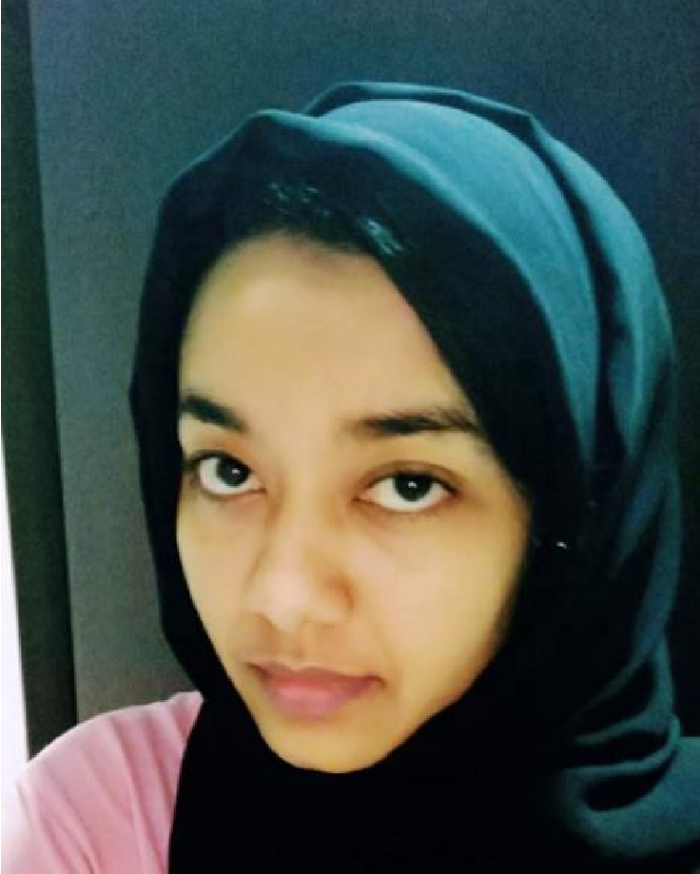
March 2016 – June 2017 Call center agent, Metlife american insurance company contact center all the gulf (UAE, Qatar, Oman, Kuwait, Bahrain) ,UAE ,Dubai
• Handling daily inbound outbound calls from customers in a high-volume call center
regarding service problems, product order progress and other concerns.
• Recognized as a top call center agent with above average satisfaction rates on monthly customer service surveys.
October 2014 – December 2015 Call center agent, Alfutaim (MAF)retail group- Carrefour contact center all the gulf (UAE, Qatar, Oman, Kuwait, Bahrain) ,UAE ,Dubai
- Handle 90+ calls daily.
- Trained 4 new employees in how to handle calls and use the system.
- Social media team.
- Handle complaints from consumers protection.
August 2013- August 2014: customer service & software data entry, Danway Company, Khartoum, Sudan
- Software data entry
- Face to face customer services. Other Relevant Information
Languages: Arabic (Mother tongue), English.
Skills: Photoshop, Ms Office Tools, quality focus , communication skills

