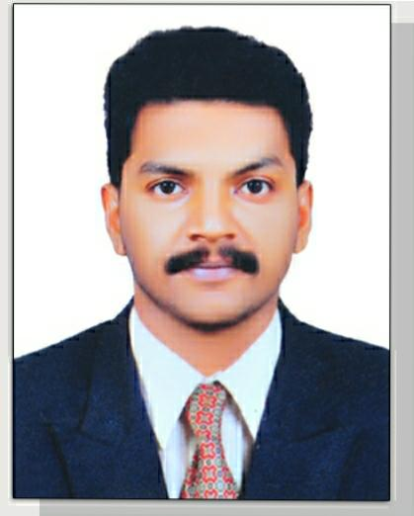 |  | Noufal  NAZARUDEEn  MANNOOR PULIPRA KIZAKKATHIL  MENAMPALLY MUKUNDAPURAM P.O  CHAVARA KOLLAM KERALA INDIA  Pin. 691585  Passport No. : R7269739
Objective  To utilize my knowledge and skill to convert organizational goals into reality and also to ensure steady growth for myself.  To build my carrier in a professionally managed company where i can make used of abilities knowledge and skill.  To ensure health and safety of the co-workers  Contact  Mobile: +971509449751    +918113035651    noufalnazar750@gmail.com  Hobbies  - Photography  - Singing  - Football  - Swimming  - Reading  Computer Skills  - Ms Office  - Photoshop  - Adobe Illustrate  - Internet  - Tally |  | QUALIFICATION  IOSH-5.01 Version  - Diploma in Industrial safety and fire safety  - Training in HSE and Fire & Safety  - STED Council Certification in Industrial Safety  - Attended Risk Assessment preparation course  - Attended Scaffold inspector training course  - Pursuing B Com Computer Application from University of Kerala  - Higher Secondary Commerce Education from Board of Secondary Education, Govt. of Kerala  WORK EXPERIENCE  - Assam Petroleum Limited  Safety Technician Assistant and OHS Trainer  Feb 2019- May 2020  - Perumkuzhiyil Super Market & Trading Co.  Safety and OHS Trainer  May 2020- Currently Working  SKILLS  - Ability to ensure Occupational Health and Safety  - Ability to resolve Occupational Hazards  - Ability to make safe Job Environment  - Ability to resolve the work problem wisely  - Ability to work well in a team  - Ability to work confidence  Declaration  I hereby declare that the above mentioned details are true to the best of my knowledge and belief.  Noufal Nazarudeen

