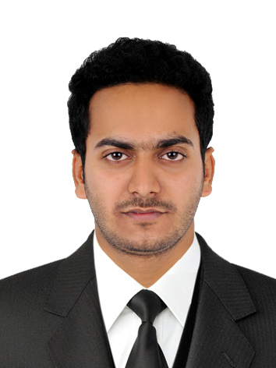

**ABDUL SUNAIF C K**

**+971582451394**

**E-mail: abdulsunaif39@gmail.com**

|  |
| --- |
| **CAREER OBJECTIVE** |

Intend to build a career in a dynamic and vibrant organization that gives scope for continuous learning and to be a part of a team that works towards growth of the organization. And to use my knowledge and experience to work in a position as demanding as possible.

|  |
| --- |
| **WORK EXPERIENCE** |

* Marjan Discount Center **:** Ras AL khaimah,UAE (Since 2018)
* Preparing Cheque
* Preparing Daily Report
* Salary to Staff
* VAT Filing
* The Professional Courier **:** Cochin, Kerala, India(June2016-January2017)
* Sorting the courier by pin code
* Scanning the courier& put into accurate pin code area section

* Assistant Accountant**:** F-Trail PVT LTD, Bangalore (March2017-April2018)
* Updating daily transaction to Manager
* Handling incoming cash and posting to the relevant bank accounts
* Checking purchase invoice
* Preparing Monthly Salary of workers.
* Prepare Monthly Invoice
* Prepare profit and Loss account.

|  |
| --- |
| **ACADEMIC RECORD** |

|  |  |  |
| --- | --- | --- |
| Course Name | Year of passing | Board / University (Name of institution) |
| Logistics and supply chain management | 2017 | Confederation of Indian industry (CII)  World University Consortium (WUC)  (GIIMS,Cochin,Kerala,India) |
| BBM | 2016 | MANGALORE UNIVERSITY,  (Srinivas Institute of Management Studies, Mangalore,Karnataka,India) |

|  |
| --- |
| **INTERNSHIP** |

* Kerala State Warehousing Corporation, Kasaragod, Kerala, India (2Months)

|  |
| --- |
| **INDUSTRIAL VISITS** |

* **Kerala State Industrial Enterprise Ltd. – Cochin International Container Freight Station, Eloor, Cochin, Kerala**

Kerala State Industrial Enterprises Ltd. KSIE as a holding company of the govt. of Kerala under the industrial department

* **Frontline Exports, Aroor, Cochin, Kerala**

Frontline Exports Pvt Ltd. is professionally managed 100 % export-oriented company established in 1991 with the state of art technology for processing seafood.

* **Dubai Port World ( ICTT ) , Vallarpadam, Cochin, kerala**

Operates the Rajiv Gandhi Container Terminal and to develop the International Container Transshipment Terminal at Vallarpadam

|  |
| --- |
| **LINGUISTICS ABILITIES** |

ENGLISH, ARABIC, MALAYALAM, HINDI

|  |
| --- |
| **PERSONAL DETAILS** |

Date of Birth : 04-02-1994 Visa status/ validity: VISA TILL NOV 15/2020

Nationality : INDIAN Marital status : Married

|  |
| --- |
| **DECLARATION** |

I hereby declare that the information furnished above is true to the best of my knowledge. References can be submitted upon request

**ABDUL SUNAIF C K**