**CURRICULUM VITAE**

**BIKRAM PRATAP KESHARI BEHERA** 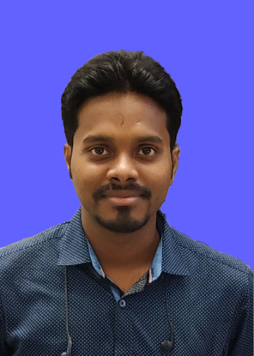

S/o- Mr. KEDAR NATH BEHERA

At-L.I.G.-46/1,H.B.Colony,

Phase-1, Chandrasekharpur

Dist. Khordha,Bhubaneswar,

Orissa- 751016

Ph.: 9438574375/7008498066

E-mail: [bikramrocks555@gmail.com](mailto:bikramrocks555@gmail.com)

**CAREER OBJECTIVE:**

To peruse a challenging profession in a dynamic and reputed organization, that provides ample opportunities to learn.

Apply and enhance my knowledge and experience for the overall growth of both i.e., myself and organization.

**EDUCATIONAL QUALIFICATION:**

| **EXAM** | **BOARD** | **YEAR** | **INSTITUTE** | **%OF MARK** |
| --- | --- | --- | --- | --- |
| 10TH | B.S.E | 2007 | G.H.S,BBSR | 66% |
| DIPLOMA | S.C.T.E.V.T | 2010 | KSE,BBSR | 67% |
| B.TECH | BPUT | 2013 | AIET,BBSR | 68% |
|  |  |  |  |  |

**BRIEF PROFILE:**

Fair communication, Interpersonal and Analytical skill, Commitment to task and time management .Ability to perform under pressure**.**

**INDUSTRIAL TRAINING :**

1month vocational training under CRM DEPT. at **SAIL, ROURKELA STEEL PLANT, ROURKELA**

**WORK EXPERIENCE:**

I have worked as a Placement Officer at **Jetking Learning Centre, Bhubaneswar** from **Oct 2015- Jan2017**

I have worked as aPlacement Officer at **Safeducate Learning Pvt Ltd. (Safexpress Group)** under **DDU-GKY** project from **Feb 17 to Aug 18**.

2 years of professional experience a Placement Officer at **Niam Educational Foundation, Bhubaneswar** from **Aug 2018 to September 2021.**

I have joined as a Placement Officer at **Skill Development Institute, Bhubaneswar** on **4th October 2021** & still continuing.

**PERSONAL DETAILS:**

**Father’s name : Kedar Nath Behera**

**Date of Birth : 15th May 1992**

**Sex : Male**

**Marital Status : Unmarried**

**Category : General**

**Nationality : Indian**

**Religious : Hinduism**

**LANGUAGES KNOWN:**

English,Hindi & Odia

**AREA INTERESTED:**

► Technical, Marketing/Sales

**HOBBY:**

Dance, Music

**DECLARATION:**

I solemnly declare that the above contents in my curriculum vitae are true to the best of my knowledge and belief.

**Place:**

**Date: Signature**