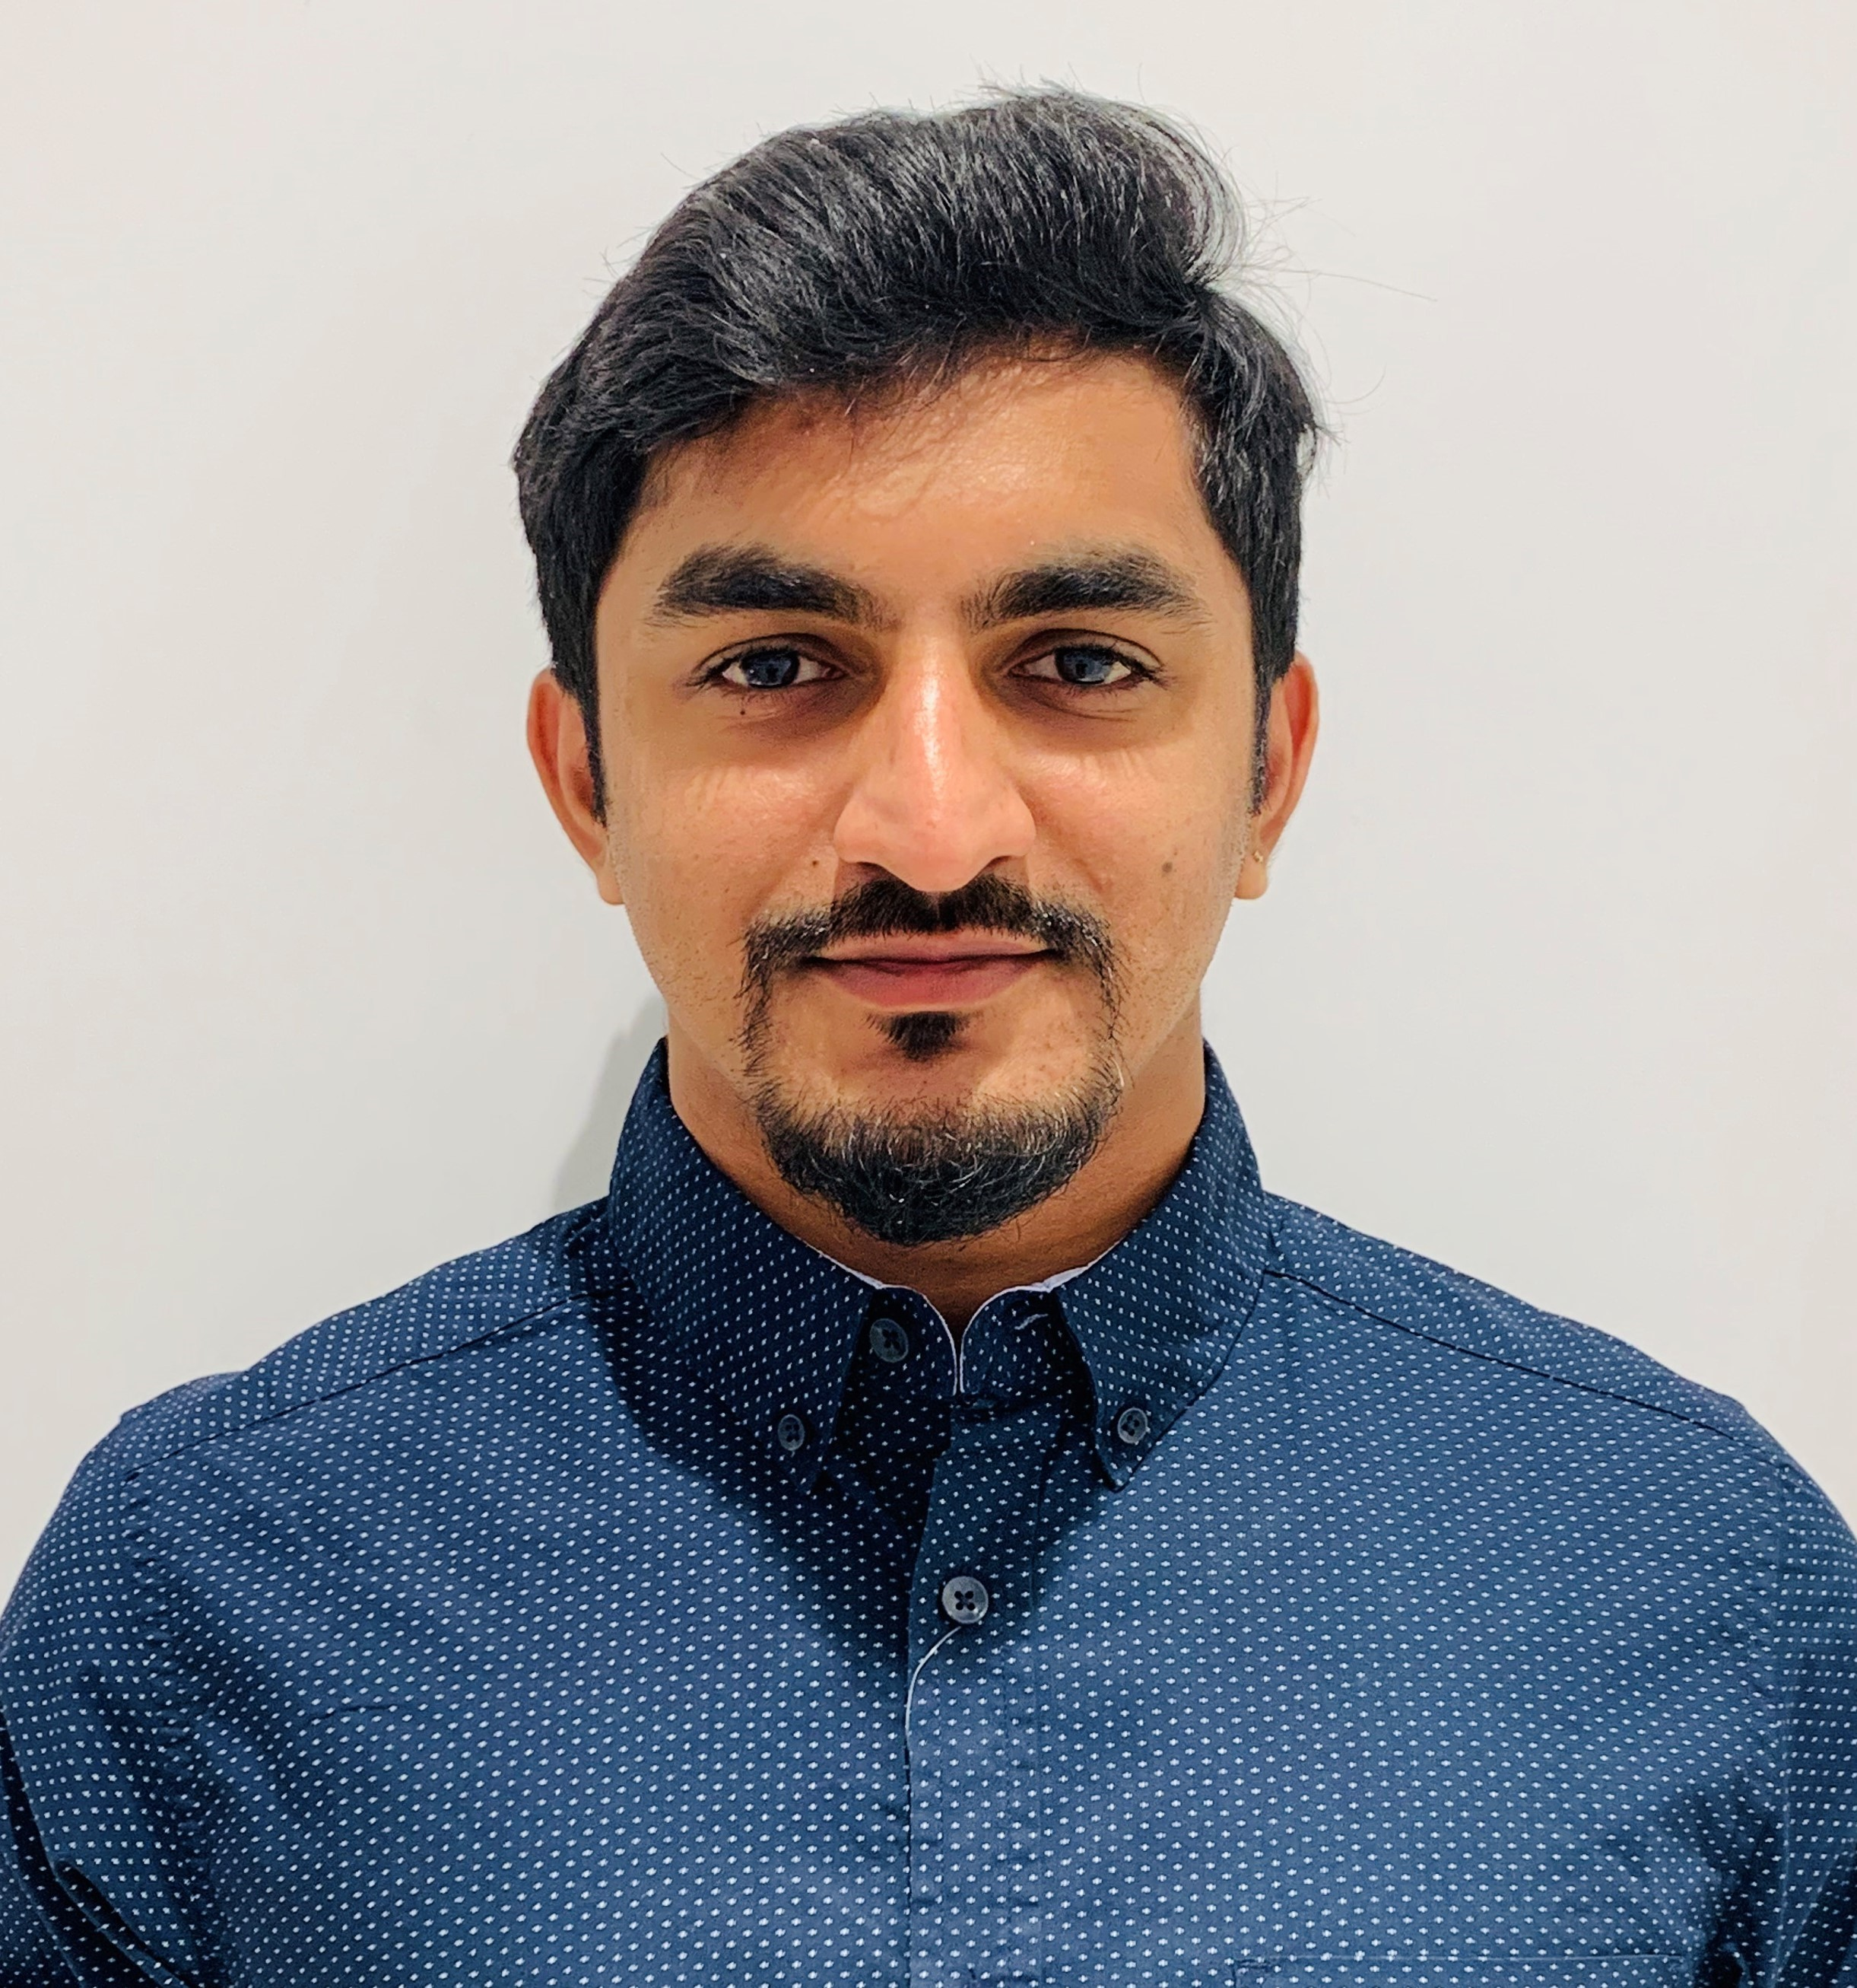

HARSHADAS K H

Place : Al Wahda, Abu Dhabi
Mobile: 0567984365
E-Mail: harshadas1992@gmail.com

SUMMARY

Dedicated IT / Operation Manager and effective leader who excels at using proven methods and cutting-edge technology to successfully cut costs, streamline operations, IT Operations and increase productivity. Assertive and enthusiastic with extensive knowledge of process optimization and an unsurpassed worth ethic.

EXPERIANCE

Dungeon Games Hall (Bin Moosa Group) – Al Wahda Mall

- Manager (IT / OPERATION) from Dec-24-2018 – Currently working
- Created Dungeon Games Hall with six fully high-end customised computer
- Developed own website for the company
- Created the company logo & theme
- Installed the latest edition HTC VIVE PRO – Virtual Reality
- Designed VR setup, arranged & successfully installed
- Self-Managing website, social media, advertising, promoting etc
- Trained & Managed the team to increase the productivity
- Increased productivity of 60% in total by the end of 2019
- Become one of the best VR game company in Abu Dhabi
- Contacting many event organizers and crew for events and party
- Conducting events & performed almost 6 events successfully
- Controlling all the financial needs of the company
- Making proper Daily, weekly, monthly & yearly reports
- Making vouchers, flyer, banner design for the company
- Setting up VR, PC with full IT support for birthday parties outside
- Managing Staff duty schedule, salary request, vacation etc
- Online support with team-viewer / any-desk
- Ability to achieve the best customer delight all the time

Al Bustan Specialty Hospital (AL AHALIA MEDICAL GROUP) – Mussaffah

- Guest Relation Officer (GRO) – from Dec-21-2016 to Dec-21-2018
- Trained all the customer relations executives to ensure patient delight
- Self-motivated in making customer delight
- Specially trained for Emergency department (day, night and on-call)
- Special training completed under Insurance provided by Ahalia group
- Dealing with Patient registration, Insurance and Billing protocols
- Managing all kind of Insurance approval, claim, eligibility check etc.
- Providing better Patient care and service
- Solving customer complaints for better service and customer delight
- Managing multiple departments at active supervision

FEDERAL BANK – Aluva, Kerala (April 2015 to March 2016)

- Worked as IT Support engineer & Customer Support.
- Installed, configured and patch updated Windows operating systems, Antivirus, Firewall, Internet security, backup solutions, MS office packages, Databases etc
- The smooth running of computer systems and ensuring users get maximum benefits
- Monitored systems and network activity and prevented unauthorized access
- Uninstalled unnecessary software’s, unwanted browser plugins and tool bars
- Scheduled daily virus scan for all systems and servers
- Installing and configuring computer hardware operating systems and applications
- Monitoring and maintaining computer systems and networks.
- Troubleshooting system and network problems
- Maintain and installing Antivirus & patches updates
- Maintain all servers/desktops/laptops/Printer/Switches/Routers/LAN

M-SQUARED Software Solutions (August 2014 to March 2015)

- Worked as Software Engineer – Programming Developer
- Specialized in ASP.NET at M-SQUARED Software Solutions (Techno Park).
- Project - Scan Guard implemented(employee Check-in and check-out)
- Involved in development of the project with new ideas and simple methods using ASP.NET, web service, SQL Server, JavaScript, JQuery, HTML, CSS and EDMX (framework).

PERSONAL DOSSIER

UAE Driving Licence : Yes

Date of Birth : 25th December 1992

Nationality : Indian

Marital Status : Married

Languages Known : English, Malayalam, Hindi and Tamil.

Visa Status : UAE Resident Visa

ACADEMIC CREDENTIALS

- Bachelor of Engineering: Computer Science (2010-2014) CGPA 7.31

