**JEAN MARY ROSE** **DAGANGON**

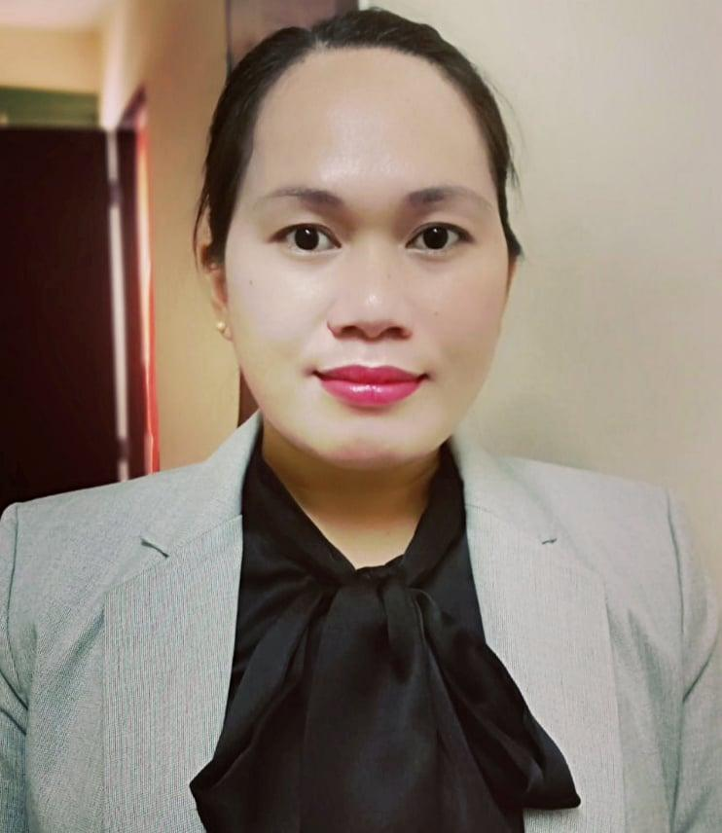

OBJECTIVE

To seek a successful career in a challenging work environment for professional growth and self- development.

Email

[jpdagangon@gmail.com](mailto:jpdagangon@gmail.com)

Al Owais B43 All

Rigga ,Dubai UAE

+971585841901

+971545086918

**EXPERIENCE**

2018 Cashier

2019 Kitchen City

Sto. Tomas Batangas, Philippines

2019 Security Guard

Leon Force

San Vicente, Tanauan, Batangas,

Philippines

2019 Housekeeping

2021 Jumeirah Park

Dubai

**EDUCATION**

2021 Receptionist and Office

Management

Filipino Institute

Al Rigga, Dubai, UAE

2011 Bachelor in Science of

2012 Elementary Education

Dapa, Surigao del Norte

2008 Bachelor in Science of

2009 Information Technology

SNCST Del Carmen Campus

**PERSONAL SKILLS**

Microsoft Word

Microsoft Excel

Microsoft Power point