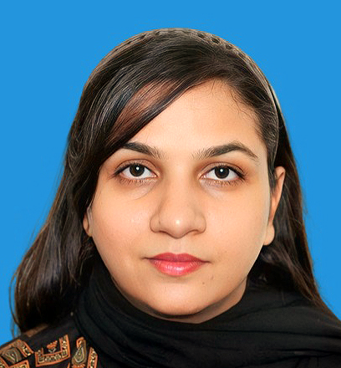  Sehar iqbal  History & Political Science Lecture    +971 543956506  Email: iqbalsahar831@gmail.com  education  M.Phil. (Political Science)  The University of Management and Technology.  Master (History)  University Of Punjab.  Bachelor of Education  Allama Iqbal Open University.  accomplishment  CTDP  Continuous Teachers’ Development Program (2007)  UPIC  US-Pakistan interreligious consortium (March 27-29,2017)  Skils  - Classroom management-expert  - Instructional strategies-expert  - Curriculum development-expert  - Student engagement-expert  - Critical thinking-expert  - Collaboration-expert  PERSONAL DETAILS  Marital Status  Married  Languages  English, Urdu, |  | Professional summary  A dedicated and detail-oriented professional with experience in customer service, sales, and administrative roles. Proven ability to manage office operations, assist in sales processes, and deliver exceptional customer experiences. Skilled in communication, time management, and maintaining organized records. Adept at creating a positive and welcoming environment, whether as a receptionist, sales executive, or administrative assistant.  HIGHLIGHTS:  Receptionist & Administrative Assistant  Scholastic | ISLAMIC School Lahore  2020 to 2024  - Managed front desk operations, including greeting visitors, handling phone calls, and managing appointments.  - Coordinated administrative tasks, such as filing, document preparation, and office supplies management.  - Assisted with scheduling meetings, handling correspondence, and maintaining office systems.  - Provided excellent customer service by answering inquiries and resolving issues promptly  Admin Officer  Haji Ramzan and Sons  2018 – 2020  - Streamlined daily administrative operations and improved office efficiency.  - Facilitated interdepartmental communication and collaboration on projects.  - Implemented office procedures and maintained compliance standards.  - Assisted in report preparation and documentation for decision-making.  - Coordinated meetings and optimized scheduling for senior management.  - Managed filing systems for efficient access to important documents.  Sales Executive  Beacon Grammar School  2012 to 2017  - Managed customer relationships and engaged in sales of educational programs and courses.  - Handled sales inquiries and provided detailed information about services.  - Negotiated contracts and closed sales with clients.  - Ensured consistent follow-up and relationship-building with clients.  Skills  - Customer Service Excellent interpersonal skills, able to manage client inquiries and resolve conflicts.  - Communication – Proficient in both verbal and written communication in English and Urdu.  - Administrative Tasks – Skilled in managing schedules, filing, and handling office correspondence.  - Multitasking – Capable of handling multiple tasks efficiently in fast-paced environments.  - Sales and Negotiation – Expertise in handling customer queries, negotiations, and closing sales.  - Problem Solving – Effective in resolving customer and internal operational challenges.

