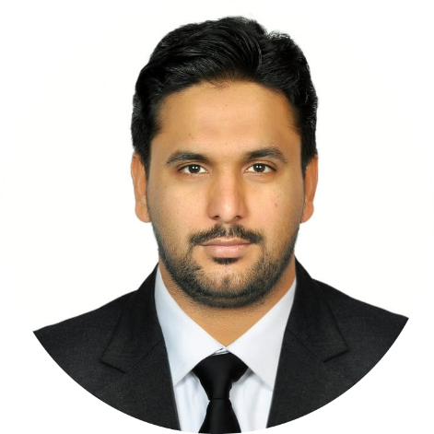  Profile  Professional and Flexible Electronics and Electrical Team Leader and Technical Professional offering 2 years overseas and 2 years of Local Experience. Fulfill all responsibilities with minimum supervision with a superior work ethic.  Highlights  Maintenance-Repair-Service, Troubleshooting-Documentation Testing New Installation Reporting, and Supervision  Personal Details |  | IMRAN SALEEM  Electrical Associate Engineer  Contact  Abu Dhabi, UAE  Cell No: +97152-6268407  Email: isaleem984@gmail.com  Hobbies  Reading Books, Traveling, and Photography  EDUCATION  Diploma of Associate Engineer (DAE Electrical)  2011 HPI (Hira Polytechnic Institute) Technical College Sargodha, Pakistan  Matriculation Science  2008 federal government high school Sargodha., Pakistan
Father Name: Mohammed Saleem  Visa Status: Residence  Company Sponsorship, Free Zone (Unlimited)  United Arab Emirates  Current Job Industry: Facility Management  Sector : (Malls, Healthcare, Musanada Project, and ADNOC HQ)  Passport No: FF5759241  Date of Birth: 09/02/1990  Religion: Islam  - Electrical Technician / BMU Operator 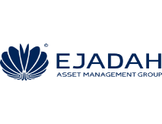  Ejadah Assets Management  UAE May 2018 to current job  Electrical Technician  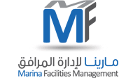  MFM (Marina Facilities Management) Nov 2015 to June 2018  Electrical Technician In MAB Facilities Management (March-2014 to Nov 2015)  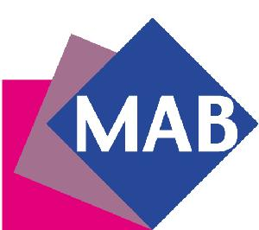 |  | lICENsE  Mobile Elevating Platform: TUV South West UAE  2016 to 2020  BMU (Building Maintenance Unit) TUV South West UAE  2016 to 2020  DRIVING LICENCE LIGHT VEHICLE  EXPIRY DATE: 26/05/2023  Professional experience  7 Years in UAE and 2 Years in Pakistan  Working for ADNOC HQ: An iconic green technology building in Abu Dhabi UAE  Maintenance Requests: Attend contain and complete all service requests, and follow the safety and timelines.  Coordinate: with our subcontractors, client, and Management  Follow-up: Pending Service requests, Subcontractors schedule visits, and PPM  Testing: Portable Appliances Testing, Thermography test  PPM: Lighting Controls, Central Battery, AHU, FCU, MDB, SMDB, DB, Blinds, and Sliding doors.  Operating: MBU and Cherry Picker Operating for Façade lighting rectification and working at height.  Project Name  Marina Mall (Abu Dhabi),  Marina Villas  GENERAL RESPONSIBILITIES  Perform difficult technical work supervising and scheduling the maintenance and repair of a variety of electrical equipment in the Building projects and Mall projects.  Follow all company and safety and security policies and procedures; report any maintenance problems, safety hazards, accidents, or injuries  Preparing reports of work done and problems observed during the site visits  Responsible for the electrical Preventive and breakdown maintenance to ensure that system is operational and meets the contract requirements  Help other crew members complete difficult and long repair projects  Ordering materials and supplies  Supervising the standard maintenance activities/ civil/Mechanical work carried out by the subcontractors  Doing monthly Planned Preventive Maintenance and maintaining all types of documentation  Responsible for providing an efficient and professional facilities management services to our top-performing clients Etihad Airways (Abu Dhabi) Working at Musanada Project in Al Ain (School Projects)  Training  Training on Health and Safety from TEVTA  Training on Emergency Preparedness and Response  Training on driving of Fork lifter and manual lifter  Training on Personal Hygiene  Communication Skill  English, Arabic Strength Hardworking, good Fearing, Professionally Committed

