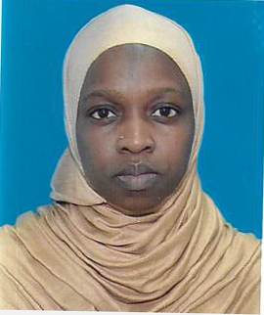

**NAME :HUSINA NANYONJO**

**PHONE: :+971-568491457**

**Email : :** [**husnamunira29@gmail.com**](mailto:husnamunira29@gmail.com)

**NATIONALITY : UGANDAN GENDER : FEMALE DATE OF BIRTH :12/06/1988 VISA STATUS** : **VISIT VISA**

POSITION: WAITRESS

A polite, well-spoken and hardworking waitress with experience of working in a busy restaurant environment looking after the needs of patrons. Attentively at all times with a willing and helpful manner that is required to answer phone calls, taking reservations and prepare bills. Always approachable, cheerful and possessing good observation skills as well as the ability to work alone or as part of a team

**WORK EXPERIENCE**

**HOTEL AFRICANA**

**POSITION: WAITRESS/FOOD RUNNER TWO YEARS**

**WORK EXPERIENCE**

**LARTE RESTAURANT STUDIO CITY UAE.**

**POSITION WAITRESS /FOOD RUNNER**

**ONE YEAR.**

***Duties***

* Providing a warm welcome for customers.
* Receive food & drink orders & serve customer requests to the standards required.
* Serving dishes to customers at tables.
* Learning the names of & building relationships with regular customers.
* Ensure timely delivery of all food & beverage items to customers.
* Understand menu content and keeping up to date with any menu changes.
* Making recommendations from the menu if requested.
* Answer guest queries in a polite and helpful manner.
* Clearing cutlery and dishes away from tables.
* Passing food orders through to the kitchen staff promptly.
* Ensuring all hotel corridors are kept clear from rubbish, glassware and crockery.
* Full product knowledge of all menu items and hotel facilities and services.
* Check on customers asking if they are enjoying their meals and service.
* **Ensuring the food service area is left clean and tidy once all the guests have left.**
* **Relaying, preparing and setting tables for the next guests.**
* **Looking after guests with special needs i.e. dietary requirements, allergies, mobility etc.**
* **Familiar with all cash handling & Credit card payment procedures.**
* **The motivation to learn new knowledge and skills.**
* **Good Housekeeping duties.**
* **Have a full knowledge of all food & beverage policies and procedures.**

**WORK EXPERIENCE HOUSE KEEPER IN OMAN TWO YEARS**

**AREAS OF EXPERT**

* **Preparing food & drinks**
* **POS system operation**
* **Hospitality**
* **Up selling techniques for wine & meals**
* **Waiting on tables**
* **Taking customer orders**
* **Customer service**

**EDUCATION ADVANCED CERTIFICATE**

**HOBBIES**

* **Reading Novels**
* **Travelling**

**REFERRES**

**AVAILABLE UPON REQUEST**