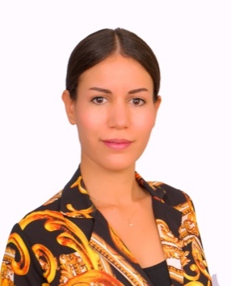
First name : LALLA TOURIA
Family name : Cheikh
Nationality : Moroccan
Phone number: 00971565593998
Email address : lallatouriacheikh@gmail.com
Driving license : UAE 2016
LANGUAGES
ARABIC : Mother tongue
ENGLISH : Fluent
FRENCH : Fluent
OBJECTIVE
Grow professionally through continuous education in working and promote company's excellence through highly competitive services.
CERTIFICATS AND DIPLOMATS
2008: Computer certificate
2007: University degree private law in at faculty of judicial sciences, economics and socials
2002: Bachelor mathematical science

WORK HISTORY

Sales manager July 2020 to present
AYS DEVELOPERS
. Implementing new strategic and long-term relationships to develop the business and build company’s reputation
. Contact potential clients through calls, emails…to offer them property consultancy services
. Carry out the marketing of property availability to attract prospective clients
. Evaluate investors’ budget and objective to identify their needs and requirements
. Build and establish good working relationship with different developers and agencies

REAL ESTATE PROPERTY CONSULTANT April 2018 to October 2019;
PANTHEON DEVELOPMENT

. Generate leads by active networking, making outbound calls and relationship building
. Ensure all leads and enquiries are attended to as per best customer service practices; follow
up with clients on a regular basis
. Determine clients ‘need and financials abilities to propose solutions that suit them
Provide guidance and assisting buyers in purchasing properties under the best terms through
Company’s` policy (SPA; Snagging; handover; collections…)

REAL ESTATE PROPERTY CONSULTANT June 2017 to April 2018;
AZIZI DEVELOPMENT

. Advertising properties through a variety of marketing techniques
. Evaluating the clients desires and economic capabilities to appropriate suggestions
. Provide information regarding legal guidelines, rates, specifications and property availability

SENIOR SALES EXECUTIVE AND MAKE UP ARTIST December 2014-June 2017;
CHALHOUB group Dolce & Gabbana, Gucci

.Assist the customers in meeting their needs in providing a professional services andproduct knowledge
.Achieve personal sales target by using advanced sales techniques and focusing on selling and up selling
.Maintain high standards of visual merchandising in term of cleanness, display and stock rotation prepare production and status reports on a weekly basis to the manage
.Build strong relationships with customers and deal with diverse customer basis
SALES EXECUTIVE October2009- October 2014;
DUTY FREE shop Morocco Airport and U.A.E. Airport
Beauty, watches jewelries and bags

.Assist the costumerin meeting their needs and presenting the most suitable products according to customer requirements
.Guaranty cross selling of products and achievement of the sales goals.
.Responsible for through checking of deliveries, inventories, receiving invoices, quality and quantity of items
.Cashiering payments through credit cards and cash in all internationals currencies
SKILLS:
.Proficient in using Microsoft Word, Excel and power point
.Hardworking, quick learner and capable of performing under pressure.
.Good communicator skills, flexible,organized,disciplined,motivated and energetic.

