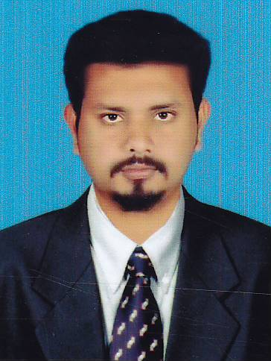

**CURRICULUM VITAE**

**JAMSEET AHAMED .F**

Mobile : **+971504857399**

**Email : ahamedjamsith@gmail.com**

**Sharjah, U.A.E**

**PROFILE**

I am an enthusiastic and dedicated professional. An exceptional employee who is able to develop and achieve targets, I can demonstrate a strong ability to do projects from conception through to successful completion. A proactive individual with a logical approach to challenges, I perform effectively even within a highly pressurized working environment.

**OBJECTIVE**

I am now Seeking a challenging position in an organization having and offering ample opportunities for growth, diversified exposure to further excel the professional skills. I am therefore keen to find a new and suitably challenging role in the organization.

**EXPERIENCE SUMMARY**

* **Java Developer** with over **1 year** of experience in **DLK Technologies**. I had knowledge about core and advanced java.
* **Junior Accountant** with over **1 year** of experience in **Kurunji Food Supply Tr**.
* **Junior Accountant** with over **6 Months** of experience in **Jeffco Food Tr. Dubai, UAE**

**Job Description**

* VAT–Preparing input tax and output tax and filing.
* Accounts Receivables
* Accounts Payables
* Handling Cash Expenses
* Credit control for the clients
* Assist for salary preparation.
* Assist with accounts related works such us prepare the vouchers.
* Sales & Purchase Entries in the system
* Coordinate office activities and operations to secure efficiency and compliance to the company policies
* Manage meetings, agendas, appointments and travel arrangements for the management.
* Familiarity with office management procedures and basic accounting principles
* Conduct clerical duties, including filing, answering phone calls, responding to the emails.
* Keep stock of office supplies and place orders when necessary.

**LEARNING EXPERIENCE**

|  |  |  |  |
| --- | --- | --- | --- |
| Specialties: | | Software Developer (Java) | |
| Operating System: | | Windows 7,8, 10 Pro and Linux Basics | |
| Environment: | | Web Applications, Windows based, Java | |
| Databases: | | Oracle SQL, MY SQL | |
| IDE or Tools: | | Eclipse, NetBeans | |
| Languages: | | Core Java and J2EE | |
| Servers | | Apache Tomcat, Glassfish | |

**COMPUTER SKILLS**

**LANGUAGES : C,C++, Java, Visual Basic**

**TOOLS : Ms.Visual Studio, NET, Flash.**

**WEB DEVELOPMENT : HTML, CSS, XML.**

**DATABASES : ORACLE, MS SQLSERVER**

**ACADEMIC QUALIFICATION**

|  |  |  |  |  |
| --- | --- | --- | --- | --- |
| Degree | Institution | University/Board | Year of passing | Percentage |
| MCA | AVC college of engineering, Mannampandal | Anna University | 2016 | 75.8% |
| BCA | AVC college of Arts& science , Mannampandal | Bharathidhasan University | 2013 | 60% |
| HSC | VIvekanada Higher Secondary School Sirkali | Matriculation | 2009 | 62% |
| SSLC | Vivekananda Higher Secondary School, Sirkali | Matriculation | 2007 | 61% |

**PERSONAL DETAILS**

**Date of Birth : 07/01/1991**

**Marital Status :Single**

**Gender : Male**

**Nationality :India**

**Visa Status :Visit Visa**

**PROFESSIONAL STRENGTH**

✓ **Handling ability and self confidence along with experiences**

I hereby state that, all information given above is clear and true to the best of my knowledge:

**JAMSEET AHAMED**