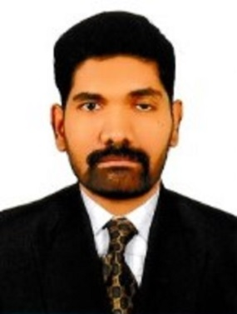RAFSAL PARAMBATH

**CONTACT INFORMATION**

Cell # +971-56 677 5233

**–**

+91 8156948408

[maherafsal@gmail.com](mailto:maherafsal@gmail.com)

OBJECTIVE

To obtain a position offering expansion and career growth especially in a people- oriented organization where an individual's achievement are recognized and awarded Willing to work in a challenging, conducive and dynamic environment opportunity to grow professionally in diverse work areas.

PERSONAL DETAILS

**Date of Birth : 17th May 1987 Nationality : Indian**

**Marital Status : Married**

JOB EXPERIENCE:

* **Worked as a Typist in a Private company for 7 Years (Abu Dhabi)**

(Mermaid Typing, Sunrise Typing )

* **Duty performing as a Senior Typist in Me Services LLC Abu Dhabi. (Department of Immigration UAE ) (Until 5 Year)**

ACADEMIC QUALIFICATIONS:

|  |
| --- |
| **Certificates / Degree** |
| **PLUS TWO** |
| **S.S.L.C** |

TECHNICAL QUALIFICATION / SKILL

* + **Ms Office (Ms Word,MS Excel, PowerPoint)**
  + **Operating System (Ms Dos, XP, Windows 7,8 and10)**
  + **Arabic Typing**
  + **English Typing**

LANGUAGES:

English, Arabic, Urdu, Hindi, Tamil, Malayalam

PASSPORT DETAILS:

Passport No : R 5541024

Date of Issue : 10/01/201

Date of Expiry : 09/01/2028

Place of Issue : Kozhikode

Visa Status : Employment

RESPONIBILITIS INCLUDE :

* **Ministry of Labour works. (U-A-E)**
* **Immigration works including company license.**
* **Fawri. (Online UAE visa Services )**
* **Emirates ID services.**
* **Tasheel Services.**
* **Ministry of Economy services.**
* **Indian visa Services.**
* **Visit / Tourist Visa Services.**
* **Emmigration New System and Old System (MOI and E Channel)**
* **Tahaluf (House Maid System)**
* **Mohre ( Servant Visa System)**
* **Echannel**

KEY SKILLS:

* Effective working alone or as a co- operative team member. * Language skills

* Self- confident, target oriented ,open to learning new skills

* Highly motivated to archive exceed targets, which boosts my morale. * Flexible, amicable & posses’ high energy levels. Effective in motivating * Strong inter personal skills

* Comfortable with working as a team * Ideas person /oracle/innovator

DECLARATION:

I hope the above details will meet with your requirement and you will give due consideration to my request and better response. I assure you all my best services at all time.

**RAFSAL PARAMBATH**