

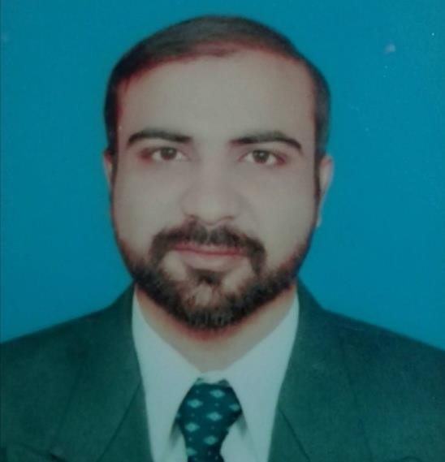**faisal Basheer**

**Managing Director And Head Of Rehab Department -**

# Contact

**Address**

Tareen Colony St#2 Thali

Road Rahim Yar Khan, Rahim Yar Khan

**Phone**

03087470307

**Email**

[malikfaisal777@hotmail.com](mailto:malikfaisal777@hotmail.com)

**Professional Summary**

Seeking a challenging position in the field of physiotherapy, emphasizing teaching, sports medicine and fitness for all Orthopedic & Neurological Rehabilitation which will allow me to develop and nurture my skills in this field. My goals are to improve my clinical experience and add to the benefit of not only the patients but to community as a physical therapist. Medical Coders work for healthcare facilities where they convert patients' information to standardized codes, which are used on documentation for healthcare insurance claims and for databases.



# Work Experience

Institute of Health & Management Sciences 2017-9-1 - 2018-1-30

Demonstrator Islamabad - Pakistan

Key Role: Teaching

Under close supervision, help provide inspirational learning and instruct students through practical classes about experiments, systems and/or methods and protocols. This could be in a laboratory context but also in other contexts such as example classes, anatomy laboratories, field settings or in the virtual environment. Provide support to students engaged in such practical work. In this context, close supervision will usually mean that the member of academic staff responsible for the session will be in the class or available and contactable if required.



# Shafi Medical Complex

2018-7-1 - 2019-2-29

Head Of Department Rehabilitation Center Islamabad - Pakistan

Key Role: Management, Analytic Thinking

Leadership qualities helped in building a mature team. Analyze information from interviews, educational medical records, consultation with other professionals, and

By diagnostic evaluations to assess clients abilities, needs, a Develop rehabilitation plans that fitclients aptitudes, education levels, physical abilities,

and career goals. Maintain close contact with clients during job training and placements to resolve problems evaluate placement adequacy.



# Medical Transcription Billing Company

2019-4-8 - 2020-2-29

Medical Coding Islamabad

- Pakistan

Key Role: Research, Audit

Accounts for coding and abstracting of patient encounters,

including diagnostic and procedural information, significant reportable elements, and complications. Researches and analyzes data needs for reimbursement.

Analyzes medical records and identifies documentation deficiencies. Serves as resource and subject matter expert to other coding staff.

Reviews and verifies documentation supports diagnoses, procedures and treatment results. Identifies diagnostic and procedural information.

Audits clinical documentation and coded data to validate documentation supports services rendered for reimbursement and reporting purposes.

Assigns codes for reimbursements, research and compliance with regulatory requirements utilizing guidelines.

Follows coding conventions. Serves as coding consultant to care providers. Identifies discrepancies, potential quality of care, and billing issues.

Researches, analyzes, recommends, and facilitates plan of action to correct discrepancies and prevent future coding errors.



# Lala Medical Complex

2020-8-1 - 2021-4-28

Head Of Rehab Department Rahim Yar Khan - Pakistan

Key Role: Assessment

working with patients with a variety of conditions, sometimes over a period of weeks or months diagnosing, assessing and treating problems encouraging

exercise and movement

advising patients on leading a healthy lifestyle keeping reports on patients and their progress

liaising with other healthcare professionals to encourage a holistic approach to treatment staying up to date with developments in treatments

being caring, compassionate, and patient.



# Lala Medical Complex

2021-5-1 - Present

Managing Director And Head Of Rehab Department Rahim Yar Khan - Pakistan

Manage resources, including the attracting, hiring and retention of personnel.

Manage Insurance Companies like jubilee, IGI and Health econnex Insurance Claims and Bills. Ensure employees move in the same strategic direction to achieve its mission. Create and report on business plans, monitoring its efficacy and progress.

Promote the wellness of staff and implementing policies inline with labour legislation and health and safety guidelines to create a diverse and positive working environment.



# Education

BISE Bahawalpur 2007-8-1 - 2009-7-30

Matric

Marks : 682 / 1050

Major Subjects : Physics Chemistry Biology



# BISE Bahawalpur

2010-8-1 - 2012-7-30

FSc (Pre-Medical) Marks :

567 / 1100

Major Subjects : Physics Chemistry Biology



# Isra University, Hyderabad

2012-10- - 2017-8-10

Doctor of Physical Therapy (DPT) Marks :

6695 / 10100

Major Subjects : Anatomy Physiology Kinesiolog

# Isra University, Hyderabad

M. Phil in orthopedic Physical Therapy

Two semesters clear thesis pending



# Awards / Honours

Award Title: Hafiz Quran

Authority: Wafaq ul Madaris Al-Arabia, Pakistan

Award URL: <http://www.wifaqulmadaris.org/gazett/infradi.php> 6



# Research & Publications

Title: PREVALENCE OF KNEE OSTEOARTHRITIS AND QUALITY OF L

Venue: The Rehabilitation Journal

URL: https://trjournal.org/index.php/TRJ/article/view/8 Title: Diabetes Mellitus and its impact on Quality of lif Venue: Pakistan BioMedical Journal

URL: [https://www.pakistanbmj.com/journal/index.php/pbmj](http://www.pakistanbmj.com/journal/index.php/pbmj) Title: Gonadotoxic Effects of Interferon Therapy on Male Venue: Tobacco Regulatory Science

URL: <https://tobreg.org/index.php/journal/article/view/>



# Membership or association Organization

**Name:** [**https://www.maps.org.pk/**](http://www.maps.org.pk/) **Member Since: 2015**

**Role in organization: Campus Ambassadors Organization Name: United Nations**

**Member Since: 2020**

**Role in organization: Volunteers Work on Health Sector. Organization Name: Pakistan Physical Therapy Association Member Since: 2018**

**Role in organization: Working as a Registered Physical Therapist.**



# Hobby

|  |
| --- |
| Quran Recitation, Sports, Exercise, Search Future Innovation Video |
| Medical Coding, Management, Culture Sharing With New People |

**Skills**

|  |  |
| --- | --- |
| **Name** | **Level** |
| Communication | Expert |
| Time Management | Expert |
| Rehabilitating Others | Expert |

# Language

|  |  |
| --- | --- |
| **Name** | **Level** |
| English | Expert |
| Urdu | Native Speaker |
| Panjabi, Punjabi | Expert |



**Reference**

**Dr. Muhammad Farrukh Shahzad Rehab Director**

**comwave institute islamabad** [**drfarrukhshahzad1@gmail.com**](mailto:drfarrukhshahzad1@gmail.com) **9203338920963**

**Dr.Riyafat Mehmood**

**Head of Rehab Department kulsum international hospital** [**riafatmehmood@yahoo.com**](mailto:riafatmehmood@yahoo.com) **923000645637**