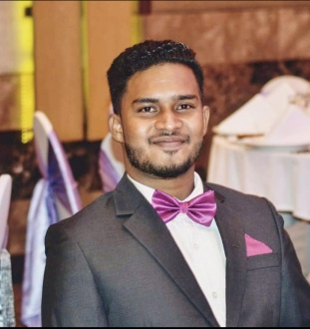  SHAIK RIZWI MUHAMMED RASHEED  Administrator  "A motivated administrative professional seeking a position in a challenging environment. Over 3 years’ experience successfully providing administrative and secretarial support to the operational department. Proficient in a range of computer applications. Well-developed communication and customer service skills”  EXPERIENCE  IT Assistant  Jem4A Recruitment (Pvt) ltd  Configuring hardware and software, setting up peripherals such as printers or routers, repairing equipment, and providing daily support for computer network users. Assistants may work at a help desk, answering calls and e-mails regarding the computer network or communication systems.  Colombo, Sri Lanka  August 2016 to October 2017  Administrator  1 Stop Printing Solutions & IT Services  Revolve around managing and distributing information within an office. This generally includes answering phones, taking memos and maintaining files. Receiving and directing visitors, word processing, creating spreadsheets and presentations, and filing.  Digital printer operators (KONICA MINOLTA C3070L) use computers to create layouts and printed materials, Lamination Machine Operating & Paper Cutting Machine Operator (CHAMPION). Their job is to listen to client specifications and adjust attributes such as size and resolution to create a high-quality finished product. People who have a strong eye for detail. Every day, they manage multiple projects with varying timelines. Digital print operators can work full or part time and are typically employed in the commercial printing, marketing, and publishing industries.  Digital Media Marketing planning and managing marketing campaigns that promote a company's brand, products, and services. Using Social Media Facebook Business, Instagram Business, Google AD.  Doha, Qatar  November 2018 Present  EDUCATION  HND In Computing & Software Development  ICBT Campus  EDEXCEL HND level 5 in Computing and Software Development  COURSE LENGTH:  18-24 months  AWARD:  BTEC/EDEXCEL Higher National Diploma. On successful completion of awarded a HND Computing & Software Development. University of Metropolitan UK  Colombo, Sri Lanka  2017  Diploma in Software Engineering  E-SOFT Metro Campus  COURSE LENGTH:  6 Month  AWARD:  Design and develop user-friendly software. Computer programming and system design are also taught. In addition to the development of software, students will learn how to test, troubleshoot and maintain programs.  Colombo, Sri Lanka 2015.  Diploma In Online Job  Amazon Lanka  Creating Online Job account & International Digital Banking Account  Freelancer, Up-work, Skrill, PayPal  Colombo, Sri Lanka  2014 |  | CONTACT INFORMATION  Email  rasheedn.rr@gmail.com  Address  Colombo, Sri Lanka  Phone  +971526039357 (Direct Line)  +94 757459569 (whats app)  Date of birth  1996-02-18  Nationality  Sri Lankan  SKILLS  - Complete tasks related to Managing a Business  LANGUAGES  English  Advanced  Tamil  Advanced  Sinhala  Advanced

