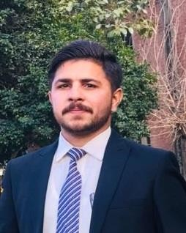  Born 05-Mar-1995 | Waheed Athar  Address: House No.P-548 neghebanpura block C railway housing, Faisalabad. Cell: +92-3227166579  Email: waheed.athar95@yahoo.com
Detail | - Hard working, possess strong planning, organizing and monitoring abilities  - Motivated, enthusiastic and determined to move forward in life  - Reliable and dependable in meeting the objectives  - Good communication and interpersonal skills, an efficient time manager  - Led several cross-functional teams and coached team members, as  appropriate, to develop skills and confidence in their ability to examine work processes, create solutions, and measure improvements.
Education & Qualification | University of Agriculture Faisalabad  Master’s in Business Administration 2020  GC University, Faisalabad  ADP(B.COM) 2016  BISE, Faisalabad  I.COM 2014  Govt. Technical Training Institute Faisalabad  Auto mechanic Car (Diploma) 2012  BISE, Faisalabad  Matriculation 2011
Professional Experience | Call center (part time) 2014  Call operator  Supreme Autos (Mechanic) 2012 to 2016  Supreme Autos (Supervisor) 2016 to 2021  Centre for disabled (NASHEMAN) Faisalabad  Instructor (Auto mechanic) Part time Jun 2019 To Jan 2022  Instructor (Auto electrician) Jun 2021 to December 2021
Computer Skills | - MS Office (Word, Excel, Power Point)  - Data Analysis and Report Writing  - System/Application Software Installation  - Hardware Maintenance & Device Installation  - Internet-Email  - Web Browsing

Personal Skills | - Quick Learner  - Self-Motivated  - Multi-Tasking  - Problem Solving Skills  - Ability to perform under pressure  - Excellent Communication Skills  - Self-Organized  - Excellent Customer Services  - Customer and Business oriented  - Ability to work on tight deadlines  - Excellent Analytical Skills  - Attention to details  - Great Understanding of Markets.  - Ability to solve complex problems Initiative  - Hardworking  - Approachable  - Great Business writing Skills
Personal Profile | Father’s Name: Abdul Khaliq Marital Status: Unmarried  CNIC No: 33102-2008886-3  Domicile: Punjab  Religion: Islam  Gender: Male  Nationality: Pakistani  Language English , Urdu, Punjabi
Interests | - Seeking opportunity of meeting with business leaders  - Exploring new business ideas  - Social Relations

