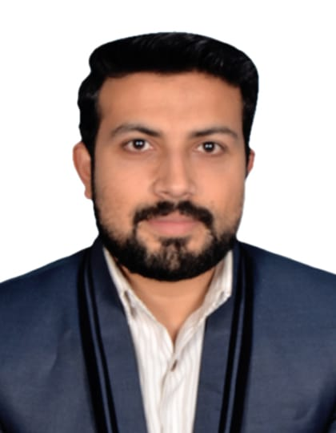
Nouman Moin

Mobile: 00971-56-6353110 00
E-mail: noumanmoin90n@gmail.com
Address: Muroor 31, Villa # 10, Flat # 10.
Abu Dhabi

Profile

I am determined to add value to the organization I work for, through my exceptional knowledge and learning abilities. I possess well developed communication skills with reputation of unwavering accuracy, credibility and integrity.

nauman.ahmad90n@gmail.co
Synopsis of Experience:

Silk Bank (First Solution) Lahore, Pakistan. (August 07, 2015 to September 03, 2016)

Worked as Sales Officer, Job Responsibilities:

- Prospecting and identifying new leads and pitching to the clients.

- Promoting the bank products i-e credit cards and payrolls to new and existing customers by making
proactive sales efforts and capitalizing on cross selling opportunities in order to achieve the sales targets

- Maintaining and developing relationships with customers via personal meetings and telephone calls.

- Listening customer’s requirements, queries and presenting appropriate resolutions.

Pakistan Telecommunication Limited, Lahore, Pakistan. (October 19, 2016 to June 02, 2017)
Worked as CSE & Email Support Executive, Job Responsibilities:

- Worked for 1218 complaint department and was responsible for resolving customer’s complaints and
Courteously, ensure customer service related activities are being done within bench marked time.

• Develop and maintain relationships with new and existing clients in order to capitalize on opportunities
and cross sell company’s products and services.

• Achieve the Sales & Service Centre monthly sales targets.

• Resolve customer’s queries, questions and complaints frequently.

• Manage Service Centre KPIs (Up selling, Adherence, Average Service Time etc.)

TRG IBEX, Lahore, Pakistan. (October 05, 2017 to February 15, 2019)
Worked as Customer Support Executive, Job Responsibilities:

MFS JAZZ CASH

- To ensure high level of customer satisfaction through excellent services.

- Resolve the customer’s amount transactions, hanged issues and reverse the customer’s amount on spot.

- To ensure the secure the confidential customer’s data and high level monitoring on daily basis.

- With the help of CRM escalation desk, resolve the customer’s queries.

- To solve queries transferred from front desk officers to solve the customer’s issues.

- Maintain relationship with clients by providing support, information and solution providing.

JEENY EASY TAXI

- JEENY EAST TAXI is Saudi Arabia base project and I was handling the cities of Riyadh, Dammam, Makah and Jeddah.
- Escalate the driver’s car maintenance and hygienic issues.
- Use XCALLY & ZENDESK to represent the JEENY EASY TAXI and providing the services with the help of dependable resources.
- Cisco Tool Kit, CRM, Ticket Update & launch a complaint in CRM
- Have a good grip of Siebel, Zen desk, blade, Xcally, CPS, CSS, Avaya Calling System, Cti services CCMS, E SHULAT and NADRA portals.

Computer Skills
- Network Engineering
- System Administrator
- Hardware Engineering
- CCNA (Security) Certified training from CISCO Net Accad
- T-Shooting
- Graphic designer specialist (Adobe Photoshop & Corel Draw)
- My SQL
- Word, Excel and Power Point
Achievements

- Participated in IEEE work shop
- Achieve Certificate in CCNA(Security) from Corvit
- Achieve Certificate training letter in CCNA(R&S) from Cisco Net Accad
- Participate in UET Al-Khawarizmi institute of Computer Science
- Achieve certificate in MS office by TRG Ibex Global

Career Goal

- To obtain a job as a professional within a progressive and innovative organization that offers responsibilities challenges and advancement opportunities.

Qualification

To obtain a job as a professional within a progressive and innovative organization, that offers responsibilities, challenges and

 | Education |  |  | Year |  |  | University/ Board
 | BS-Software Engineer |  | 2018 |  |  |  | Lahore Leads University, Pakistan
 | CCNA(Security) |  | 2018 |  |  |  | Corvit Networking Academy, Lahore, Pakistan
 | FS.C Pre Engineering |  | 2014 |  |  |  | Pakistan Degree College of Commerce, Lahore, Pakistan
 | Matriculation |  | 2011 |  |  |  | Royal Heaven Cambridge School,Lahore, Pakistan
To obtain a job as a professional within a progressive and innovative organization, that offers responsibilities, challenges and
To obtain a job as a professional within a progressive and innovative organization, that offers responsibilities, challenges a

To obtain a job as a professional within a progressive and innovative organization, that offers responsibilities, challenges an

Pe PERSONAL INFORMATION:

- Father Name: Moin-Ud-Deen
- DOB: 09-07-1993
- Visa Type: Tourist Visa
- Nationality: Pakistani
- Marital Status: Single
- Address: Muroor 31, Villa # 10, Flat # 103, Abu Dhabi, UAE

References: Will furnish promptly upon request

