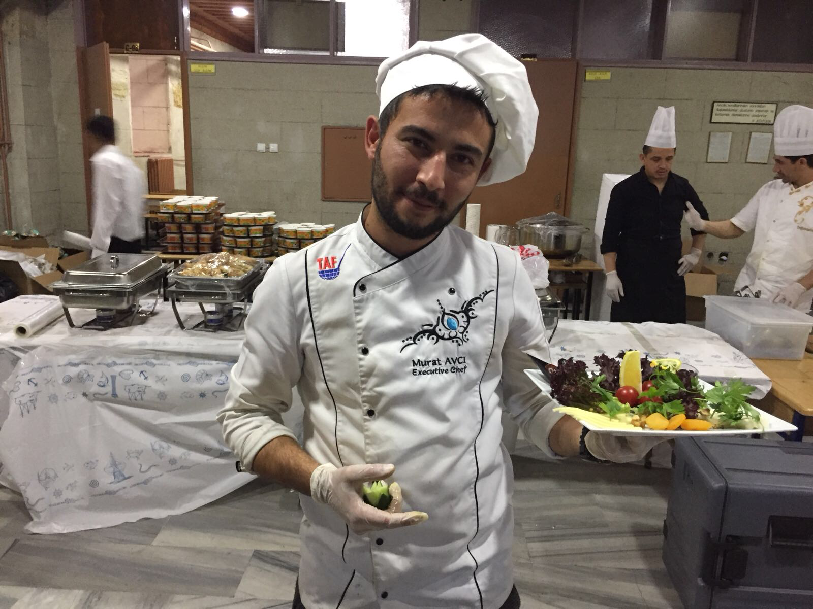
Name: MURAT Surname: AVCI
Phone: +971509559780
Phone 2: +971509174237
Email: Muratavci-chef@hotmail.com
Personal Characteristics
A creative and focused Executive Chef who has extensive hands on experience of working in all areas of a commercial kitchen. Trained and studied in preparing and supervising the preparation of foods of all types. Adept at managing all food-related personnel and activity in the hospitality field in the best ways to cook design and present foodstuff. I previously worked in restaurants, hotels and other similar establishments. In my current positions I have no problem carrying out all the responsibilities which go with it. I possesses the manual dexterity needed to use and operate a wide range of cooking and kitchen equipment's, and is able to help a kitchen operation to maintain a high level of profitability. Monitoring the equipment performance, prepare specialty foods, and be involved in menu development. Right now I am looking for a suitable position with a company that will give me a truly unique experience, and excellent grow up opportunities.

WORK EXPERIENCE
Jumeirah Group –Executive Chef/march 2020 -present
Dubai/U.A.E
Assisted head chef in kitchen maintenance, organization of supplies, scheduling staff shifts and supervision of kitchen staff. Created a first-in, first-out food rotation system which cut down wastage by 90%. Oriented new staff members on kitchen operations and evaluated their performance within a specified time frame. Planned weekend breakfast, lunch and dinner buffet menu for 500 seating capacity. Directed food preparation in the kitchen and assigned staff to each station

Bus Grill -Chef de Cuisine -Shenzhen – China. May 2018 – November 2019.
Supervises menu planning, food preparation and managing 35 team members. Reviews and restructures meal plans to ensure that food cost is within acceptable range and food quality is not compromised. Collaborates with the Chef de Cuisine in creating new recipes. Directs kitchen team activities to assure top quality meal service –accurate food preparation, attractive plating, and timely delivery at precise food temperature. Meets with restaurant managers twice a month regarding restaurant sales, menu, customer feedback and inventory
Hilton Hotel– Executive Souce Chef – Mekke - Saudi Arabia 2016 February – February 2018
Oversee all kitchen operations with high volume setting. Supervise 25 member team and manage, recruiting, training, scheduling, purchasing, invetory, sanitation, menu research/development, seasonal promotions, price structuning and food/labor costs. Monitoring portion control, with the aim of ensuring that all meals are profitable. • Ordering co coordinating the delivery of food supplies.

Emirgan Sutis Restaurant - Sous Chef - Doha/Qatar May 2014 – January 2016
Supervises menu planning, food preparation and managing 35 team members. Reviews and restructures meal plans to ensure that food cost is within acceptable range and food quality is not compromised. Collaborates with the Executive Chef in creating new recipes. Directs kitchen team activities to assure top quality meal service –accurate food preparation, attractive plating, and timely delivery at precise food temperature. Meets with restaurant managers twice a month regarding restaurant sales, menu, customer feedback and inventory.
Hotel Alcalde - Sous Chef - Guadalajara / Mexico 2012 – 2014
Assited sous chef in kitchen maintenance, organization of supplies, scheduling staff shifts and supervision of kitchen staff. Created a first-in, first-out food rotation system which cut down wastage by 90%. Oriented new staff members on kitchen operations and evaluated their performance within a specified time frame. Planned weekend breakfast, lunch and dinner buffet menu for 500 seating capacity. Directed food preparation in the kitchen and assigned staff to each station

Sheraton Hotel-Azerbaijan /Bakü /Junior sous chef 2010 / 2012
Responsible for delivering high-quality, great tasting food to patrons, and for keeping a impeccable kitchen and very clean food preparation area. Also in charge of ensuring systems compliance and delivering team briefings. Duties: • Creating innovative and authentic dishes. • Occasionally approving timesheets for junior kitchen staff. • Writing up annual performance reviews of all kitchen staff. • Inspecting meals and trays for attractiveness as well as palatability. • Monitoring portion control, with the aim of ensuring that all meals are profitable. • Ordering co coordinating the delivery of food supplies.

Tribeca Restaurant-İstanbul/Turkey/chef de party 2007 / 2010
Responsible for ensuring that food specifications and labor objectives meet all goals set by the Head Chef as well as customer requirements. Also in charge of scheduling duties for general kitchen staff, and organizing the daily responsibilities of cooks and also assisting them when necessary. Making sure that all the kitchen brigade works to the highest culinary standards. Creating news menus and dishes on a daily basis. Checking the number of reservations that have been made and then estimating how much food will be needed for those meals.

Grand Yazıcı Beach&Hotel/ Bodrum/Turkey
Chef /2005 / 2007
Making sure that all in house kitchen and catering policies are implemented, monitored and maintained. • Reminding staff to be mindful of the costs of ingredients and food. • Maintain general cleanliness of the kitchen and dining areas. • Addressing any staff performance or training issues. Making suggestions to the Head Chef on how to improve performance. Keeping accurate paperwork and administrative records of each shift. Identifying and then disciplining underperforming members of staff. Helping to develop the culinary skills of junior chefs.
Grand Azur &Resort Hotel Dömi chef de party Marmaris / Turkey 2004 / 2001
Responsible for delivering high-quality, great tasting food to patrons, and for keeping a impeccable kitchen and very clean food preparation area. Also i was Running the whole Restaurant including Front of house and back of the house.

ACADEMIC QUALIFICATIONS
National Britania HACCP Certificate 2010
Marmaris Professional Culinary Arts Diploma – Marmaris -05.07.2015
Adnan Menderes İnternational Culinary &Arts of Kitchen Universty -DİDİM – 18.03.2018
Denizli High School 2001 -2004
Ahmet Nuri Erikoğlu Primary School 1993 -2000
REFERENCES
Sezgin Gülen
Hoqqa Gıda sanayi ve Limited Ş.T.İ
Executive Chef / United Arab Emirates +971551947044‬‬‬‬‬‬‬‬‬

Bülent Tokatlı
Kai Çengelköy İnternational Kitchen Restaurant
Culinary Coordinator Executive Chef / +905383280867 İstanbul / Turkey

