CURRICULUM VITAE

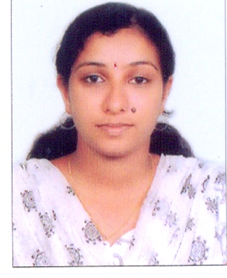
ANJU MOHAN
Ambalatharayil (H) Mobile: 91-9400965358
Poomala p.o
Chengannur Email:anjumohan57@gmail.com
Alappuzha (District)
Pin -689520

CAREER OBJECTIVE

To be a part of an organization where get a chance to use my knowledge and skills to contribute in the progress of the organization as well as myself.

SKILLSUMMARY

- Flexible and quickly adaptable to situations.
- Good organizer.
- Problem solving and negotiating skills with effective presentation Skills
- A proactive team player.
- Efficient in Building Customer Relation.
- Hard working and Self Control.

EDUCATIONAL QUALIFICATION

Course | Institution | Board/ University | Year of completion | Marks Awarded
MCA | KVM CE&IT, Cherthala | Cochin University of Science And Technology,  Kerala | 2015 | 74%
BCA | MES College , Erumely | MG University | 2012 | 65%
H S C(Biology Science) | S.N.T.H.S.S,  Chengannur | Higher Secondary Board of Education | 2009 | 70%
S.S.L.C | S.N.T.H.S.S,  Chengannur | Kerala State Board of Education | 2007 | 80%

WORK EXPERIENCE

- Working as a PHP Programmer in Ticyt, Chengannur. From 2015 June.

PROJECTS

- pragathicreators.com
- www.aleenaevents.com
- amruthanjali.in
- http://njcreationzphotography.com/
- http://royaldreamsevents.in/
- http://iter.ticyt.com/
- http://hsgtrading.net/
- qualitytechbuilders.com
- www.cityeventsmanagement.com

COMPUTER SKILLS

- MS Office.
- PHP, C,C++ ,javascript,ajax
- Windows Operating Systems
- Basics of hardware and internet applications.

INTERESTS

- Listening Music, Gardening .

PERSONAL DETAILS

Date of Birth : 24th May 1992
Fathers Name : Mohanan A K
Gender : female
Marital Status : Married
Nationality : Indian
Languages known: English, Malayalam & Tamil .

- DECLARATION:
I do hereby declare that the above given pieces of information are true to the best of my knowledge and belief.

Place: Chengannur
Date: 2/01/2017 Anju Mohan

