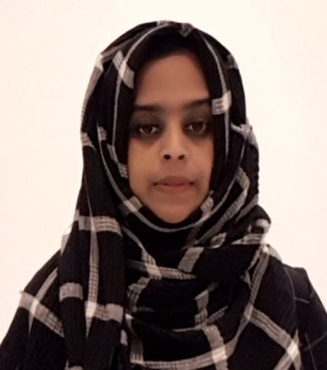

**RAFEEDHA FAHAD**

**EXPERIENCE**

16.12.2017-16.04.2018

**PURCHASE OFFICER (** **Al Mayan Trading FZE, Dubai)**

**Combined overview of roles..**

* Researched potential vendors.
* Prepared and updated database of vendors.
* Compared and evaluated offers from vendors.
* Negotiated pricing and contract terms of agreement
* Processed Purchase Requisition Form for the required products.
* Tracked orders and ensured timely delivery
* Reviewed quality of purchased products.
* Maintained updated records of purchased products, delivery information and invoices.

01.11.2014- 23.11.2016

**LECTURER INCOMPUTER SCIENCE (Co-operative arts and science college, Kerala, India** )

* Observed teammates and offered constructive criticism for best practices
* Prepared and delivered lectures to undergraduate students
* Worked within a busy environment, supported teammates in order to ensure smooth running of day to day activities.
* Assisted Chief Academic Officer for various administration work

27.10.2013 -24.01.2014

**LAB INSTRUCTOR (Shantiniketan Indian School,Doha,Qatar**)

* Developed and supervised various laboratory activities for computer science courses.
* Assisted Vice Principal for Various Documentation Works.

01.06.2010-30.12.2011

**FACULTY OFCOMPUTER APPLICATION (Ansar Institute of Management Studies, Kerala, India** )

* Participated in faculty and parent conferences.
* Developed excellent rapport with students
* Prepared and delivered lectures to undergraduate students.

**EDUCATION**

2006-2008

**MASTER OF SCIENCE IN COMPUTER SCIENCE (Kannur University, Kerala, India)**

2002-2005

**BACHELOR OF SCIENCE IN CHEMISTRY (Calicut University, Kerala, India)**

2000-2002

**HSC FROM KERALA STATE BOARD**

1999-2000

**SSLC FROM KERALA STATE BOARD**

**EMAIL :** [**rafeedhafahad.ak@gmail.com**](mailto:rafeedhafahad.ak@gmail.com)

**PHONE : +971 558580201**

03.06.2018-28.11.2019

**PURCHASE OFFICER (Salalah Building Materials Trading, Ajman)**

i

**SKILLS**

* Oracle 10g: Database Administration workshop I & II
* Oracle 10g: Introduction To SQL
* Oracle 10g: Fundamentals Of PL/SQL
* Diploma in Computer Application (DCA)

**LANGUAGES KNOWN**

**PERRSONAL DETAILS**

* Nationality : Indian
* Date of birth : 21-05-1984
* Religion : Islam
* Marital status : Married
* Visa status : Sponsorship
* Country of Residence : UAE
* English,
* Hindi,
* Malayalam
* Tamil

**CERTIFICATION COURSES**

* Office Tools: MS Word, Advanced MS Excel, MS PowerPoint, MS Outlook.
* Operating Systems: Windows, Linux
* Programming Languages: Java, C, C++, VB.NET, HTML, SQL
* Databases: Oracle Database 10g, SQL Server 2005, My SQL, MS ACCESS