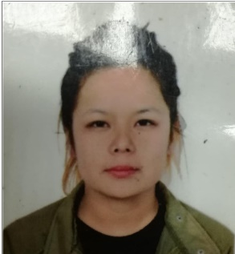

***Chahana Ale***

*Contact number:* ***+971-563179894***

*E-mail:* ***charumagar2@gmail.com***



**OBJECTIVE**

To place myself in a responsible workplace and to employ my experience and skills in a progressive organization, where I can put my maximum efforts and prove my skills to pursue a challenging career as a **Sales Associate .**

**SUMMARY OF QUALIFICATIONS**

* Highly skilled in assisting customers.
* Profound ability to handle customers and resolve problems effectively.
* Able to work with diverse and multicultural customers.
* Open to learn new skills and interpersonal skills.
* Extremely organized with a high level of attention to details.
* Good with numbers, and able to use modern computerized equipment and Retailing software.
* Good sense of humor.
* Can speak, read and write English, Nepali and Hindi.

**WORK EXPERIENCE**

***Sales Associate***

*JOOP COLLECTION KATHMANDU, Nepal*

***(2016-2018)***

***Sales Associate***

*SPLASH LANDMARK, DUBAI UAE*

***(2019 to present)***

***Current Job Responsibilities:***

* Greeting customers entering establishments.
* Answering queries from customers.
* Assisting customers to find the goods and products which they are looking for.
* Reaching to all customer’s concerns quickly, with a sense of importance.
* Processing sales and payments using POS system.
* Conducting product’s inventory in the display area and in the warehouse.
* Making Purchase Order and receiving goods from suppliers.
* Helping staffs to get best result for the store.

***EDUCATION***

***SLC (10th standard)***

***Year of 2013***

***Wilson Academy, Kathmandu, Nepal***

***Higher Secondary (+2)***

***Year of 2015***

***Rising Star Collage of Management, Kathmandu, Nepal***

***PERSONAL INFORMATION***

Date of Birth : 26/08/1998

Sex : Female

Citizenship : Nepali

Religion : Hindu

Status : Single