CURRICULUM VITA 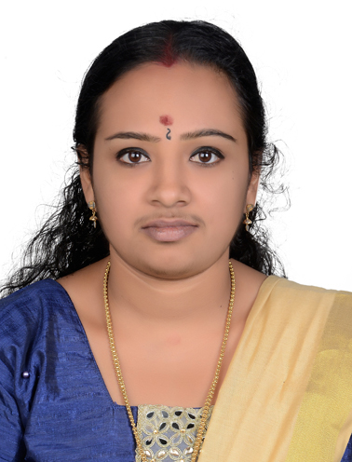 SHEEJA PH : 00971523498260 EMAIL : sheejaarimbra@gmail.com DUBAI,UAE

POST APPLIED FOR ACCOUNTING, DATA ENTRY, CASHIER, SALES, RECEPTIONIST……

PROFILE

A Suitable position with an organization where I can utilize the best of my skills and abilities that fit to my education, skills and experience a place where an encourage and permitted to be an active participant as well vital contribute of development of the company. SKILLS Extremely hardworking self motivated and able to work independently in a team environment under supervision Keep excellent inter personal relations with colleagues and ready to help them
PERSONAL INFORMATION

DATE OF BIRTH 04/11/1986 FATHER NAME KRISHNAN A MARITUAL STATUS MARRIED NATIONALITY INDIA VISA STATUS VISTING VISA
QUALIFICATION

12th CLASS PASSED

T T C PASSED
BA SOCIOLOGY
EXTRA QUALIFICATION
Hard work and flexible Great team player
Fast learner and innovative Patient and social comfortable Well good med and presentable Can work under pressure and for long hours
LANGUAGES KNOWN
English, Hindi, Malayalam WORK EXPERIENCE
Worked as a “ ACCOUNTANT CUM AUDIT ASSISTANT ’’ period for 1st
December 2013 to August 2019
WORK KNOWLEDGE
VAT return, GST return, Excel, Balance Sheet, Financial Statement etc….
PASSPORT INFORMATION

Passport NO : T2617745
Issue Date : 30/03/2019
Expiry Date : 29/03/2029
Issue Place : MALAPPURAM

DECLARATION

Here I am kindly declared that the above mentioned details all are true in the best of my knowledge and believe.

SHEEJA

