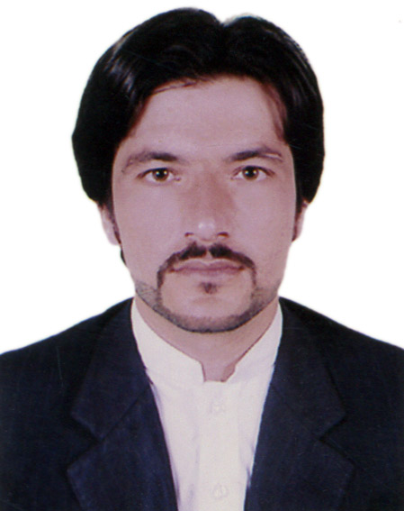

ABRAR JADOON
Contact: 0569512447
Email: abrarjadoon@yahoo.com
DUBAI
CAREER OVERVIEW
A sales management professional with overall 5 years' experience in sales & operations department, I have worked in Sales, and operation in Events and exhibition and Financial services industry. I have a proven track record of developing new business and motivating a team to consistently exceed targets. I've completed a Masters of science degree and am now seeking a new professional challenge.
KEY STRENGTHS
- High level computer skills including Excel, Word and Powerpoint
- Overall Five years experience in Marketing/Sales & operations both face to fac. Creativity & negotiations.
  - Strong business development capabilities with UAE experience. Judgement & Decision Making.
  - Critical thinking, Problem solving,People Management
  - Operations to complete a project on time, Cognitive Flexibility
  - Arranging vehicles and labours, handling logistics.
  - weekly, monthly yearly business analysis .
CAREER HISTORY
Oct 2016  july 2018 Sales Manager
ALQODRA FINANCE CONSULTANT Dubai
Alqodra finance consultant basically providing financial services.
Key responsibilities
- hire train & Leading team of executives
- Build up strong relationship with Clients.
- Develop and execute sales strategies
- Maintain and strengthen a large portfolio of clients
- Coach, mentor and motivate sales team
- Manage sales budgets and set targets
Key achievements
  - I have done a deal of 3.3 M AED with company Al SaifAlfadi
Operation executive
Alkhalid and zahid services L.L.C Dubai
Alkhalid and zahid service company provide labours and vehicle serviceall over UAE. I am leading whole operations dealing pricing arranging labours vehicles etc
Key responsibilities
- Purchasing for a project assigned by project manager
- Manage vehicles and labours for Events & Exhibition. worked with logistics companies.
- successfully organise bentaly, Ferrari McLaren events.
- Review pricing and service levels
- Develop product literature and customer delivery target and time.
Qualifications
- Degree institute year
Master of science hazara university Pakistan 2014
Bachelor of science. Awkum mardan Pakistan 2011
- Certificate
I received IT certificate from Peshawar technical board Pakistan.
(Microsoft office, outlook, window, hardware).
Languages
English /Speaking/Reading/writing ...Hindi ... Speaking.. / Arabic.. reading writing
Pushto /Speaking/Reading/writing.... Urdu .../Speaking/Reading/writing

