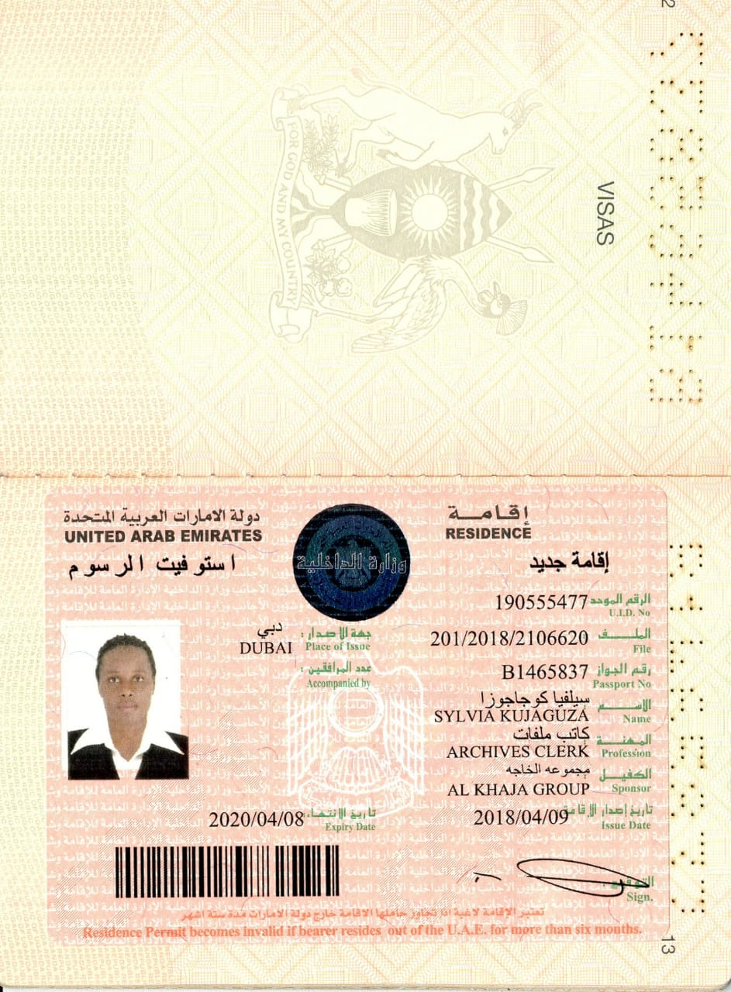

**APPLYING FOR SECRETARY/RECEPTIONIST**

**KUJAGUZA SYLVIA**

**PERSONAL DETAILS**

Nationality : Ugandan

Gender : Female

Passport No : B1465837

Marital Status : Single

E-mail :[bixler2008@yahoo.com](mailto:bixler2008@yahoo.com)

Mobile No : +971-581242119

+971-566725430

**OBJECTIVE**

As a highly motivated and creative individual,my career aspiration is to contribute the best of my services to this company. Utilize the knowledge, communication skills and efforts to work effectively in an organization. Be a responsible team player, making significant contributions to the success of the organization goals and strategic directions, As well as accuracy and confidentiality.

**PERSONAL SUMMARY**

A polite, well spoken and hard working person with experience of working in a busy environment. flexible team player,selfmotivated,professionally confident and friendly,willing to learn and train others.

**EDUCATIONAL ATTAINMENT**

The national council of Uganda YMCA( SECRETARIATE)

Uganda advanced certificate of education.(UACE)

Uganda certificate of education.(UCE)

Uganda institute of bankers and financial services.(Accounting)

**COMPUTER EXPERIENCE**

Microsoft word, Microsoft excel,

Microsoft outlook, Power point,

Tally 9, Quick books, Navision.

**WORK EXPERIENCE**

**CURRENTLY:**

**Company**: Alkhaja Group of companies UAE

**Position**: secretary/receptionist

**Location**: Dubai UAE

**Duties:**

Receiving phone calls, taking minutes in meeting and arranging appointments for meetings, Preparation for staff training, Welcoming guests, Making LPO and requisitions for items on demand from suppliers. Making periodic reports, Filling, balancing petty cash daily.

**June 2015-July 2017**

**Company:** Centenary bank

**Position:** Receptionist

**Location:** Kampala-Uganda

**Duties**

❖ As a receptionist: Welcoming guests and attending to their needs, arranging meetings for the guests and company, training plans for staff, delivering packages /parcels to their designated offices or departments. Receiving parcels from clients on behalf of company, Filling.

**STRENGTHS**

❖ Good communication skills

❖ Good Customer care

❖ Excellent attention to detail

❖ Ability to work independently and work in a team

❖ Able to respond quickly in emergency situation

Accuracy in data and confidentiality.

**REFERENCE**

Alkhaja group of companies uae.

+971 (4) 2678837,+971 55 4025833

www.alkhajagroupuae.com

I hereby testify the accuracy of information declared above are true and correct to the best of my knowledge and belief.