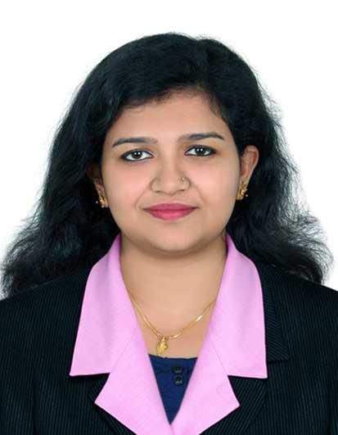  Aiswarya M  Flat No 1309, Khalid Plaza,  Sharjah - UAE  Contact number:+971 501713929 Email:aiswarya.murali002@gmail.com  PERSONAL DETAILS:  Date of Birth : September 17, 1995  Marital Status : Married  Nationality : Indian  Languages known: English,Malayalam,Tamil | OBJECTIVE  Seeking a suitable position in an organization where I can utilize my skills in an effective way for upgrading my career.  SKILL SET  Technical Skills:  - Microsoft Office  - Windows  - C#,ASP MVC,JAVA  - SQL,PGAdmin  - Networking  Soft Skills:  - Quick learner  - Excellent communication abilities  - Good team player  - Self Motivated,Hard Work.  PROFESSIONAL EXPERIENCE  Worked as an Associate Software Engineer in GDS Pvt.Ltd from May 2018 to July 2019.  PROJECT DETAILS  Leave Management System  Platform: C#, MVC  BackEnd:SQL  Leave management system(LMS) is a web based application used for managing employee details of our company.  Empigest  Platform: C#, MVC  BackEnd:SQL  Empigest is a construction equipment (forklift)supplier in Portugal.We have created an application for the contacts and calculation of forklifts  Elcamino  IDE: Eclipse  Platform:JAVA  BackEnd: PGAdmin  Elcamino is a web based application used by medical officers to store their patient details like medical records ,history of illness etc .  EDUCATION  Amrita School of Arts & Sciences,Kochi (2016-2018 )  MCA with 6.05 CGPA  Amrita Vishwa Vidyapeetham, Amritapuri (2013-2016 )  BCA with 6.78cgpa  Vidyadhiraja Higher Secondary School, Trivandrum (2013)  Plus 2(state) with 70%  Nirmala Bhavan HSS ,Trivandrum (2011)  SSLC(state) with 65%  Course in LAN & WAN Administration Using Cisco router & Switch  PROJECTS  - Heart Disease Prediction Using Data Mining Techniques  THESIS SUBMITTED  - Illustration Of Random Forest And Naïve Bayes Algorithms On Indian Liver Patient Data Set.  CO-CURRICULAR ACTIVITIES:  - • Serve an Hour - Student Coordinator- Awareness campaigns at government schools, conducted by the college.  - • Participated in major events in college such as Technical Fest ‘Vidyut’ conducted at Amrita College.  - • Coordinator at Mata Amritanandamayi’s birthday celebrations for five years.  - • Coordinator and active member of Amrita Sanjeevani (Seva Organization)and ABC (Amala Bharatam Campaign - Clean India).  - • Part of the coordination team of International Level Coding Contest ACM-ICPC ,Amrita Vishwa Vidyapeetham.  DECLARATION  I hereby declare that the information provided above is genuine to the best of my knowledge.  Sharjah AISWARYA M

