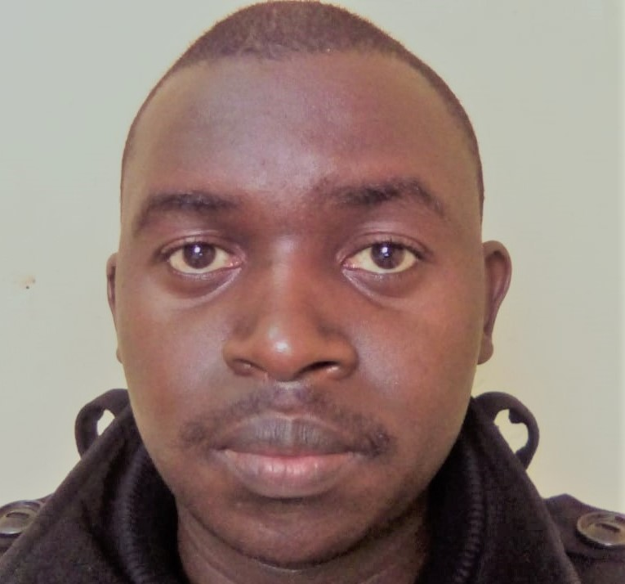**CURRICULUM VITAE**

**NAME: DAVID WAINAINA KINYANJUI**

**Phone Number: +971565730671, Nationality: Kenyan Email;**[**dawainaina@gmail.com**](mailto:dawainaina@gmail.com)**, Gender: Male**

**Languages; Fluent in English and Swahili, both written and spoken**

**CAREER OBJECTIVES**

To diligently apply the knowledge gained in economics to help grow and develop the economy of the country at large and to effectively demonstrate timely delivery of tasks to meet deadlines.

**COMPITENCIES**

* Problem solving skills
* management and presentation skills
* Regulatory reporting and analytical skills
* Accounting, Economics, Tax reporting and finance skills
* Time keeping and Budgeting

GOOD UNDERSTANDING OF QUANTITATIVE SKILLS IN ECONOMICS

**EDUCATION BACKGROUND**.

2013- 2017 University of Kabianga: **Bachelor of Arts in Economics**

2009-2012: Lari High School: Kenya Certificate of Secondary Education B+

2000-2007: Bathi Primary School: Kenya Certificate of Primary Education C+

**Professional Courses**

Programming Languages; C+ Certificate in Programming-University of Kabianga

Main Software Used

1. SPSS

2. SAP

3.Quickbooks

**EMPLOYMENT HISTORY**

**2017 -2019.**

* **Accountant and Operations manager at Fourway wholesalers limited**
* **Manage all accounting transactions**
* **Prepare budget forecasts**
* **Publish financial statements in time**
* **Handle monthly, quarterly and annual closings**
* **Reconcile accounts payable and receivable**
* **Ensure timely bank payments**
* **Compute taxes and prepare tax returns**
* **Manage balance sheets and profit/loss statements**
* **Report on the company’s financial health and liquidity**
* **Audit financial transactions and documents**
* **Reinforce financial data confidentiality and conduct database backups when necessary**
* **Comply with financial policies and regulations, I am able to resolve issues or discrepancies during the process of invoices and payment to vendors.**

**Maintain e-folders and Hard files for paid/deposit/credit memos/wire transactions/vendor & customer permanent files.**

* **Manage the hold of shipments and authorizing release based on payments.**
* **Maintain stock lists and orders office supplies as needed**
* **Manage staff expense requests**
* **Interact with directors and carries out their request**
* **Being a wholesale and a distributor company, I was responsible for allocating routes for the company trucks, monitor the fuel consumption, supervise loading and offloading of trucks, lease with the director on important changes to be made in the company, I participated in hiring of new employees. I assigned work to new employees among other managerial jobs.**
* **August-Nov 2017; polling/counting clerk; Independence Electoral and Boundaries Commission.**
* **Successfully conducted elections in Starehe constituency at Pangani girls high school polling station 14 as clerk one and later as deputy presiding officer during the repeat elections.**
* **JULY 2017; Financial advisor at SANLAM insurance company.**
* **Done consultation on insurance sales and investment plans in education and life insurance**

2016/09/22- 10/25; student electoral commissioner, university of Kabianga

2016/05-08: Attachment at Mumias Sugar Company- Treasury and Finance department

2015/04-09: IPSOS Research Company; Data collection

2013/04-06: sales and marketing at Fair price enterprises: merchandiser

2013/07-09 Lari high school; Mathematics teacher

COMPUTER SKILLS

2012 JAN; ZIPTECH COMPUTER COLLEGE

Done ten computer packages among them MS word, MS excel and access.

**ACHIEVEMENTS**

1. Chosen as the chairperson student council Lari boys high school in 2011
2. Participated in science congress at the provincial level held in Alliance high school and attained position 3 in a home science talk
3. Participated in debate competition held in St. Paul’s University and USIU Africa in 2013 and 2015 respectively
4. Organized the Universal children’s day celebrations at Kapmaso primary in November 2015
5. Chaired the 3rd student electoral commission of the University of Kabianga.

**MEMBERSHIP AND RESPONSIBILITIES**

Member of the debate club in University of Kabianga where I have learnt communication skills and interpersonal skills and served as the contact person.

Member of the peer counselling club of university of Kabianga where I served as the events coordinator for two academic years.

**CONFERENCES ATTENDED**

University of Kabianga first international conference 2016 November

ACCA held at Kabianga University 2014 September

KASNEB Held at university of Kabianga 2015 Feb

Research conference held at university of Kabianga 2015 March

Debate competition held at USIU – Africa 2015 June

Scholar’s festival held at St. Paul's University 2013 October

Kenya heads of Secondary Schools Association held at Bomas of Kenya 2011 April

**INTERESTS**

Reading educative materials

Playing golf

Socializing

Motivating others

Debating.

Travelling and seeing new places

REFEREES

1. Mrs. Kabitha Gathoni

CEO Fourway wholesalers Ltd

+254720608179

1. George Kinyariro

Director Fourway Wholesalers Limited

+254721568939