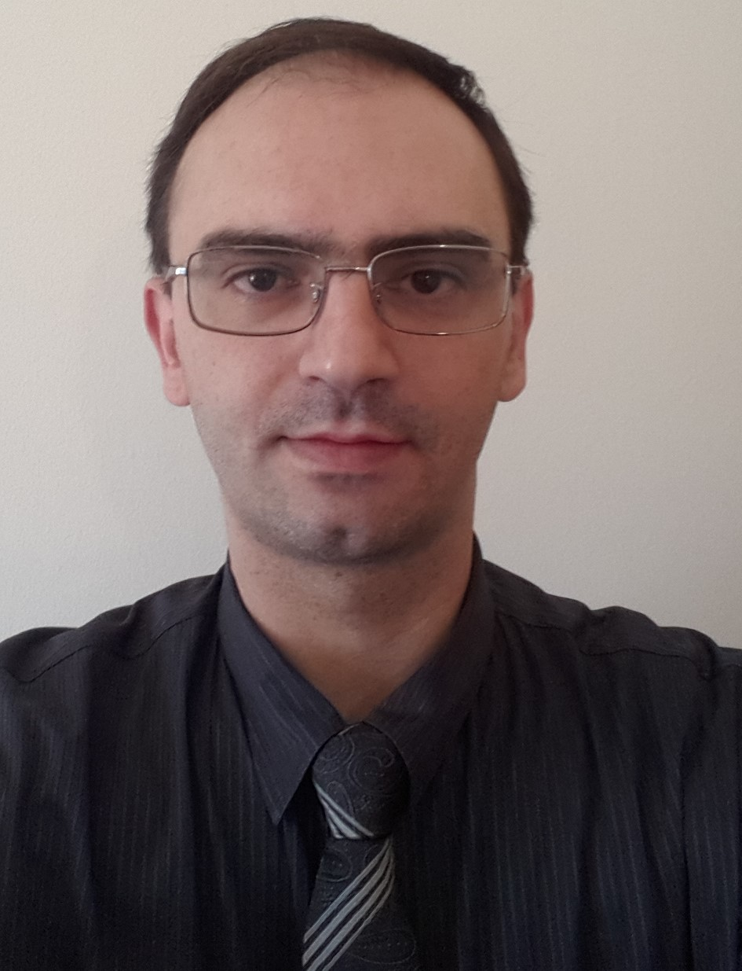
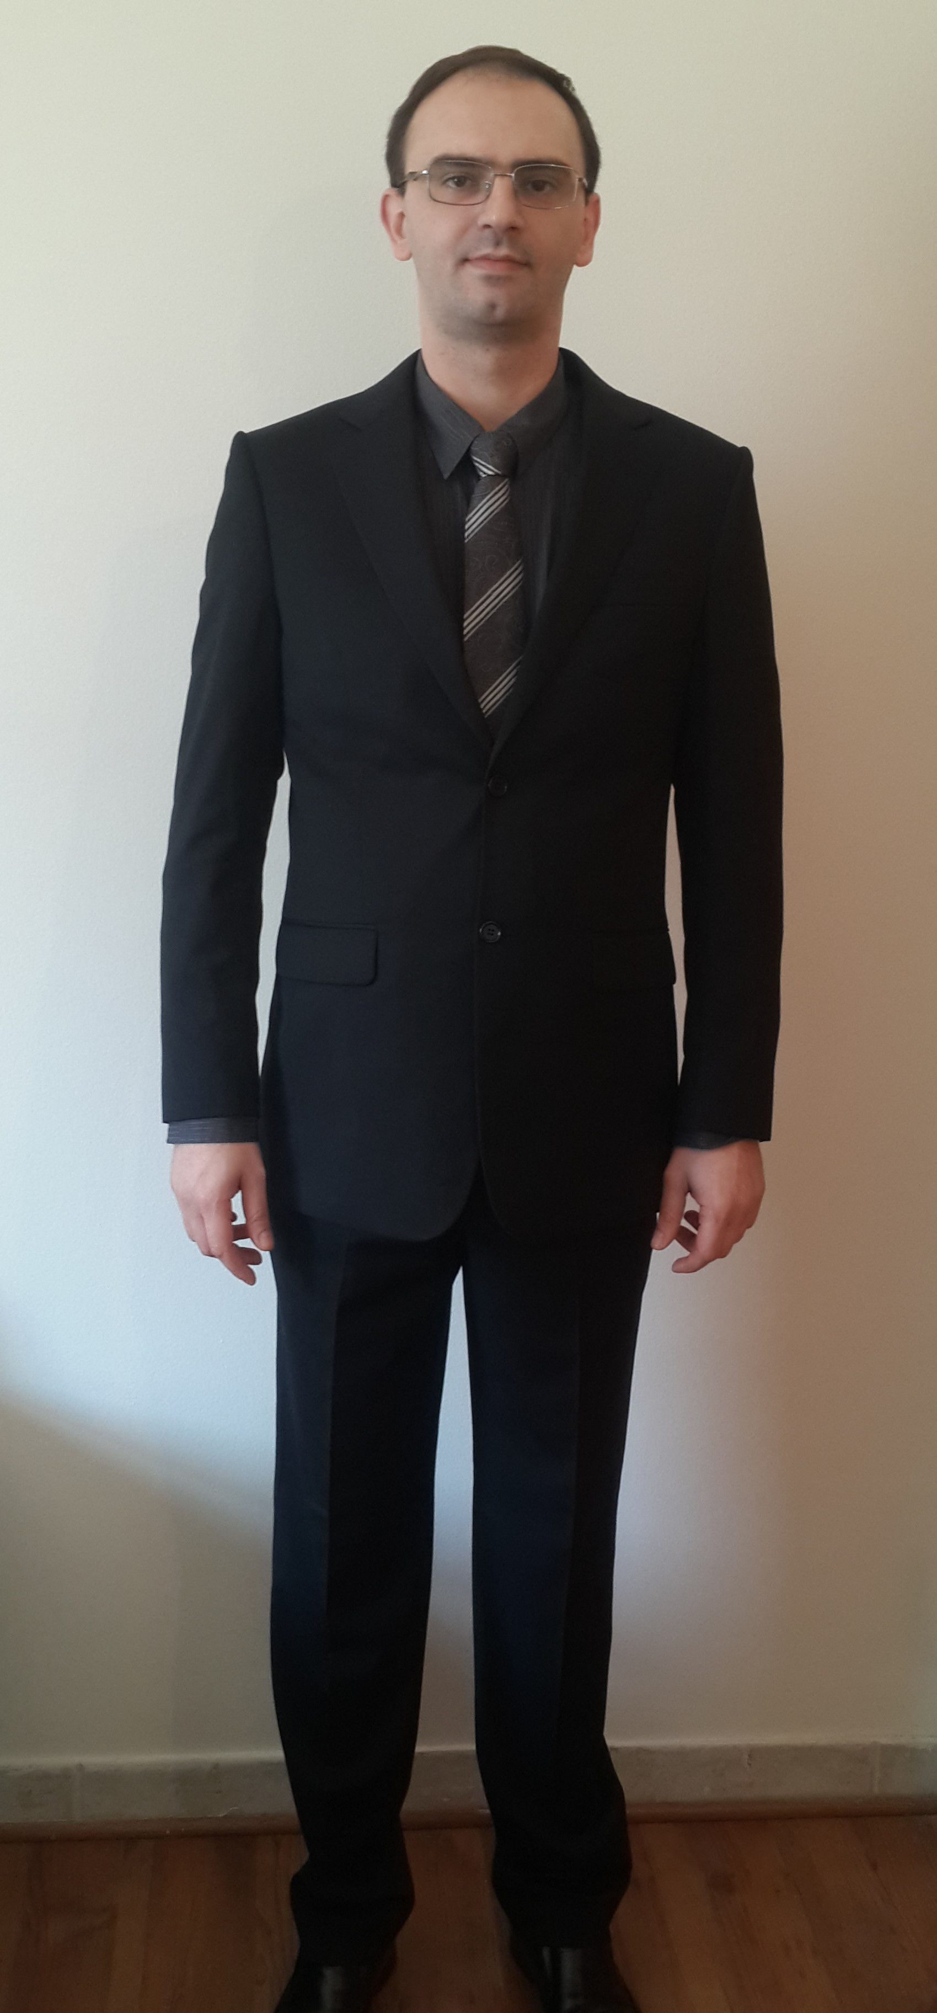
Mladen Matic
Address: Dubai, JVC, Autumn 1, G22
Mobile Phone: +971553669807
Email: matic.mladen@hotmail.com
Skype: mladen.matic.80
Professional Profile:

I am an experienced Manager within the hospitality industry with an array of skills gained from the various roles I have successfully undertaken. I have demonstrated my ability to manage, mentor and motivate a team to ensure that all roles and responsibilities are completed to the highest of standards. As a customer focused individual, I always aim to go the extra mile to maximise customer satisfaction and improve business performance. Now seeking a new opportunity where I can utilise my skills and add value to my prospective employer.
Key Skills:

- Management & Leadership
- Professional Approach
- Inventory Control
- Analytical
- Customer Focused
- Excellent Communication Skills
- Flexibility
- Problem-solving
- Time Management

Employment Experience:

April 2018 – Current
The Coffee Club, Dubai, UAE
Restaurant Manager

Key Responsibilities:
- Agreeing and managing budgets
- Training, evaluating and leading diverse front and back of house team
- Ensuring compliance with licensing, hygiene and health and safety legislation/guidelines
- Promoting and marketing of restaurant with marketing team
- Cost control by monitoring wastage, effective ordering, stocktaking and effective roster planning
- Handling customer enquiries and complaints
- Assessing and improving profitability
- Handling administration
- Preparing and presenting daily, weekly and monthly sales reports
- P&L management
- Managing and overseeing the entire restaurant operation
- Reposting to Area manager

March 2014 – August 2017:
Fortnum & Mason, Dubai, UAE
Assistant Restaurant Manager

Key Responsibilities:
- Working for a prestigious and up market English food retailers and restaurants, responsible for providing excellent levels of customer service at all times
- Working closely with the Manager to ensure the smooth running of the restaurant
- Responsible for providing a warm and welcoming environment for customers
- Successfully managing the shift, ensuring all roles and responsibilities are completed to a very high standard
- Adherence to all company standard operating procedures at all times
- Attending to customers, taking orders and liaising with kitchen staff to ensure orders are processed correctly
- Accurately processing cash and card payments
- Completion of daily and monthly reports
- Maintaining high levels of professionalism at all times

Previous Roles:

July 2011 – July 2013: Mamig Restaurant, Doha, Qatar
Head Bartender

February 2006 - July 2011: Rendezvous Caffe, Negotin, Serbia
Manager and Owner

July 2003 – July 2006: SR Tehmatic, Negotin, Serbia
Salesman and Repairman

July 2000 – July 2003: DOO Unimat, Negotin, Serbia
Assistant Supervisor
Education & Qualifications:

Gimnasium, Negotin, Serbia
High School Education – 12 grades (Natural Sciences)
Additional Information:

I.T. Skills: Proficient user of MS Office Applications, POS, ICG system, NAV, Maitre’d, Email & Internet
Other: Driving License Issued from Serbia and UAE
Languages: Serbian (native), English (fluent), Croat (fluent) & Bosnian (fluent)
References: Available upon request

