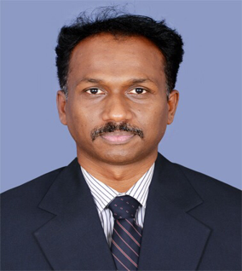 **CURRICULAM VITAE**.

**ARUN.V**

**Email:** [**varunotp.85@gmail.co**](mailto:varunotp.85@gmail.com)**m**

**Phone: 0585643385**

**CAREER OBJECTIVES**

To build a challenging career with my sound knowledge, communication, Presentation and interpersonal skills. To be a part of a productive team being representing and responsive

**WORK EXPERIENCE**

* **Company**: Teleperfomance, Bangalore (From Nov 2017 to Jan 2019). Designation: Customer Service Associate.
* **Company**: Serco Bpo, Bangalore (From Dec 2012 to Jan 2015). Designation: Senior CSA (Customer Service Associate).
* **Company**: Serco Bpo, Bangalore (From April 2011 to June 2012).

Designation: CSA (Customer Service Associate).

* **Company** : Prowess Marketing company pvt ltd .(From 2007 to 2009).

Designation : Admin assistant.

**EDUCATIONAL QUALIFICATION**

* MBA-Hr passed from the Bharathiar University in the year of 2018.
* Bsc. Industrial chemistry passed from the UNIVERSITY OFCALICUT in the year 2007

**COMPUTER KNOWLEDGE**

* Microsoft office specialization in EXCEL

Verify.certiport.com – HnNM-XL5p

* M.S.Office
* P.G.D.C.A(Post Graduate Diploma in Computer Application)

**PERSONAL PROFILE**

Age & Date of Birth : 34, 06.05.1985

Gender : Male

Marital status : Single

Nationality : Indian

Religion : Hindu

Language proficiency : English, Malayalam, Tamil, Kannada.

**PASSPORT DETAILS**

Passport No : J3354515

Issued place : Malappuram

Issued date : 23 October 2010

Date of expiry : 22 October 2020

**DECLARATION**

I solemnly declare and affirm that all the above-furnished details are true to the best of my knowledge and belief.

(Arun)