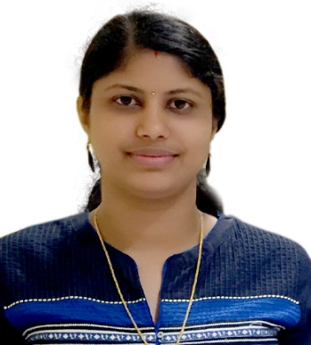

**Surya Prakash**

**ELV(BMS) Estimation & Sales Engineer**

Mob: +971504046936 / +971503787527

Email: [suryaps118@gmail.com](mailto:suryaps118@gmail.com)

|  |
| --- |
| **PROFILE SUMMARY** |

Hardworking, reliable and professional ELV/BMS Estimation & Sales engineer with over four years of experience. Prior work history includes working with independent clients and developing cost analyses of various business functions. Skilled in accurately forecasting corporate expenses and implementing policies to manage such expenses. Collaborated with senior management staff to analyze cost estimates across various operational aspects of business and optimize profits through reduced costs. Extraordinary ability to maintain multiple running project calculations accurately and clearly. Able to adjust work planning and pacing to meet changing customer budgetary requirements.

|  |
| --- |
| **EDUCATIONAL QUALIFICATION** |

* Bachelor of Engineering in Electronics & Communication Engineering, India, 2012
* Cad 2D & 3D

|  |
| --- |
| **ORGANIZATIONAL EXPERIENCE** |

**JULY 2014 – JUNE 2018 : VERGER DELPORTE UAE LTD., UAE**

**Growth Path**

**January 2015 – June 2018: ELV (BMS) Estimation & Internal Sales Engineer**

**July 2014 - January 2015: ELV (BMS) Asst. Estimation & Internal Sales Engineer**

**Job Responsibilities:**

* Prepare Building Management System (BMS) requirements of the project as per available documents and in consultation with the customer.
* Proactive interaction with the customer during the project estimation cycle for inputs, clarifications and information required to deliver the quality estimate within timeline.
* Study tender specifications and prepare compliance statement and list of deviations.
* Preparation of inclusions and exclusions.
* Quantity take-off from tender documents.
* Preparation of BMS Input/output summary from Control Schematics and Sequence of Operations.
* Preparing the I/O Points list according to the requirements of the Project Specification.
* Selection of DDC controllers, Gateways and Field Devices such as Sensors, Control Valves, Actuators, Flow Meters, Energy / BTU meters, etc. as per tender requirements.
* Propose cost effective and competitive solutions.
* Proficient in working on Microsoft Office Excel, Word and knowledge of AutoCAD
* Making the bill of quantity (BOQ) as per the Points List.
* Prepare Equipment list, Price Quotations, Single line diagrams/Schematics, System proposals in response of customer requirements.
* Designing the appropriate locations of DDC controllers and DDC Panels.
* Provide technical and engineering support to the field, related to design, equipment’s/devices, such as drawings and other engineering information.
* Knowledge to choose appropriate Field Instruments such as Smart Transmitters like Pressure, Flow, Temperature, Level, Differential Pressure Transmitters, Sensors, Differential Pressure Switches, 2-way and 3-way Control Valves.

|  |
| --- |
| **IT SKILLS** |

* MS Office Suite (Word, Excel and PowerPoint), email and internet, ERP software with professional typing skill

**Personal Details**

Date of Birth : 20-05-1990

Sex : Female

Nationality : Indian

Marital Status : Married

Driving License : India & India

Languages Known : English, Hindi & Malayalam

Passport No : R9035419

Visa Status : Visit Visa

Address : Dubai, UAE

Hobbies : Driving, Cooking & Socializing