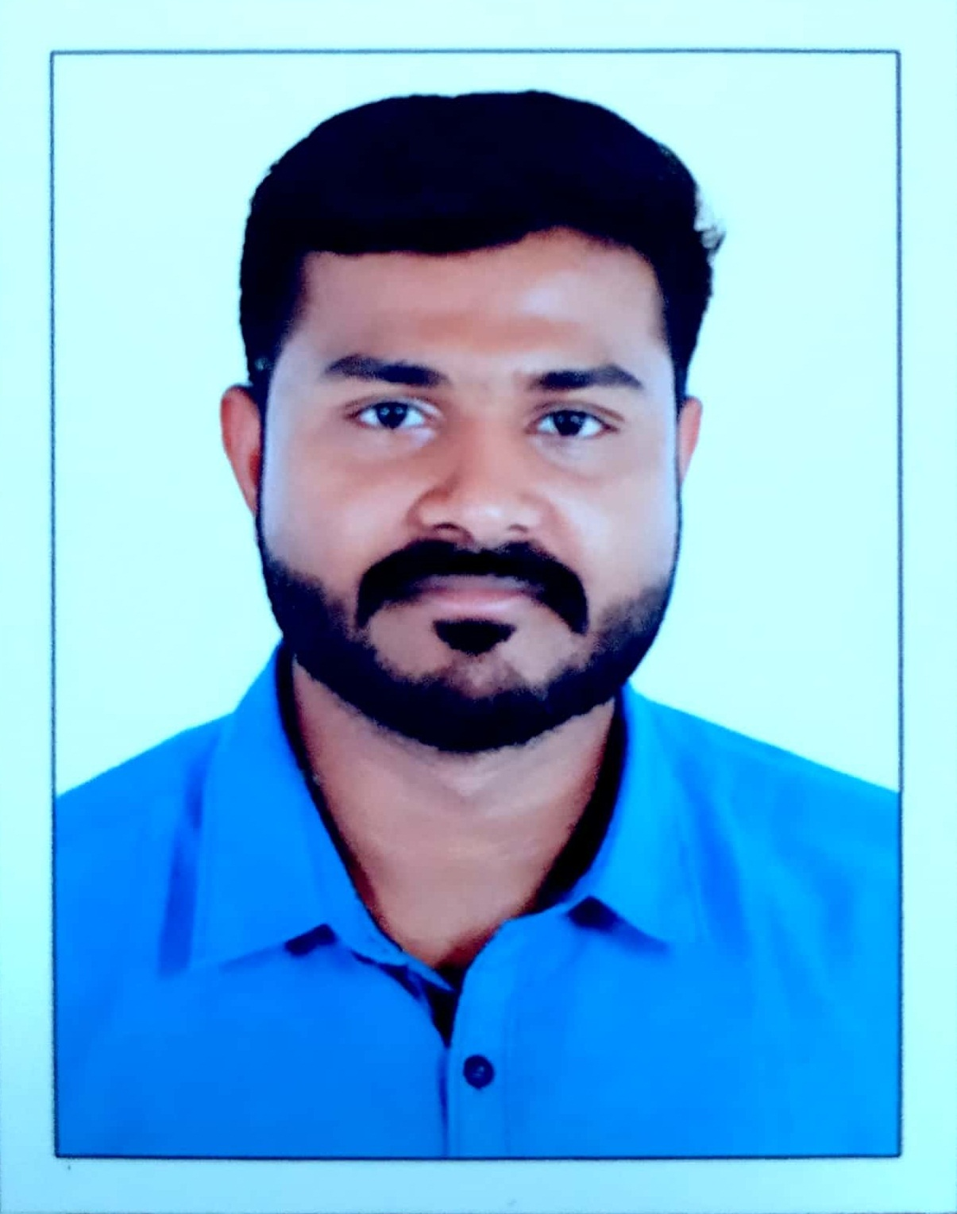  Contact  No:+971567528807  No:+971561756017  Present Address  Al Salam living city,  Hameem bridge area.  Abu Dhabi  Permanent Address  Chethipurackal[H],  Chempumpuram Po  Alappey (DIST)  Kerala Pin: 688505  Personal Data  Date of Birth:  13th Feb 1990  Sex:  Male  Marital status:  Married  Languages Known:  English,Hindi, Malayalam and Tamil.  Nationality:  Indian  Passport No:  H9592443  Valid Till:  11/08/2020  Driving license:  Holding valid UAE driving license. | NITHIN C JOSE  nithinchethipurackal@gmail.com  Profile  Result oriented and experienced professional with proven track record of success in the area of plastic and expandable polystyrene production, maintenance, Quality control, warehouse management and customer service. Successful in achieving set goals within parameters of cost, quality, profitability and resource utilization.  STRENGTHS  Ability to handle difficult situations, Problem solving skills, commitment to work, Punctuality, leadership skills and hardworking.  Educational Qualifications  - Diploma in Electrical& Electronics Engineering(2012-2015)  State board of technical education, Tamilnadu.  - National trade certificate as an Electrician(ITI) ( 2009-2011)  National council for vocational training.  - Diploma in Fire& safety Engineering.(2008)  - Completed HSE-Board of HSE Kerala.  - Completed secondary school examination.  Board of public examination, Kerala.  Career snapshot  1. STYROPACK FOR PLASTIC FACTORY LLC – ABU DHABI (Subsidiary of Palletco LLC)  From Oct 2016 to still continue.  Job Responsibilities  1. PRODUCTION/PLANT SUPERVISOR  - Planning and organizing production and delivery of goods.  - Coordinate with factory workers for better production.  - Reporting plant or machinery breakdowns to management.  - Reporting to the production manager about the production and factory maintenance on daily basis.  - Organizing external contracts, like cleaning or supplies  - Motivating production team for easy function of factory.  - Entry of Production daily reports into system and sending reports to higher management.  - Monitoring quality control of finished Goods  - Making records for production as per Dubai central laboratory (DCL) standards.  - Daily production monitoring and quality checking as per DCL regulations.  - Documentation for ISO auditing.  - Raw material handling, checking, storage and documentation properly  - Labour duty arrangements and shift planning.  - Monitoring and keep records for boiler.  2. STYROPACK FOR PLASTIC FACTORY LLC – ABU DHABI (Subsidiary of Palletco LLC)  From Oct2015 to Oct 2016)  2. MAINTANANCE ELECTRICIAN  Job Responsibilities  - Maintenance of shape molding, injection molding and block molding machines  - Repair & maintenance of injection molds and shape molding molds  - Offer assistance to operations in running machines at standard speeds and centreline conditions so as to enhance productivity and efficiency  - Offer assistance with troubleshooting of equipment problems  - Guarantee operation of mechanical gadgets and machinery by ensuring completion of preventative maintenance prerequisites on production machines, motors, air compressors, conveyor systems, boilers, cooling towers and pneumatic tools  - Troubleshoot hydraulic and pneumatic machine breakdowns and provide preventive maintenance services.  - Keep proper record of work activities, including all procurement and maintenance.  Area Of Interests  - Production and quality control  - Maintenance of hydraulic& pneumatic machines  - Documentation  - Factory supervision  - Raw material handling and store keeping.  Strengths  - Ability to lead and work in a group  - Flexibility to adapt new environments and to perform with zeal  - Fast learner  - Good at time management and scheduling  - Working with a systematic approach to convert dreams into success.  Computer skills  - Knowledge of MS office MS Excel, Out Look. Mat lab.  - Knowledge about computer Hardware and software.  - Facts ERP 9 Latest Version.  - Use of all office equipment’s  Extra-Curricular Activities  - , Listening music, Pencil drawing, Cricket and travelling  Declaration  I hereby declare that the information furnished above is correct and true to the best of my knowledge.  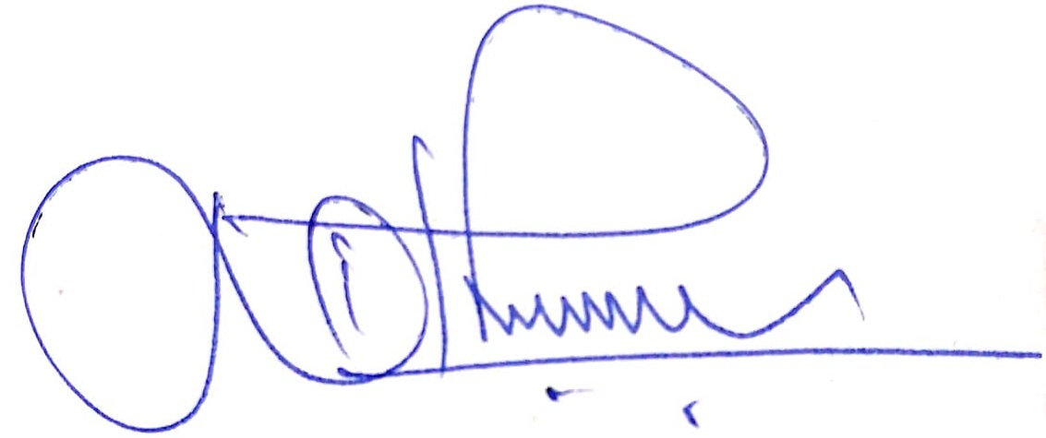  Date : 27-01-2020 NITHIN C JOSE  Place : Abu Dhabi

