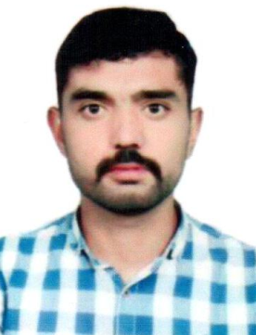
MUHAMMAD TAYYAB
B Tech Hons. Civil Engineer/ Safety Professional
Cell: +971 52 373 6927
Cell: +92 304 415 8002
Email: muhammadtayyab7780@gmail.com

Carrier Objective:
To become a competent & dynamic professional working in an organization that places high value on professional growth for self-motivated individuals seeking challenging assignments for responsible positions.
Key Skills:
- Self Motivation
- Excellent interpersonal and communication skills in a professional manner.
- Ability to learn and work under pressure.
- Confident and good team player.
- Ability to learn quickly and adapt to changing environments and willingness to accept responsibilities.
- Ability to deal effectively with multicultural environment
Educational Qualification:

Degree | Year
B.Tech Hons (Civil) from Superior University, Lahore. | 2016
B.Tech Pass (Civil) from Superior University, Lahore. | 2014
D.A.E (Architecture) from P.B.T.E. | 2012
Matric (Science) From B.I.S.E Lahore. | 2009

Training Certificate:

Qualification | Institutes | Date of Completion
IOSH Managing Safely | IOSH | Oct, 2019
Fire Safety | BTI, Lahore. | Feb, 2019
Accident Investigation Technician | BTI, Lahore. | Apr, 2019
Work at Height | BTI, Lahore. | Jul, 2019

Computer Skills
- Micro Soft Office
- Auto Cad
Professional Experience:
- Worked as a Building Inspector & Supervisor in Arch SOL, DHA Lahore for 5 years
- Worked as a Road Surveyor in Chaudhary Engineering Pakistan for 6 months
- Worked as a Building Inspector & Supervisor in Galleria Design in Lahore Pakistan for 1 years

Personal Details:

Date of Birth : 26/10/1993
Nationality : Pakistan
Marital status : Single
Gender : Male
Languages : English, Punjabi & Urdu

Passport Details:
Passport No. : AL7137002
Visa Status : Visit Visa (1st March 2020)

ASSETS:
Good understanding of Human Behavior, keen desire to achieve Success, Self-Discipline, Optimistic attitude, Good planning skills, spirit of team work and cooperation, Adaptability and learning ability, believe only in results, regular and punctual.

DECLARATION:
I hereby declare that the facts given in resume are correct to best of my knowledge and belief.

MUHAMMAD TAYYAB

