AHMED SULIMAN HASSAN
Dubai- UAE
Mobile: +971552758820
E-mail: ahmed_suliman25@yahoo.com

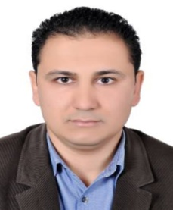

Objective

- I am currently seeking a position that will provide further growth and enrichment
my career in a dynamic and growing organization. I’m looking forward to discuss how I may be of service at your company.
- Dynamic 15 years of Site Supervision, Civil and Architectural Sections, Working Drawing,
self-motivated, Hard Working with a Positive Attitude Team focused Personality able to assist and improve Group Productivity as well as following Company Procedures and Guideline.

Education

- Faculty of Engineering (Civil Department) ZagazigUniversityMay2003
  - Bachelor: Civil Engineering
  - Project: Reinforced Concrete Design
Work Experience

(1)-CIMOLAIRIMOND MIDDLE EAST GENERAL CONTRACTING (AD– UAE)
August 2017 – Jan 2019
MASDAR VISITOR CENTRE @ MASDAR CITY – ABU DHABI
Engineer: UNII ENGINEERING OFFICE & KEO
Job Description:

Project Manager :-
- The MVC Project is 85M AED | UAE, Abu Dhabi, Masdar City: EPC Turnkey Fast-track Project.
- The project designed and constructed along with Estidama pearl 3 rating, Masdar’s KPI’s, and AD Authorities regulations. Total built-up area 10400 m2, G+2, offices and retails.
- Managing the project contract, claims, VO's, NCR's, time extensions.
- Managing the procurement plan, cash flow, subcontracts and quotations.
- Managing and controlling the project life cycle, updating recovery plan
- Engaged the project manager with the project management plan and stakeholders.
- Restructuring the project resources and implementing cost reduction
- Tracking, follow-up authorities’ submittals and approvals
- Managing and reviewing the tender documents.
- Feasibility study and cost analysis.
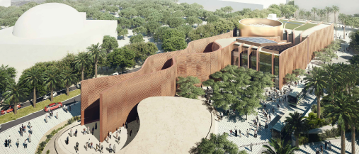

(2)-MODULAR GENERAL CONTRACTING (Dubai – UAE)
November 2016 – July 2017
ACCELERATOR BUILDING @ MASDAR CITY – ABU DHABI
KRYPTO LABS OFFICE @ MASDAR CITY – ABU DHABI
Engineer: UNII ENGINEERING OFFICE & AL AIN CONSULTANT OFFICE
Job Description:

Project Manager :-
- The Accelerator Building 80M AED | ongoing project; UAE, Abu Dhabi, Masdar City: EPC Turnkey Fast-track Project.
- The project designed and constructed along with Estidama pearl 3 rating, Masdar’s KPI’s, and AD Authorities regulations. Total built-up area 9,800 m2, G+2, offices and retails.
- Managing the project contract, claims, VO's, NCR's, time extensions.
- Managing the procurement plan, cash flow, subcontracts and quotations.
- Managing and controlling the project life cycle, updating recovery plan
- Engaged the project manager with the project management plan and stakeholders.
- Restructuring the project resources and implementing cost reduction
- Tracking, follow-up authorities’ submittals and approvals
- Managing and reviewing the tender documents.

Kryptolab Project | 22M AED | ongoing project; UAE, Abu Dhabi, Masdar City: EPC Turnkey Fast-trank project.
The project designed and constructed along with AD authorities regulations and standards. Total built-up area 4,000 m2, G+1.

(3)-SAUDI CONSOLIDATED ENGINEERING COMPANY (KHATIB & ALAMI)
July 2014 – October 2016
(KAP1) KING ABD ALLAH PROJECT FOR SECURITY CENTERS DEVELOPMENT @ JUBAIL
Owner : MINISTRY OF INTERIOR.
Engineer : SAUDI CONSOLIDATED ENGINEERING COMPANY (KHATIB & ALAMI)
Contractor : SAUDI OGER LTD.
Job Description:

- Resident Engineer responsible for site supervision with the following tasks: -
- Ensure performance of the work in strict accordance with the drawings, plans and specifications.
- Maintain a detailed diary of the day work activities, issues, work approved or rejected, hours of operation, labor and equipment used, etc.
- Coordinate with the Contractor's Senior Construction Manager in charge of the work on a frequent basis to ensure that no issues are encountered.
- Coordinate with the Assistant Resident Engineer and discipline Engineers to ensure that the relevant sections of works are managed, supervised and inspected correctly.
- Ensure that works are being constructed to the latest construction and shop drawings.
- Monitor the Contractor’s progress of the works, and liaise with the Planning Engineer accordingly.
- Attending progress meetings with the Employer and Contractor when required
Representation of the company at daily site meetings with the Contractor when necessary
- Ensure full coordination of the Contractors
- Ensure that works are compliant with the Contractor's HSE plans at all times.
(4)-CHINA RAILWAY CONTRUCTION COMPANY (RIYADH – KSA)
July 2012 – June 2014
UKADH SPORTS CLUB @ TAIF
Owner : GENERAL PRESIDENCYOF YOUTH WELFARE.
Engineer : ARABIAN OFFICE FOR CONSULTANCY SERVICES
Contractor : CHINA RAILWAY CONTRUCTION COMPANY.
Job Description:

Construction Manager responsible for construction site with the following tasks: -
- Schedule the project in logical steps and budget time required to meet deadlines.
- Determine labor requirements and dispatch workers to construction sites.
- Inspect and review projects to monitor compliance with building and safety codes, and other regulations.
- Interpret and explain plans and contract terms to administrative staff, workers, and clients, representing the owner or developer.
- Prepare contracts and negotiate revisions, changes and additions to contractual agreements with architects, consultants, clients, suppliers and subcontractors.
- Obtain all necessary permits and licenses.
- Direct and supervise workers.
- Study job specifications to determine appropriate construction methods.
- Select, contract, and oversee workers who complete specific pieces of the project, such as painting or plumbing.
- Requisition supplies and materials to complete construction projects.
- Prepare and submit budget estimates and progress and cost tracking reports.
- Develop and implement quality control programs.
- Take actions to deal with the results of delays, bad weather, or emergencies at construction site.
- Confer with supervisory personnel, owners, contractors, and design professionals to discuss and resolve matters such as work procedures, complaints, and construction problems.
- Plan, organize, and direct activities concerned with the construction and maintenance of structures, facilities, and systems.
- Investigate damage, accidents, or delays at construction sites, to ensure that proper procedures are being carried out.
- Evaluate construction methods and determine cost-effectiveness of plans, using computers.
- Direct acquisition of land for construction projects.
(5)-AL ASHRAM CONTRACTING CO. (Dubai– UAE)
April 2007 – March 2012
ASPIN TOWER (B+G+M+56TYP. +2SERV. +TERRACE)& CAR PARKING BUILDING (G+9 TYP.) @ Dubai
Owner : FORTUNE GROUP
Engineer :ENG. ADNAN SAFARINI CONSULT. OFFICE
Contractor : AL- ASHRAM CONTRACTING CO. L.L.C
Job Description:

- Project Engineer responsible forconstruction activities
- Follow all work and the work checked carefully at the site supervision and control all activities at site.
- PerformanceofInspection Requests for all civil section for inspecting (Steel Rft, raft foundation, all type of slabs, heat insulation & waterproofing works & testing) and architectural finishing works [floorings – walls – ceilings & internal and external cladding systems (alum. –glazing)
- Correspondences & co-ordination with contractors other than official meetings attendance.
- Preparation of daily technical & safety site instructions and forwarding & following it with the contractor.
- Correcting all errors found in the site and find appropriate methods for rectifying the said errors.
- Documenting all inspections, problems, delays or similar items related or affecting the project schedule.
- Monitoring the materials and equipments used in site.
- Checking all method statements & materials used on site as per tender specifications.
- Coordinating with allsections (Civil & Architectural &Electrical & Mechanical and materials) during construction.
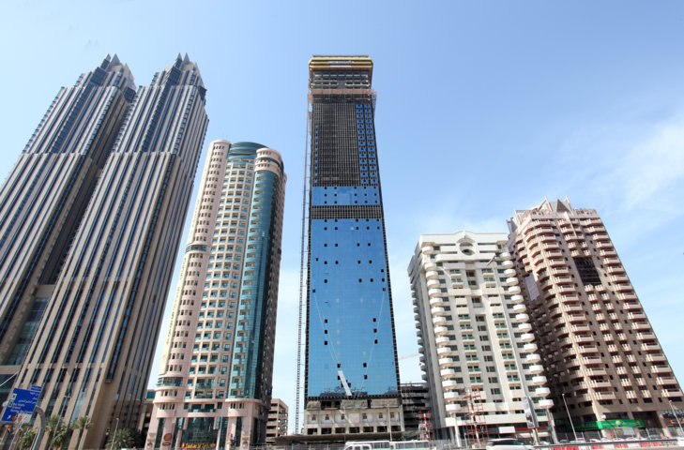

- AL SOUQ AL KABEER (B+G+M+6TYP. +GYM) @ Dubai
- Owner : DUBAI INTERNATIONAL REAL STATE
- Engineer : HEGAZY CONSULTANCY OFFICE
- Contractor : AL ASHRAM CONTRACTING CO. L.L.C

Job Description:

- Setting out the works in accordance with the drawings and specification
- Liaising with the project planning engineer regarding construction programmes
- Checking materials and work in progress for compliance with the specified requirements
- Observance of safety requirements
- Resolving technical issues with employer’s representatives, suppliers, subcontractors and statutory authorities
- Quality control in accordance with CSIs/procedures method statements, quality plans and inspection and test plans, all prepared by the project management team and by subcontractors
- Liaising with company or project purchasing department to ensure that purchase orders adequately define the specified requirements
- Supervising and counselling junior or trainee engineers
- Measurement and valuation (in collaboration with the project quantity surveyor where appropriate)
- Providing data in respect of variation orders and site instructions
- Preparing record drawings, technical reports, site diary

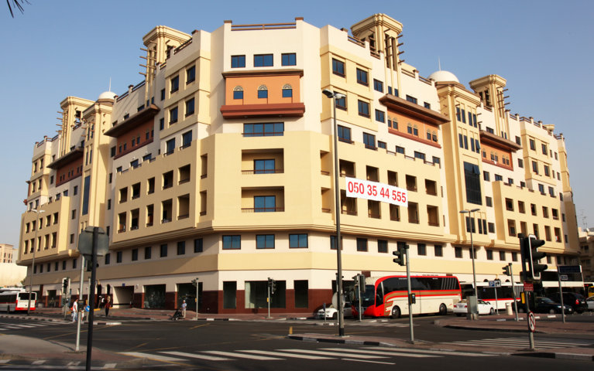

- (6)-AL ALAMIA CONTRACTING COMPANY- EGYPT
January 2004–February 2007

  - Description of work:

- Supervise the implementation of Construction of group of villas in (Al Yasmeen village)
- Implementation of concrete structure for a Governmentalbuildingin Port Said
- Implementation of Architecture development projects for vital zones in Port Said city like as the main Sea Entrance to be a tourism zone with high environmental characteristic.
- Implementation of several housing units

Technical Skills & Knowledge Areas

- Auto CAD
- SAP
- Primavera
- MS Office Package
- RCD Design

Languages

- Arabic (Mother Tongue).
- English (very good; spoken and written).

Personal Information

Date of Birth :1/9/1981
Nationality : Egyptian.
Religion : Muslim.
Social status : Married.
Driving License : UAE & KSA
Visa Status : Visit Visa

